Java Projects

Professor William J. Wolfe [william.wolfe@angelo.edu](mailto:william.wolfe@angelo.edu) Angelo State University

Description: This document contains several Java projects, progressing from simple to difficult. All the projects were developed using the (free) Netbeans IDE and the (free) Java JDK. All the code is included, and users are encouraged to take each project (especially the later ones) and convert them into more elaborate applications of their own design.

**Project Index**

1. Getting Started
2. Printinglntegers
3. Population
4. BinaryNumbers
5. ASCII
6. Factorial
7. MultiplicationTables
8. PrimeNumbers
9. RandomCharacters 10.GCD
10. MathQuiz
11. Encryption
12. InsertionSort
13. CardGame
14. QuadraticEquations
15. Permutations
16. NumberGuessingGame
17. ComputeGrades
18. RandomDrawings
19. Grid
20. MouseClickDraw
21. Sierpinski
22. Asteroids
23. RockPaperScissors
24. ArithmeticGUI
25. HangmanN ew
26. Minesweeper
27. ClockAnimation
28. SimpleAnimation
29. AnimatedBalls
30. BouncingSticks
31. RotatingPolygon
32. Life 34.Pong
33. ShootingGameNew
34. SideScrollGame
35. MadLibS



1



**Java Project: GettingStartedl**

**Description:** Some simple java exercises for getting accustomed to the Netbeans interface and simple java code.

**Create** a new Netbeans Project, name it **GettingStartedl**

**Netbeans** > file > new project> choose project: java application <next> Project Name: GettingStarted <finish>

**Your screen** will now look something like:

*l//l/l//lll/ll//ll!/I/I/IIII//I//I/I/IIII/IIIIII/IIIIIIII*

/*

* To change this license header, Project Properties.
* To change this template file, choose Tools I Templates
* and open the template in the editor.

*\*I*

package gettingstartedl;

/**

*

* @author wwolfe3

* /

public class GettingStartedl

/**

* @param args the command line arguments

*/

public static void main(String[] args) {

//Your java code goes here

}

*/I//IIIIIIII//III/IIIIIIIIII//IIIII/IIIIIIIIIIIIIIIIIIIII*

**This code will be delted and replaced with the code on the following page.**

2

**Delete all the above code, replace it with the follow code:**

package gettingstartedl; import java.util.Scanner;

public class GettingStartedl {

public static void main(String[) args) System.out.println("Hello World");

System.out.println("l + 2 + 3");

System.out.println(l + 2 + 3);

|  |  |  |
| --- | --- | --- |
| System.out.println("l" | + 2 | + 3); |
| System.out.println(l + | "2" | + 3); |
| System.out.println(l + | 2 + | "3"); |
| System.out.println(l + | 2 + | 3); |

System.out.println("a" + "b" + "c"); int a= 89;

System.out.println(a + "b" + "c");

Scanner input= new Scanner(System.in); System.out.println("Please enter the length:"); int length= input.nextint(); System.out.println("length ="+length);

System.out.println("max integer="+ Integer.MAX_VALUE); System.out.println("max double="+ Double.MAX_VALUE);

String x = "hello"; x = x +"there";

System.out.println("x

char z = 10036;

" + x);

for (inti= 40; i < 128; i++) { System.out.println("z =" + (char) i);

**After clicking the green "Run" arrow on the menu bar you should get an output that looks like the follow (the computer will prompt you to enter a length try 10)**

3

Sample Output:



**...ag Output - GettingStarted (run)** 0 !al **abrogate.jpg**

run:

Hello World 1 + 2 + 3

6

123

123

33

6

abc

89bc

Please enter the length:

10

length= 10

max integer= 2147483647

max double= 1.7976931348623157E308

x = hello **there**

**z = (**

**z** *=* **) z =** * **z** *=* **+**

**z** =-•

**z** = .

**z** =

**z =** *I*

**z** = 0

**z** *=* **1**

**z = 2**

**z** = 3

**z =** 4

**z** = **5**

**z =** 6

**z** = 7

**z = 8**

**z = 9**

**z** = :

**z** = ;

**z = <**

**z - -**

**z := >**

7 ;;; **1**

**4**

###### Java Project: GettingStarted2

**Description:** Some simple exercises to get started in Java programming.

**Create** a new Netbeans Project, name it **GettingStarted2 Netbeans** >new> project> java application> GettingStarted2 **Type in code:**

*/ll/!l/l//llll/l/ll!/lll!//llllll/!//I//////*

package gettingstarted2;

public class GettingStarted2

public static void main(String[] args) {

//A= pi r squared

System.out.println("area =" + 3.14 * 5.0 * 5.0);

doubler: 5.0;

double area= Math.PI* r * r;

System.out.println("area ="+area); System.out.println("max integer="+ Integer.MAX_VALUE); System.out.println("max double="+ Double.MAX_VALUE);

**When it's typed in, click the "Run" arrow. Sample Output:**

area = 78.5

area = 78.53981633974483

max integer = 2147483647

max double = l.7976931348623157E308 BUILD SUCCESSFUL (total time: 0 seconds)

**5**

###### Java Project: GettingStarted3

**Description: GettingStarted3: This program prompts the user for a score (0 -100) and then presents the associated letter grade.**

**Create a new Netbeans Project, name it GettingStarted3 Netbeans > new> project> java application > GettingStarted3 Type in code:**

package gettingstarted3;

import javax.swing.JOptionPane; public class GettingStarted3 {

public static void main(String[] args) {

//yesNoExample();

//dialogWithif();

//dialogCircleArea(); convertScoreToLetter();

public static void yesNoExample() { JOptionPane.showMessageDialog(null, "OK to continue",

"Warning", JOptionPane.WARNING_MESSAGE);

private static void dialogWithif() {

String input= JOptionPane.showinputDialog("Type Something");

System.out.println("Input = 11 + input);

int choice= JOptionPane.showConfirmDialog(null, "Make your choice");

System.out.println("choice = 11 + choice); if (choice == 0) {

System.out.println("You chose \"Yes\" ");

if (choice == 1) {

System.out.println( 1 You chose \"No\" 1 1 ) ;

if (choice == 2) {

System.out.println("You chose \"Cancel\" 1 1 ) ;

6

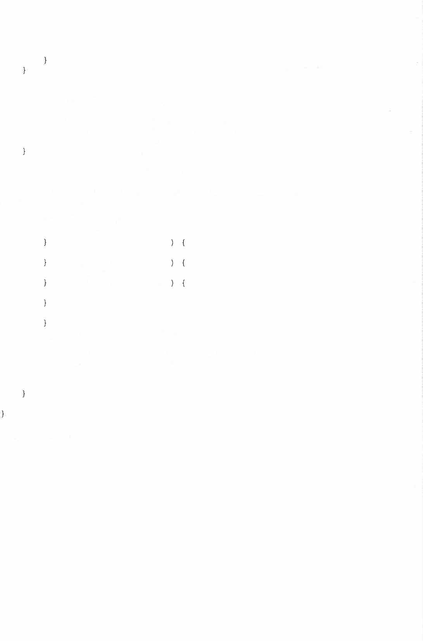

private static void dialogCircleArea() {

String radius= JOptionPane.showinputDialog("Please enter the circle radius:");

doubler = Double.parseDouble(radius); System.out.println("You entered a radius of: "+ r); System.out.println("Area = 11 +Math.PI* Math.pow(r, 2));

private static void convertScoreToLetter() { int score=

Integer.parseint(JOptionPane.showinputDialog(''Please enter a score (0 - 100): "));

char letter;

if (score >= 90 ) **{**

letter = I A';

else if ( score >= 80 letter = I B I ;

else if ( score >= 70 letter = 'C';

else if (score>= 60 letter = 'D';

else {

letter= 'F';

//System.out.println("Your score of"+ score+" earned a grade of"+ letter);

JOptionPane.showMessageDialog(null, "Your score of"+ score+" earned a grade of 11 + letter);

Sample Output:

7

* + lnput



Please enter a score (0 - 100):

**Cancel** [ **OK**

Input

**Please enter a score (0 - 100): 801**

**Cancel** -J ~~(~~ OK

.._____ .,

* + Message

**Your score of 80 earned cl**..**grad of B**

.

'

OK

8

###### Java Project: GettingStarted4

**Description:** GettingStarted4: Simple Java exercise. Compute the area and cirumference of a circle and the area of a triangle. Also compute a Fahrenheit to Celsius temperature conversion table. Finally, use another for loop to print out a list of ASCII characters using their decimal code.

**Create** a new Netbeans Project, name it GettingStarted4 **Netbeans** >new> project> java application> GettingStarted4 **Type in code:**

package gettingstarted4; public class GettingStarted4

public static void main(String[) args) {

//area of a circle:

double radius= 10;

double area= Math.PI* Math.pow(radius, 2); Systern.out.println("area ="+area);

//circumference of a circle: double c = 2 *Math.PI* radius; Systern.out.println("c =" + c);

//area of a triangle:

double base= 10;

double height= 3;

area = 0.5 *base* height; System.out.println("area of triangle

" + area);



//f to c:

double f;

for(f = 0.0; f <= 212; f = f + 1) {

double celsius = 5.0/9.0 * ( f - 32 ); System.out.println("f =" + (int)f +" c = "+

(int)celsius);

}

for(int i = 4000; i < 4128; i++) System.out.println((char)i);

9

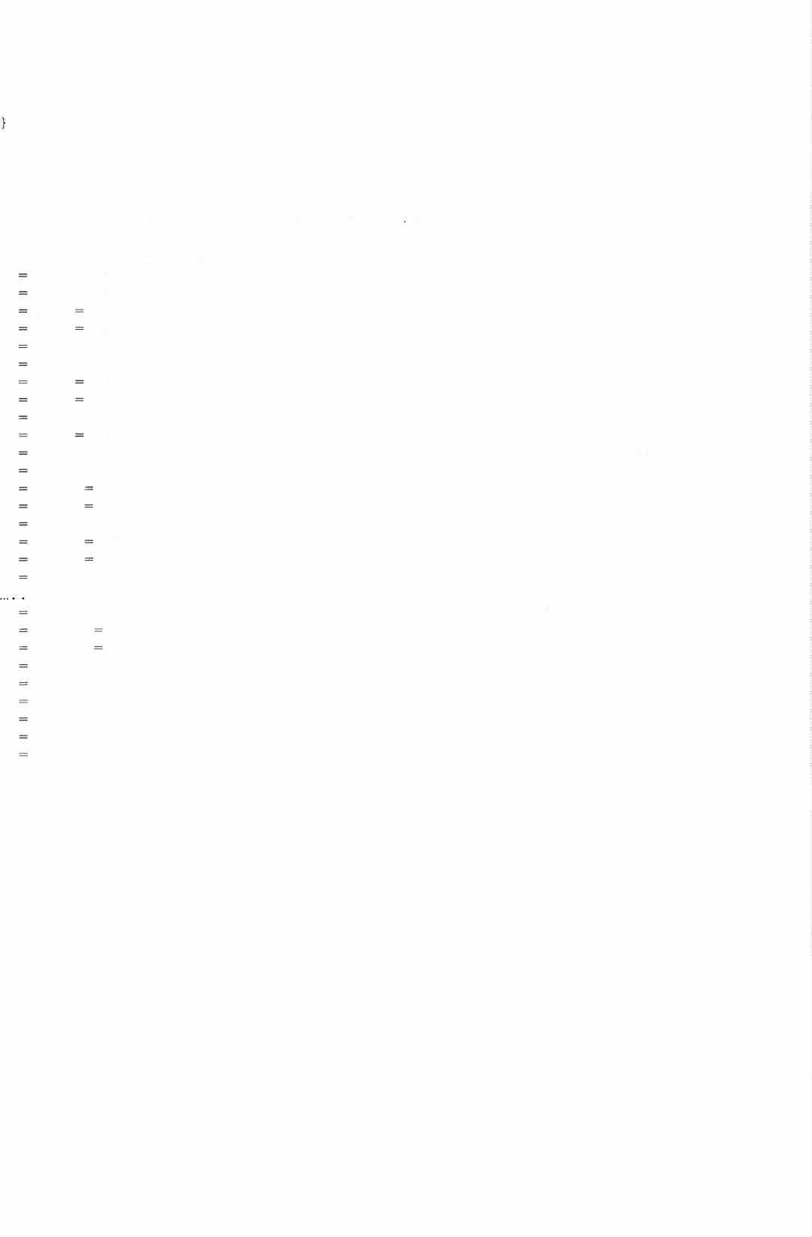

**Sample output: (the output is very long, so here it is abreviated):**

area= 314.1592653589793

C = 62.83185307179586

area of triangle= 15.0 f O C = -17

f 1 C = -17

f 2 C -16

f 3 C -16

f 4 C = -15

f 5 C = -15

f 6 C -14

f 7 C -13

f 8 C = -13

f 9 C -12

|  |  |  |  |  |
| --- | --- | --- | --- | --- |
| f f | 10  11 | C  C | =  = | -12  -11 |
| f | 12 | C |  | -11 |
| f f | 13  14 | C  C | = | -10  -10 |
| f | 15 | C |  | -9 |
| f | 16 | C |  | -8 |
| f | 17 | C | = | -8 |
| f | 204 | C | = | 95 |
| f | 205 | C |  | 96 |
| f | 206 | C |  | 96 |
| f | 207 | C | = | 97 |
| f | 208 | C | = | 97 |
| f | 209 | C | = | 98 |
| f | 210 | C | = | 98 |
| f | 211 | C | = | 99 |
| f | 212 | C | = | 100 |

10



BUILD SUCCESSFUL (total time: 0 seconds)

###### Java Project: Printinglntegers

**Create** a new Netbeans Project, name it Printingintegers

**Netbeans** >file> new project> project> java application <next>> Project Name: Printinglntegers > <finish>

**Description:** Print a list of integers in a rectangular layout, skipping those integers that contain, or are a multiple of, a specified digit. Uses a method (indexOf) to detect if a character is in a given string.

**Sample Output:**

**[s Output - Printinglntegers (run) 0** I **Prthtlngtnte:gers,java**

run:

Please enter a value of n:

100

C'

How many integers per line?

10

Which digit, and its multiples, to skip?

**7**

1 **2 3** 4 **5 6** * **8 9** 10

11 12 **13 '4<T** 15 **16 18 19** 20

**tt 22** 23 24 25 26 ** ** **29 30**

31 32 33 **34** 36 ** **38 39** 40

41 ** **43 44** 45 46 ** **48** 50

**51** 52 **53 54** 55 ** 58 59 **60**

61 62 **64** 65 **66** ** 68 69 **

** ** ** ** ** ** ** ** ** 80

81 82 83 85 86 **\*J!<** 88 89 90

-** 92 **93** 94 95 96 ** ** 99

BUILD SUCCESSFUL (total time: 8 seconds)

11

package printingintegers; import java.util.Scanner; public class Printingintegers

public static void main(String[] args) { Scanner input= new Scanner(System.in);

System.out.println("Please enter a value of n:"); int n = input.nextint();

String nString = "" + n; //length of n treated as string int maxDigits **=** nString.length(); System.out.println("How many integers per line?");

int p = input.nextint();

System.out.println("Which digit, and its multiples, to

skip?");

stars);

int m = input.nextint(); for(int i = 1; i < n; i++)

if ( ((i%m) **==** 0 ) 11 hasM(i,m) ){ int iLength = ("" + i) .length(); String stars = getStars(iLength);

System.out.format("%"+ (maxDigits + 1) + "s",

else {

System.out.format("%"+ (maxDigits + 1) + "d", i);

}

if( i % p == 0) { System.out.println("");

System.out.println("");

System.out.println("");

public static String getStars(int p) { String stars="";

for(int k = 0; k < p; k++) { stars+="*";

return stars;

public static boolean hasM(int i, int m) { char c = String.format("%s", m) .charAt(0); String x **= ""** + i;

return x.indexOf(c) >= 0;

13

**Java Project: Population**

**Description: Predicts the population based on assumptions about birth**

**and death rate.**

**Sample Output:**

**run:**

**pop year O= 312032486 pop year 1 = 314812582**

**pop year 2 = 317592678**

**pop year 3 = 320372774**

**pop year 4 = 323152870**

**pop year 5 = 325932966**

package population; public class Population

public static void main(String[] args) {

//Given: current pop, birth rate, death rate, immig. rate

//predict the population for 5 years

//a birth every 7 seconds.

//a death every 13 seconds.

//an immigrant every 45 seconds. int pop = 312032486;

System.out.println("pop year O ="+pop); int n = 365 * 24 * 60 * 60;

int births= n / 7;

int deaths = n / 13;

int immigrants= n / 45;

int net = births+ immigrants - deaths; int years= 5;

for (inti= 1; i <= years; i i + 1) pop= pop+ net;

System.out.println("pop year"+ i +" " + pop);

14

**Java Project: BinaryNumbers**

**Description:** Print a list of binary numbers, in order. It uses a method to convert a decimal number to its binary equivalent.

**Netbeans** > file > new project > project > java application <next> > Project Name: BinaryNumbers > <finish>

**Sample Output:**

**�put - BinaryNumbers (runl ('.'> � 6in.iryNumbers.java Cl**

it, run:

1



1011

10101

11111

101001

110011

111101

1000111

1010001

1011011

1100101

1101111

1111001

10000011

10001101

10010111

10100001

10101011

10110101

10111111

11001001

11010011

11011101

11100111

11110001

11111011

100000101

100001111

100011001

100100011

100101101

100110111

101000001

101001011

101010101

10

1100

10110

100000

101010

110100

111110

1001000

1010010

1011100

1100110

1110000

1111010

10000100

10001110

10011000

10100010

10101100

10110110

11000000

11001010

11010100

11011110

11101000

11110010

11111100

100000110

100010000

100011010

100100100

100101110

100111000

101000010

101001100

101010110

11 100

1101 1110

10111 11000

100001 100010

101011 101100

110101 110110

111111 1000000

1001001 1001010

1010011 1010100

1011101 1011110

1100111 1101000

1110001 1110010

1111011 1111100

10000101 10000110

10001111 10010000

10011001 10011010

10100011 10100100

10101101 10101110

10110111 10111000

11000001 11000010

11001011 11001100

11010101 11010110

.11011111 11100000

11101001 11101010

11110011 11110100

11111101 11111110

100000111 100001000

100010001 100010010

100011011 100011100

100100101 100100110

100101111 100110000

100111001 100111010

101000011 101000100

101001101 101001110

1-01010111 101011000

101 110 111

1111 10000 10001

11001 11010 11011

100011 100100 100101

101101 101110 101111

110111 111000 111001

1000001 1000010 1000011

1001011 1001100 1001101

1010101 1010110 1010111

1011111 1100000 1100001

1101001 1101010 1101011

1110011 1110100 1110101

1111101 1111110 1111111

10000111 10001000 10001001

10010001 10010010 10010011

10011011 10011100 10011101

10100101 10100110 10100111

10101111 10110000 10110001

10111001 10111010 10111011

11000011 11000100 11000101

11001101 11001110 11001111

11010111 11011000 11011001

11100001 11100010 11100011

11101011 11101100 11101101

11110101 11110110 11110111

11111111 100000000 100000001 11

100001001 100001010 100001011 11

100010011 100010100 100010101 11

100011101 100011110 100011111 11

100100111 100101000 100101001 11

100110001 100110010 100110011 11

100111011 100111100 100111101 11

101000101 101000110 101000111 11

101001111 101010000 101010001 11

101011001 101011010 101011011 1,

15

package binarynumbers; public class BinaryNumbers

public static void main(String[] args) int n **=** 2015;

String nBinary **=** convertToBinary(n); int maxDigits **=** nBinary.length(); int p = 10; // numbers per line

for (int *i* **=** 1; i **<=** n; i++) { System.out.format("%"+ (maxDigits + 1) + "s",

convertToBinary(i));

if ((i % p) **==** 0) System.out.println("");

public static String convertToBinary(int k) 1 String binary="";

while (k > 0) {

if (k % 2 **==** 1)

binary= 1 + binary; else {

binary 0 + binary;

}

**k k / 2;**

return binary;

16

#### Java Project: ASCII

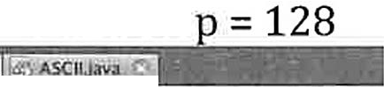

**Description:** Print a list of ASCII (or Unicode) characters with their decimal and binary representations.

**Netbeans** > file > new project > project > java application <next> > Project Name: ASCII> <finish>

**Sample Output:**

1. with start= 0 and sto

* **Output -ASCII lrunJ 0**

Cl> - !14 1t1111. lm'- -- --'---

rWl'. 7 95 1011111

|  |  |  |
| --- | --- | --- |
|  | 96 | 1180000 |
| a | 97 | 1100001 |
| b | 98 | 1100010 |
| C | 99 | 11811011 |
| d | 100 | 1180100 |
| e | 101 | 1180101 |
| f | 102 | 1100110 |
| g | 103 | 1100111 |
| h | 184 | 1101000 |
| 1 | 185 | 1101001 |
| j | 106 | 1101010 |
| k | 187 | 1101011 |
| l | 108 | 1101100 |
| m | 109 | 1101101 |
| n | 110 | 1101110 |
| o | 111 | 1101111 |
| p | 112 | 1110000 |
| q | 113 | 1110001 |
| r | 114 | 1110010 |
| s | 115 | 1118011 |
| t | 111> | 1118100 |
| u | 117 | 1110101 |
| V | 118 | 1110110 |
| w | 119 | 1110111 |
| X | 120 | 1111000 |
| ***y*** | **121** | 1111001 |
| z | 122 | 1111010 |
| { | 123 | 1111011 |
| I | 124 | 1111100 |
| } | 125 | 1111101 |
| ~ | 126 | 1111110 |
|  | 127 | 1111111 |
|  | 128 | 10000000 |

•BUILD SUCCESSFUL (total time, 0 seconds)

1. with: start= 9728 and stop = 9839;

17

**- Output - ASCII (run) 0**

CT>

CV

J> YISII

ll 9806

11\ 9807

1' 9808

**ll!Ul**

10011001001110

10011001001111

10011001010000

9809 10011001010001



* 9810 10011001010010

I( 9811 10011001010011

9812 10011001010100

* 9813 10011001010101

9814 10011001010110

981S 10011001010111

9816 10011001011000

A 9817 10011001011001

•

9818 10011001011010

•

9819 10011001011011

I 9820 10011001011100

.I.9821 10011001011101

9822 10011001011110..

9823 10011001011111

* 9824 10011001100000

9825 10011001100001

9826 10011001100010

.r. 9827 10011001100011

;; 9828 10011001100100

* 9829 10011001100101

9830 10011001100110

9831 10011001100111

*,:.* 9832 10011001101000

, 9833 10011001101001

*r* 9834 10011001101010

.IJ 9835 10011001101011

9836 10011001101100

* 9837 10011001101101

9838 10011001101110

9839 10011001101111

'<'BUILD SUCCESSFUL (total time: 0 se oods)

18

package ascii; public class ASCII

public static void main(String[] args) {

//note: Greek upper case: 913 --> 937

*II* Greek lower case: 945 --> 969 int start= 9728;

int stop = 9839;

int maxDigits = ("" + stop) .length() + l;

int maxBinaryDigits = convertToBinary(stop) .length() + l; for(int i = start; i <= stop; i++) {

System.out.format("%3s", (char)i); System.out.format("%"+ maxDigits + "s", i); System.out.format("%"+ maxBinaryDigits + "s",

convertToBinary(i) );

System.out.println("");

System. out. format ("%3s", (char) 9728); public static String convertToBinary(int k)

String binary=""; while (k > 0)

if (k % 2 1)

binary= 1 + binary; else {

binary

}

0 + binary;

k = k *I* 2; return binary;

19

#### Java Project: Factorial

**Description:** Computes the factorial of a given integer in two ways: iterative (with a loop) and recursively (self-referencing method).

**Sample Output:**

**run:**

**10 factorial (iterative)= 3628800**

**10 factorial (recursive)= 3628800**

**BUILD SUCCESSFUL (total time: 0 seconds)**

package factorial; public class Factorial

public static void main(String(] args) { int n = 10;

int factorial= 1;

//first way (without recursion) for (int i = 1; i <= n; i++) {

factorial= i * factorial;

System.out.println(n + 11 factorial (iterative) 11 + factorial);

//second way (with recursion) factorial= getFactorial(n);

System.out.println(n + 11 factorial (recursive) = 11 + factorial);

public static int getFactorial(int n) { if (n == 0) {

return 1;

return n * getFactorial(n - 1);

20

**Java Project: MultiplicationTables**



**Description:** Print a multiplication table for a given integer size. **Netbeans** > file > new project > project > java application <next> > Project Name: MultiplicationTables > <finish>

**Sample Output: n = 20**

tfil Ourput • MultlplicatlonTabl (run) 0 ] **e1)** .&.Scil,JaYa

|  |  |  |  |  |  |  |  |  |  |  |  |  |  |  |  |  |  |  |  |  |
| --- | --- | --- | --- | --- | --- | --- | --- | --- | --- | --- | --- | --- | --- | --- | --- | --- | --- | --- | --- | --- |
| run: |  | | | | | | | | | | | | | | | | | | | |
|  | 1 | 2 | 3 | 4 | 5 | **6** | 7 | **8** | 9 | 10 | 11 | 12 | **13** | 14 | 15 | 16 | 17 | 18 | 19 | 20 |
| 1 | 1 | 2 | 3 | **4** | 5 | **6** | 7 | **8** | **9** | 10 | 11 | 12 | **13** | 14 | 15 | 16 | 17 | 18 | 19 | 20 |
| 2 | 2 | 4 | 6 | 8 | 10 | **12** | 14 | 16 | 18 | 20 | 22 | 24 | 26 | 28 | 30 | 32 | 34 | 36 | 38 | 40 |
| 3 | 3 | 6 | 9 | 12 | 15 | 18 | 21 | 24 | 27 | 30 | 33 | 36 | 39 | 42 | 45 | **48** | 51 | 54 | 57 | 60 |
| 4 | 4 | 8 | 12 | 16 | 20 | 24 | 28 | 32 | 36 | 40 | 44 | 48 | 52 | 56 | 60 | 64 | 68 | 72 | 76 | 80 |
| 5 | 5 | 10 | 15 | 20 | 25 | 30 | 35 | 40 | 45 | 50 | 55 | 60 | 65 | 70 | 75 | 80 | 85 | 90 | 95 | 100 |
| 6 | 6 | 12 | 18 | 24 | 30 | 36 | 42 | 48 | 54 | 60 | 66 | 72 | 78 | 84 | 90 | 96 | 102 | 108 | 114 | 120 |
| 7 | 7 | 14 | 21 | 28 | 35 | 42 | 49 | 56 | 63 | 70 | **77** | 84 | 91 | 98 | 105 | 112 | 119 | 126 | 133 | 140 |
| **8** | 8 | 16 | 24 | 32 | 40 | 48 | 56 | 64 | **72** | 80 | **88** | 96 | 104 | 112 | 120 | 128 | 136 | 144 | 152 | 160 |
| 9 | 9 | 18 | **27** | 36 | 45 | 54 | 63 | 72 | 81 | 90 | 99 | 108 | 117 | 126 | 135 | 144 | 153 | 162 | 171 | 180 |
| 10 | 10 | 20 | 30 | 40 | 50 | 60 | 70 | 80 | 90 | 100 | 110 | 120 | 130 | 140 | 150 | 160 | 170 | 180 | 190 | 200 |
| **11** | **11** | **22** | **33** | 44 | 55 | 66 | **77** | 88 | 99 | 110 | 121 | 132 | 143 | 154 | 165 | 176 | 187 | 198 | 209 | 220 |
| 12 | 12 | 24 | 36 | 48 | 60 | 72 | 84 | 96 | 108 | 120 | 132 | 144 | 156 | 168 | 180 | 192 | 204 | 216 | 228 | 240 |
| **13** | **13** | 26 | 39 | 52 | 65 | 78 | 91 | 104 | 117 | 130 | 143 | 156 | 169 | 182 | 195 | 208 | 221 | 234 | 247 | 260 |
| 14 | 14 | 28 | 42 | 56 | 70 | 84 | 98 | 112 | 126 | 140 | 154 | 168 | 182 | 196 | 210 | 224 | 238 | 252 | 266 | 280 |
| 15 | 15 | 30 | 45 | **60** | 75 | 90 | 105 | 120 | 135 | 150 | 165 | 180 | 195 | 210 | 225 | 240 | 255 | 270 | 285 | 300 |
| 16 | 16 | 32 | 48 | 64 | 80 | 96 | 112 | 128 | 144 | 160 | 176 | 192 | 208 | 224 | 240 | 256 | 272 | 288 | 304 | 320 |
| 17 | 17 | 34 | 51 | 68 | 85 | 102 | 119 | 136 | 153 | 170 | 187 | 204 | 221 | 238 | 255 | 272 | 289 | 306 | 323 | 340 |
| 18 | 18 | 36 | 54 | **72** | 90 | 108 | 126 | 144 | 162 | 180 | 198 | 216 | 234 | 252 | 270 | 288 | 306 | 324 | 342 | 360 |
| 19 | 19 | 38 | 57 | 76 | 95 | 114 | 133 | 152 | 171 | 190 | 209 | 228 | 247 | 266 | 285 | 304 | 323 | 342 | 361 | 380 |
| 20 | 20 | 40 | 60 | 80 | 100 | 120 | 140 | 160 | 180 | 200 | 220 | 240 | 260 | 280 | 300 | 320 | 340 | 360 | 380 | 400 |

I»

le]

BUILD SUCCESSFUL (total time: 0 scconas)

package multiplicationtables; public class MultiplicationTables

public static void main(String[] args) int n = 20;

int maxDigits = ("" + n*n) .length(); System.out.format("%" + (maxDigits + 1) + "s", " "); for (int i **=** 1; i **<=** n; i++) {

System.out.format("%"+ (maxDigits + 1) + "d", i);

System.out.println("");

for (int j = 1; j <= n; j++)

System.out.format("%"+ (maxDigits + 1) + "d", j); for (inti= 1; i <= n; i++)

System.out.format("%"+ (maxDigits + 1) + "d", i*j); System.out.println("");

21

**Java Project:** PrimeNumbers

**Description:** Print out the prime numbers up to some maximum value. **Netbeans** > file > new project > project > java application <next> > Project Name: **PrimeNumbers** > <finish>

Sample Output: n = 10000

■ **-•-** ■■**1**

**ta u---l'ri W11h,Hl1u.N o\3U - !!!!:·::!!!" ':":!- =-- - - - - - :s:fo:;:...::-=..:::-.:.:.•::..,..,;t,!§i- ;:- ...**

' 7 U>

;, • • • • • •

**9661**

**11 13 "' 17 • 19** *i.D*

**• 2 3 • 2 9 · C i**

**•\**

**l1 • 3 7 ..**

**9ti97**

* **967'**

**9679**

* **96.H**

**41 • 4J**

.**., 47** •

* + **S)**

**61**

**-**

., **• 59**

••

**972'1**

**9743**

.

.

**971**.**9**

. **9749**.

**71 .- 73**

**8)**

**111 • tel**

11,

.

* **'7**

**., 111**

**• 79**

**119**

* **149**

**9733**

- **9883**

**9767**

97"39

**!1769**

'"

**lSl**

,.,

**..-**

,.,.

**173**

* **U7**

**.. 13'7 • 139**

* **1S1**

**>l 167**

**t 179**

9711

**9791**

**9811**

**91)3**

**9717**

**9117**

**9829**

..

.

**9939**

**19\ -.. \93**

**211**

.

* **22]**
* **2'3**

**,. l.J? • 199**

* **227 229**

**.. 239**

**1851**

**9871**

HU

**9957** ,,

**91!18] 9887**

**9997**

,.,

**271 •**

**281 • 21)**

* + **Z9l**

.

**Jll )13**

'"

**"' 2S7**

**_.. 277**

**-. 317**

**_. 317**

,..

**Hll**

**9941**

**9923**

**9'73**

**991:i7**

**95129**

**9949**

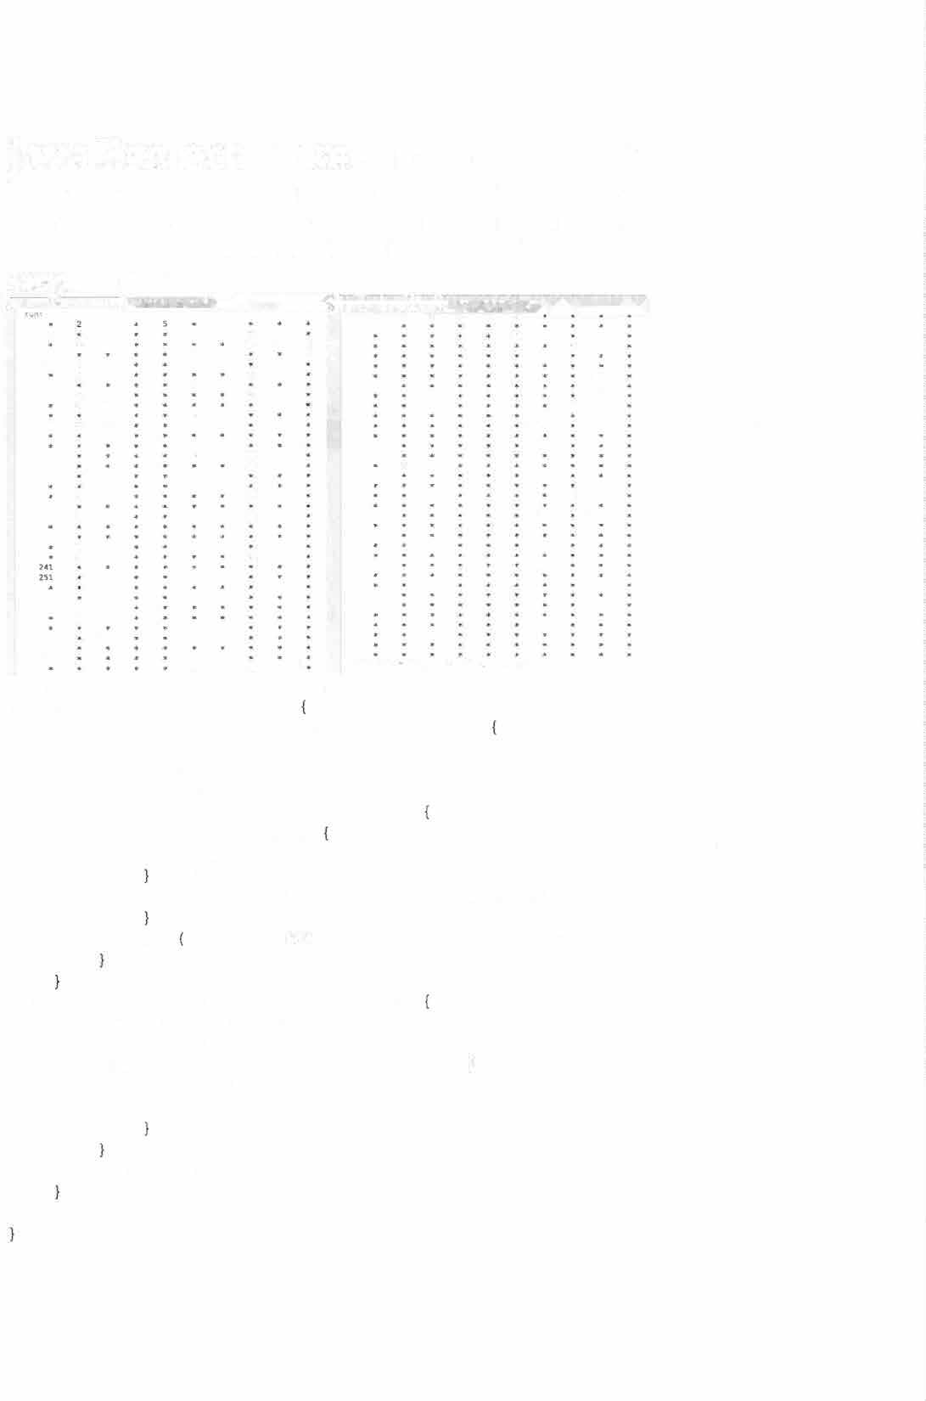

* + - **3)7**

**"' 347 • 349 [11,Hl,ll ::i\l(CfSS.rvt. {':.D\_.\ 1,:u.· f' , ti·,.1 l**

package primenumbers; public class PrimeNumbers

public static void main(String[] args) int n = 10000;

int maxDigits = (**1111** + n). length (); int p = 10;

for (inti= 1; i <= n; i++) if (isPrime(i))

System.out.format("%"+ (maxDigits else {

|  |  |  |  |
| --- | --- | --- | --- |
| + 1) | + | "d", | *i);* |
| + 1) | + | "s", | "*"); |

System.out.format("%"+ (maxDigits

if (i % p) = 0 ) System.out.println('"');

public static boolean isPrime(int p) boolean value= true;

if (p == 1) return false;

for (int i = 2; i <= p / 2; i++) { if (p % i == 0) {

value= false;

return value;

22

Java Project: RandomCharacters

**Description:** Print random characters of all sorts.

**Netbeans** > file > new project > project > java application <next> > Project Name: RandomCharacters > <finish>

**Sample Output:**

S **Output - RandomCharacters (run) 0 Primehlumbers.java**

**RandomCharacters,java**

Cl>

ID

a

run:

|  |  |  |  |  |  |  |  |  |  |
| --- | --- | --- | --- | --- | --- | --- | --- | --- | --- |
| 245 | 451 | 746 | 891 | 403 | 86 | 78 | 390 | 535 | 245 |
| 704 | 24 | 573 | 110 | 978 | 836 | 870 | 983 | 55 | 874 |
| 211 | 995 | 191 | 777 | 69 | 416 | 64 | 261 | 675 | 540 |
| 378 | 356 | 799 | 320 | 712 | 10 | 838 | 85 | 126 | 972 |
| 681 | 731 | 747 | 305 | 436 | 921 | 52 | 725 | 187 | 990 |
| 306 | 303 | 988 | 750 | 786 | 434 | 597 | 360 | 32 | 825 |
| 227 | 628 | 567 | 835 | 364 | 746 | 478 | 727 | 122 | 837 |
| 370 | 609 | 956 | 847 | 772 | 769 | 386 | 966 | 615 | 669 |
| 117 | 4 | 17 | 125 | 560 | 660 | 323 | 484 | 103 | 936 |
| 503 | 406 | 907 | 224 | 365 | 981 | 991 | 405 | 34 | 654 |

0110110001

1001010001

1001010010

0111111011

1000000001

1101010111

1100101000

1110011010

1011001001

1000100101

Jc4Xq7Sf6VnBOx0Ao7Lw0Vg4Mh0Ou1 Ky0Ck2Br8Yn8Kn1Qq3Lr7Sj6Jc8Iy4 Jsllg4Aq2Hn4Cp6Uj3Kl2Vs2Md8On8 Tv1Rl0Mh5Xx1To0Kc8Io5Bh4Tg7Sa2 WW4Fi6Jd4Ug2Sb2Lu0Yl5Lm4To6St4 Ev8Jt3Oe6Qp0Si0Ur5Up3Gy4Ys8Bt6 Ey2Yh4Lg2Kp2Fg5Gs2Ot2Ht2Or3Jkl Tn6Fg4Ki3Ae5Tm2Hq4Qu4Iv4Jx3Hr3 Hp2Dy3Lm0Krn3Vm3Ge4Rs0Mq4Eu8Jol Lw6Io7Mh2Dd6Js2Wt7Ea8Pp8Hi5Fr8



BUILD SUCCESSFUL (total time: 0 seconds)

23

package randomcharacters; import java.util.Random; public class RandomCharacters

public static void main(String[] args) Random r = new Random();

int n = 10; int p = 1000;

int maxDigits = ("" + p) .length();

//print an nxn block of random integers for (int j = l; j <= n; j++) {

for (inti= l; i <= n; i++) System.out.format("%"+ (maxDigits + 1) + "d",

r.nextint(p));

}

System.out.println("");

System. out. println ('"'); int out;

//print an nxn block of binary bits for (int j = 1; j <= n; j++) {

for (inti= 1; i <= n; i++) if (r.nextBoolean()) {

out = 1; else {

out = 0; System.out.format("%d", out);

System.out.println("");

System.out.println("");

//print an nxn block of random letters and digits for (int j = 1; j <= n; j++) {

for (int i = 1; i <= n; i++) { System.out.format("%c", getRandomChar(r, 'A', System.out.format("%c", getRandomChar(r, 'a', System. out. format ("%c", getRandomChar (r, '0',

System.out.println("");

System.out.println("");

**I** Z **I ) ) ;**

**I** z **I ) ) ;**

**I** 9 **I ) ) ;**



public static char getRandomChar(Random r, char from, char to) int k = r.nextlnt((int)to - (int)from);

char c = (char) (k + from); return c;

24

#### Java Project: GCD

**Description:** Calculate and print the greatest common divisor of a pair of numbers.

**Sample Output:**

**2 J 5 fi 7 B 9 a 11 12 13 H t s U V U 19 29 21**

**l • • • " ' • • • • • • • • • •**

**2 • Z " ' • 2 • 2 • 2 • 2 • Z • 2 • 2 • 2**

**l • • l • • 3 • • 3 • • J • • J • • 3**

**• • 2 • 4 • 2 • 4 • 2 • 4 • 2 • 4 • 2 • 4 •**

**! • • 5 • • S • S • ♦ • • S •**

**• 2 l 2 • 1 • 2 l 2 • 6 • 2 l 2 • 6 • 2 l**

• **2 • •**

*, . . . . . . . . . 1 . . 1*

**2 • - • 2 • .. 2 • 1 1 • 2 1 1 4 1 1**

**l ! • • l 3 • • 9 • • 3**

**u 1 . 1 1 1 $ 2 2 . t - 1 8 • 2 • 2 5 2 • 2 • 1 8 •**

. ..

. " ..

**tl**

**• • 11 "' • • • • ♦**

.

**H Z l .s - 1 . ) 2 • 1 Z • Z J 4 • 6 • 4 l ll: ,. .. • • • • •**

**1 4 • 2 • 2 • 2 7**

**lS • • 3 • 5 3 1 6 • 2 • 4 • 2 •**

**11 * • • •**

**• 2 • 2 • 1 4 • 2 • 2 • 2 7**

**J ) • l • • " 3 • J 1 • 2 • 4 • 2 • 1 6 • 2 · ♦ 4 - .**

**\* • • 17 •**

**1 1 • 2 3 2 • 6 •**

**1t . . . . .**

**2 9 2**

**6 • 2 3 2 • 1 1 • 2**

**-. 19 • •**

**21 2 •**

. .

..

**3 • •**

**J • 7 l • • 3 " • 21**

.

.

**4 5 2**

**• 11 •**

**• • Z S 4 ♦ 2 • 2 e ♦**

**21**

**2**,.**3**

**22 •**

**2 •**

***1$***

**26 •**

* **3**
* **3 7**

**l • • 6 •**

**s**.

**• 2 • 2 •**.

**2 • 2 •**

**2 • 2 • 2 • 2 1 3 2 • 2 • 2**

**2 11**

**8 3 2 • 12 •**

**5**

**2 l 8 • 6** . • •

. .

**2 • 2 • 2 • 2 • 2**

. . .

.

**2 •**

**27 l * •**

.

,

**.**

**.**

**l 9 • • l • • l • 9 •**

**2 7 · • • 1 4 • 4 • 2 • ♦**

**Z lS 2**

. . . ,.

**3 1 • 2 3 2 S 6 • 2 l l l • f i •**

**31 •**

**3 2 • 2 • 4 • 2 • 8 • 2 • 4 •**

**33 • J • • 3 • • 3 w. 11 l • l - 4 • 2 • 2 • · 2 • 2 • 2 • 2 •**

**2 •** . ' • 4

**Z • 16 it 2 • •**

**• l • • 3 • •**

**2 • 2 17 2 • 2 •**

**2 •**

**• * • • • • • • • * • •**

**2 • • 2 .-. 16 17** . **1**

**9 19 • 6 • 2 U 2 '" 18 • 19 3 ? • 2 27 • 38**

..

* **8**

**7 • 3 ,.**

**... ] 13 J • •**

* ♦ ,,. ..

**8 • 2 • 4**

**• 2 1 3 • 1 3 3**

. .. . **• 4** . .

**2 • 2 ,. " 2 • 2 * • l • 2 • 2 * • 2**

**• 5 • 11 ... 1' .. • • • 11 • ZS**

. **2 .. l? 3 • • 6 • 4 3 1 2 3 1 2** .

. .

. . . ,.

**• 2 • 2** • 2 • • 2 **• 2 2**

. .. .

**9**

**2 7 9 • • 1 .. • 3 • • 9 l**

**2 2**

**3**

**2**

**.. 2ae • 2 * • s a • u • ,i • 14**

**• 281 • • • • • • • • •**

**2 • 282 • 2 2 • 6 • • 8**

**..,283**

. **2 3 2** . **6**

**2 • 2 U • 2 , . · 2 • 4**

**• l • • 2 8 S • 3 • 5 3**

**2 • 2 • 2 6 • 2 • 2 * 2**

. **.** . .

**.. 287 •**

. .

**• 2 • • 2 •**

**• l * 3 • • 1 S**

. ...

.

**• 2 w l l l l l l 2**

.

.

**7**

9 8 6

.

* **7**

• **2 • 2 9 8 3 4**

**• • • 289 •**

* **fi * 8**

**9** •**2 12**

**18 2**

**• 2 * 4 • • 4 ? • 2 9 2 2 • '**

.

**2 5 2 • M t • Z • l**

.' **2** .

**3 14 • 2 7 •**

. **• 2 •**. ..

**3**

. .

* + **5**

**a**

**3 11 • 9**

•

**l • • l •291 3 " ' •**

**3**

**2**

**\* 293 •**

.

**2 3 2 • 2 9 - 4 - - 2 f**

**S • • • • l . 9 5 . - " ' 5**

**• 2 • 2 9 6 • 2 • 4**

**3 • • 3 • • 2 9 7 • 3**

* + **2**

1< 'Iii "' •

**2 •**

* **13**

**2 • 2 • 2 211291**

**• • • • • • • 299**

**3 21 • 6 • 4 15 ... 12 • 18 l 4 • 6 5 4 l 2 • J H**

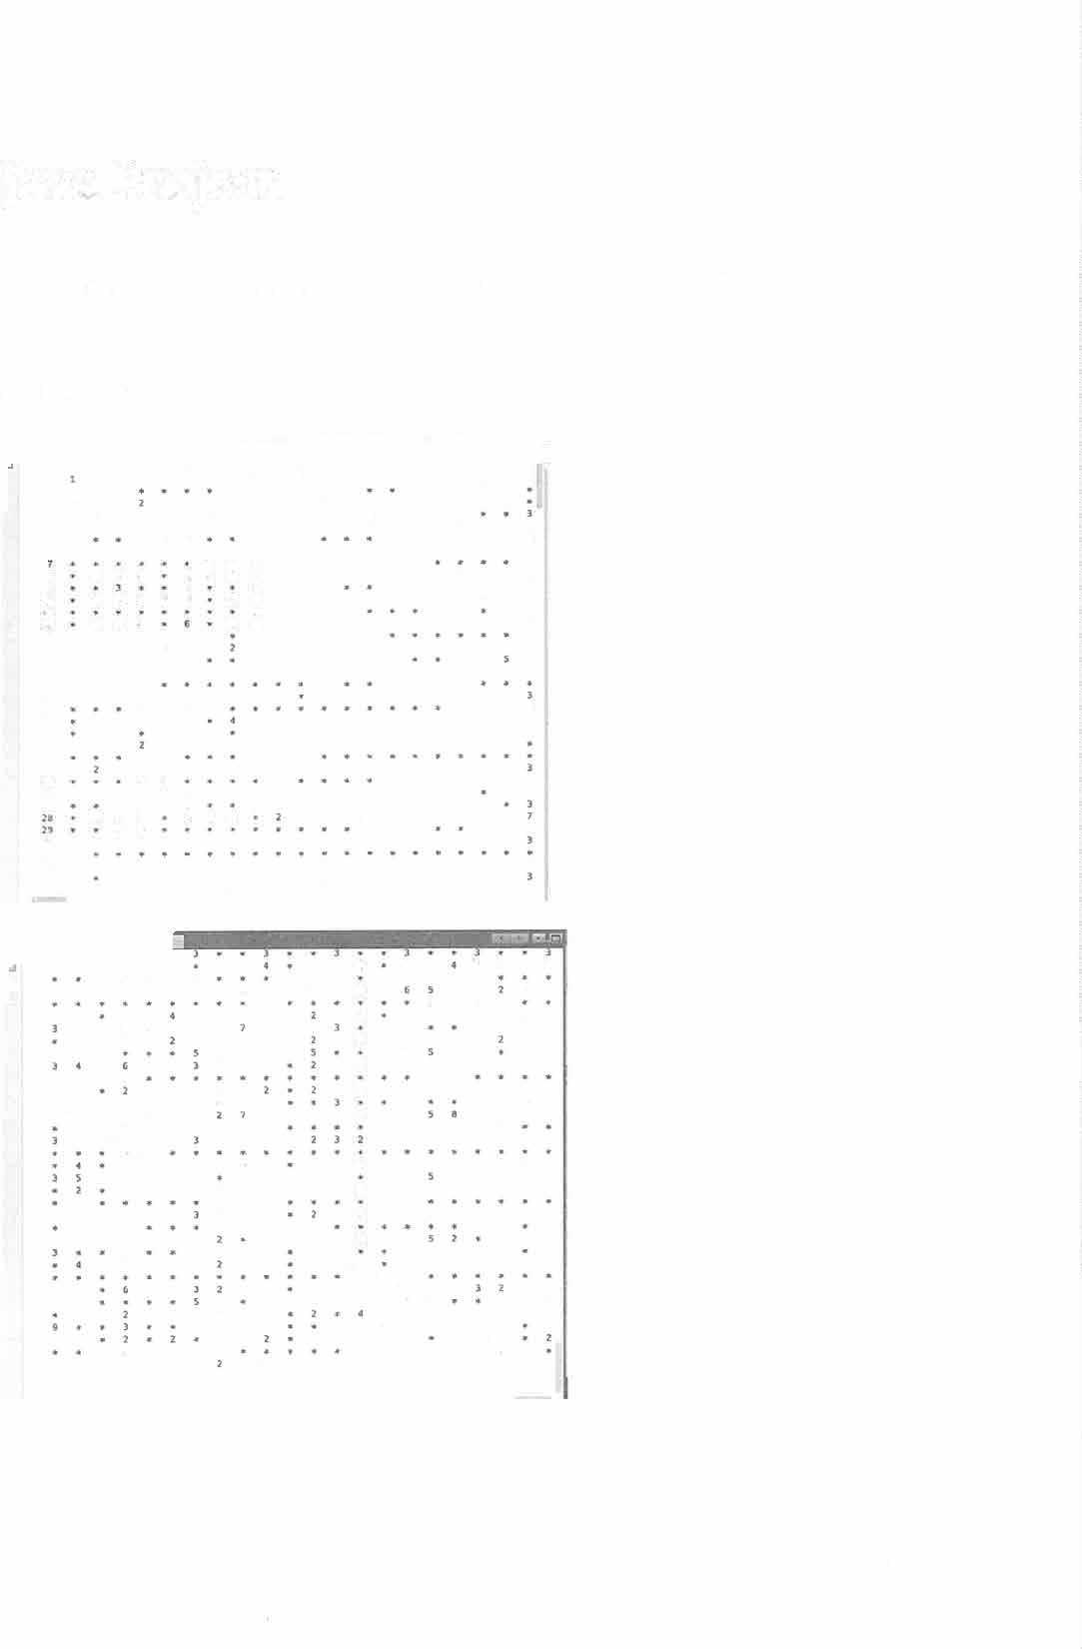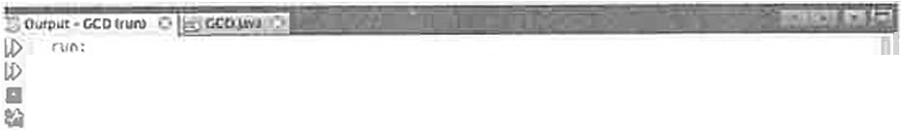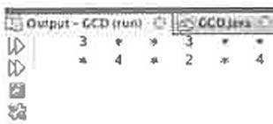

26

package gcd;

public class GCD {

public static void main(String[] args) int n = 300;

int maxDigits = ("" + n) .length(); System.out.format("%"+ (maxDigits + 1) + "s", ""); for (int i = 1; i <= n; i++) {

System.out.format("%"+ (maxDigits + 1) + "d", i);

System.out.println("");

for (int j = 1; j <= n; j++) { System.out.format("%"+ (maxDigits + 1) + "d", j); for (int i = 1; i <= n; i++) {

int thisGCD = gcd(i,j); if(thisGCD == 1) {

System.out.format("%"+ (maxDigits + 1) + "s",

ft*,,);

gcd (i, j));

else {

System.out.format("%"+ (maxDigits + 1) + "d",

System.out.println("");



public static int gcd(int a, int b) { if (a== 0) return b;

if (b == 0) return a;

if (a> b) return gcd(b, a% b); return gcd(a, b % a);

27

#### Java Project: MathQuiz

**Description:** Solve arithmetic problems as fast as you can.

Besides the jave file, the code uses a file called best.txt. There is only one number in best.txt, the fewest seconds that the user has taken to solve the randomly generated set of arithmetic problems.

,PtroJcts Files ***O*** l...------- ----__:_tl

MathQuiz

Output - MathQulz (n.in)

=s=o=ur'.nj::::ce:=;---;::I = = s=t o= r v::::::;l- -:--:: =-...1._:[

H i

[J build

nbproject

1--1 src

Cl **best.t>ct *AA = = - =***

g) build.xml

manifest.mf

L.J MergeSon

1' 24



best.txt has only one number in it, the best time (seconds) that the quiz has been completed in so far.

**Sample Output:**

ID rw\:

U> best: 24 seconds

Solve the following problems as quick as you can.

U

Hit enter to start the problems and the timer

**849**

**+924**

1773

2S2

**+882**

1134

929

**+644**

1573

920

**+477**

1397

354

**+803**

1157

Seconds= 46

wrong= 0

BUILD SUCCESSFUL (total tl c: 1 rinJtc 4 1cconds)

28

package mathquiz; import java.io.File;

import java.io.FileNotFoundException; import java.io.PrintWriter;

import java.util.Scanner; public class MathQuiz {

public static void main(String[] args) throws FileNotFoundException {

int n = 5; //number of problems to solve

int m 3; //number of digits in the numbers int a (int) Math.pow(l0, m - 1);

int b (int) Math.pow(l0, m) - 1; int n_wrong = 0;

int best= getBest();

Scanner input= new Scanner(System.in); String enter= input.nextLine();

long start= System.currentTimeMillis(); for (int i = 0; i < n; i++) {

int x = getRandomint(a, b); int y = getRandomint(a, b); int correct= x + y; printProblem(x, y);

int you= input.nextint();

while (correct != you) { n_wrong++;

System.out.println("incorrect, try again:"); printProblem(x, y);

you= input.nextint(); finish(start, best, n_wrong);

public static void finish(long start, int best, int n_wrong throws FileNotFoundException{

long t = System.currentTimeMillis() - start; long yourTime = t / 1000; System.out.println("Seconds =" + yourTime); System.out.println("wrong =" + n_wrong);

if (yourTime < best) {

System.out.println("New best time: "+ yourTime); File bestFile = new File("best.txt");

PrintWriter output= new PrintWriter(bestFile); output.print(yourTime);

output.close();

public static int getBest() throws FileNotFoundException File file= new File("best.txt");

Scanner getBest = new Scanner(file); int best= getBest.nextint();

System.out.println("best ="+best+" seconds");

29

System.out.println("Solve the following problems as quick as you can.");

Systern.out.println("Hit enter to start the problems and the

timer");

return best;

public static void printProblem(int x, int y) { int length= ("" + x) .length(); System.out.println(" "+ x); System.out.println(" +" + y); System.out.print(" ");

for (int j = 0; j < length; j++) System.out.print("-");

System.out.println("");

public static int getRandomint(int a, int b) { return (int) ((b + 1 - a) * Math.random() + a);

30

**Java Project:** Encryption

**Description:** Encode a message with an encryption cipher and then decode it. The cipher is a randomized, shuffled, alphabetic list.

**Sample Output:**

**� Output - Encryption {run) 0 Encryption.java**

*t:f> t:f>*

[l

run:

**AYEAJWARTA WX ZGA ZAPTGAJ Sf PVV ZGWRKX UNVWNX TPAXPJ**

*

To see the encryption key type <enter>:

A B C D E f G H I J K L M N O P Q R S T U V W X Y Z P I T M A f K G W U B V D R 5 E L J X Z N O Q Y H C

To see the original message type <enter>:

**EXPERIENCE IS THE TEACHER OF ALL THINGS - JULIUS CAESAR**

**BUILD SUCCESSFUL (total time: 7 seconds)**

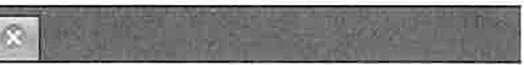

package encryption; import java.util.Random; import java.util.Scanner;

public class Encryption {

public static void main(String[] args) int n = 26;

char[] alphabet= new char[n]; char[] key= new char[n];

for (inti = 0; i < n; i++) { alphabet[i] = (char) (i + 65); key[i] = alphabet[i];

key= createRandomKey(key);

String input= "Experience is the teacher of all things - Julius Caesar";

input= input.toUpperCase();

String output= encrypt(input, key); System.out.println(output);

Scanner scanner = new Scanner(System.in); Systern.out.println("To see the encryption key type

<enter>:");

String getEnterl = scanner.nextLine();

31

for (int i = 0; i < n; i++) { System.out.print(alphabet[i] +" ");

System.out.println("");

for (inti= 0; i < n; i++) System.out.print(key[i] +" ");

System.out.println("");

system.out.println("To see the original message type

<enter>: ") ;

String getEnter2 = scanner.nextLine(); System.out.println(input);

public static char[] createRandomKey(char[] key) { int n = key.length;

int m = n * n;

Random r = new Random(); for (int p = 0; p < m; p++)

int swapl = r.nextint(n); int swap2 = r.nextint(n); char temp= key[swapl]; key[swapl] key[swap2]; key[swap2] = temp;

return key;

public static String encrypt(String input, char[] key) { String output="";

for (int **k** = 0; **k** < input.length(); **k++)**

char thisChar = input.charAt(k); if (thisChar == ' ') {

output += ' ';

else if ((int) thisChar > 91 II (int) thisChar < 65) {

output+= else {

t * I ,•

int index= (int) input.charAt(k) - 65; output+= key[index];

return output;

32

**Java Project:** InsertionSort

**Description:** Sorts a random array of integers, using the method called "insertion sort".

**Sample Output:**

run:

Original array:

a[0] = 8

a[l] = 16

a[2] = 91

a[3] = 40

a[4] = 50

a[S] = 29

a[6] = 53

a[7] = 28

a[8] = 87

a[9] = 86

Sorted array:

a[0] = 8

a[l] = 16

a[2] = 28

a[3] = 29

a[4] = 40

a[S] = 50

a[6] = 53

a[7] = 86

a[8] = 87

a[9] = 91



BUILD SUCCESSFUL (total time: 0 seconds)

33

/*

* Insertion sort -- ref: Algorithms Text, Cormen

*/

package insertionsort; import java.util.Arrays; public class InsertionSort

public static void main(String[] args)

//initialize an array of integers: final int N 10;

int[] array= new int[N];

//generate ranom integers from Oto 99: for (inti= 0; i < array.length; i++) {

array[i] **=** (int) (100 *Math.random());

//print the random array: System.out.println("Original array:"); printArray(array);

insertionSort(array);

//Java has a sort function: Arrays.sort(array);

//print the sorted array System.out.println("Sorted array:"); printArray(array);

private static void printArray(int[] a) { for(int i = 0; i < a.length; i++) {

System.out.println("a[" + i + "] =" + a[i]);

private static void insertionSort(int[] a) { for(int j = 1; j < a.length; j++) {

int key= a[j]; inti= j - 1;

while( i >= 0 && a[i] > key) { a[i+l] **=** a[i];

i **=** i - 1;

a[i+l] = key;

34

#### Java Project: CardGame

**Description: This program "deals" a poker hand, and checks for pairs, three of kind, and four of a kind. Just the beginning of what could be a fund poker playing game.**

**Sample Output:**

**4+4 9•9+ T•**

**Has a pair of 4's**

**BUILD SUCCESSFUL (total time: 0 seconds)**

package cardgame;

import java.util.Scanner; public class CardGame {

public static int[) hand public static int[) deck

new int[S]; new int[52];



public static void main(String[] args) {

//lab4_exercise_l(); lab4_exercise_4();

private static int randomlnteger(int a, int b) { return (int) ((b - a) * Math.random() + a);

private static void lab4 exercise 1()

//generate two integers

//for timing:

long start, stop;

start= System.currentTimeMillis(); System.out.println("start time="+ start); int nl, n2;

int n_digits = 2;

int a = (int) Math.pow(lO, n_digits - 1); int b = (int) Math.pow(lO, n_digits);

nl = randomlnteger(a, b); n2 = randomlnteger(a, b);

System.out.println(" "+ nl); System.out.println(" "+ n2); System.out.println("+ "); int correct= nl + n2;

Scanner input= new Scanner(System.in); int answer = input.nextlnt();

35

while (answer != correct) { System.out.println("Wrong, try again:"); answer= input.nextint();

System.out.println("Got it"); stop= System.currentTimeMillis();

System.out.println("It took you"+ (stop - start) / 1000.0

+ " seconds.");

private static void lab4 exercise_4() {

// choose a random card

// model the deck as: 52 cards, indexed from Oto 51.

// print the whole deck:

//printDeck(); initializeDeck(); shuffleDeck(); dealPokerHand(); sortHand(); displayPokerHand(); if (hasPair() >= 0)

System.out.println("Has a pair of"+ getRank(hasPair()

% 13) + "'s");

if (hasThree() >= 0) {

System.out.println("Has three"+ getRank(hasThree() %

13) + "'s");

private static int getSuit(int suit) {

switch (suit) **{**

case 0:

return 9829; //hearts

case **1:**

return 9830; //diamonds

case 2:

return **9824;** //spades

case 3:

return 9827; //clubs default:

return 9837; //flat

private static char getRank(int rank) if (rank > 0 && rank < 9) {

return (char) (49 + rank); switch (rank) {

36

case 0:

return **'A';**

case 9:

return I T I;

case 10:

return 'J';

case 11:

return IQ I;

case 12:

return IK I ;

return (char) rank;

private static void printDeck() { for (int i = O; i < 52; i++) {

int rank= i % 13; int suit= i / 13;

s stem.out.println(getRank(rank) +" "+ (char) getSuit (suit) );

}

private static void initializeDeck() for(int i = 0; i < 52; i++) {

deck[i] = i;

private static void shuffleDeck () for(int i = 0; i < 10000; i++)

int cardl = randominteger(0, 52); int card2 = randominteger(0, 52);

//swap cardl with card2 int temp= deck[cardl]; deck[cardl] = deck[card2]; deck[card2] = temp;

private static void dealPokerHand() { for (int i = 0; i < 5; i++) {

//hand[i] randominteger(0, 52); hand[i] = deck(i];

private static void displayPokerHand() for (int i = 0; i < 5; i++) {

37

char cardRank = getRank(hand[i] % 13);

char cardSuit = (char) getSuit(hand[i] / 13); System.out.print(cardRank + "" + cardSuit); System.out.print(" ");

System.out.println("");

private static int hasPair() { for (inti= 0; i < 4; i++)

for (int j = i + l; j > i && j < 5; j++) if (hand[i] % 13 == hand[j] % 13) {

return hand[i];

return -1;

private static int hasThree() {

//assumes the hand is sorted by rank int[] rank= new int[S);

for (inti= O; i < 5; i++) rank[i) = hand[i) % 13;

for(int i = 0; i < 3; i++) { if(rank[i) == rank[i+l) && rank[i)

return hand[i);

return -1;

private static void sortHand() { int[) rank= new int[5];

for (inti= 0; i < 5; i++) rank[i] = hand[i) % 13;

boolean flag= true; while (flag) {

flag= false;

for (inti= 0; i < 4; i++) { if (rank[i) > rank[i + 1])

int temp= rank[i]; rank[i) = rank[i + 1]; rank[i + 1] = temp; int temp2 = hand[il; hand[i) = hand[i + 1]; hand[i + 1] = temp2; flag= true;

rank [i+2]) {



38



**Java Project:** QuadraticEquations

**Description:** This program solves randomly generated quadratic equations a x**2** + b x + c = 0. Where a, b and c are integers between 0 and 10. This range can be easily changed in the program to solve other equations.

**Sample Output:**

**run:**

**a=5 b=9 c=3**

**The quadratic equation:**

**5x"2** + **9x** + **3 = 0**

**Has solutions:**

**Real solutions:**

**x1 = -0.44174243050441603**

**x2 = -1.3582575694955838**

**BUILD SUCCESSFUL (total time: 0 seconds)**

package quadraticequations; public class QuadraticEquations

public static void main(String[] args) {

//quadratic equation

// x = (- b +- sqrt( b squared - 4 a c) )/2a

//note: can't take sqrt of a negative number

int a = randominteger(0, 10); int b = randominteger(0, 10); int c = randominteger(0, 10);

System.out.println("a ="+a); System.out.println("b =" + b); System.out.println("c =" + c);

39

System.out.println("The quadratic equation:"}; System.out.println(a + "x 2 +" + b + "x + "+ c +"

System.out.println("Has solutions:");

0 II) ;

if (a== 0) {

System.out.println("x System.exit(l);

" + -c I b} ;



double discriminant= Math.pow(b, 2} - 4 *a* c; if (discriminant>= 0) {

double xl = (-b + Math.sqrt(discriminant}}/(2 *a}; double **x2** = .(-b - Math.sqrt(discriminant}}/(2 * a); System.out.println("Real solutions:"}; System.out.println("xl "+ **xl);** System.out.println("x2 =" + **x2);**

else {

double cl_real = -b / (2 * a); double c2_real = -b / (2 * a);

double cl_imaginary=Math.sqrt(-discriminant)/(2* a); double c2_imaginary=-Math.sqrt(-discriminant)/(2* a); System.out.println("Complex solutions:"); System.out.println("cl_real ==" + cl_real}; System.out.println("cl_imaginary = "+ cl_imaginary); System.out.println("c2_real =" + c2_real}; System.out.println("c2_imaginary = "+ c2_imaginary);

private static int randominteger(int a, int b) return (int} ((b - a)* Math.random()+ a);

40

### Java Project: Scramble

**Description:** Scramble the words in a paragraph by shuffling the internal letters of each word, keeping the first and last letters in place.

**Sample Output:**

**l:e** Output - Scramble (run) **0** [® Scramble.java

U>

ct>

lg

run:

**Adcoirncg** to **rescerah at Cbirdgame Uitvesinry,** it **d'eosnt in waht oedrr** the **ttteres in a wrod are,**

the **only iaropnmtt** tinhg is that the fisrt **and tsat letetrs be at** the **rhgit place. The rest can**

**be a** ttaot **mess and you** can **stitt raed** it

wohitut **porelbm.** This is **bsueace** the hmuan **mind does**

not **raed evrey letter by isletf,** but the **wrod as a wohte**

Please hit <enter> to see the correct version:

matetr

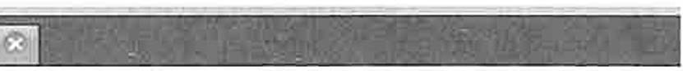

According to research at Cambridge University, it doesn't matter in what order the letters in a word are,

the only important thing is that the first and last letters be at the right place. The rest can

be a total mess and you can still read it

without problem. This is because the human mind does not **read every** letter by itself, but the **word**

as a **whole**

**BUILD SUCCESSFUL (total time: 7 seconds)**

package scramble;

import java.util.Random; import java.util.Scanner;

public class Scramble {

public static void main(String[] args) {

String sentence = "According to research at Cambridge University, it doesn't matter \nin what order the letters in a word are, \nthe only important thing *is* that the first and last

\nletters be at the right place . The rest can\nbe a total mess and you can still read it \nwithout problem. This is because the human mind does \nnot read every letter by itself, but the word\nas a whole";

String out="";

Scanner scanner = new Scanner(sentence);

41

int count= 0;

while (scanner.hasNext())

String word= scanner.next(); count++;

out+= innerScramble(word) +" if ((count% 10) == 0) out+=

System.out.println(out);

I I •,

"\n";

Scanner consoleinput = new Scanner(System.in); System.out.println("");

System.out.println("Please hit <enter> to see the correct version:");

consoleinput.nextLine(); System.out.println(sentence);

}

//getScramble scrambles the entire input string public static String getScramble(String input)

String output= input;

char[] outChars = output.toCharArray(); Random r = new Random();

for (inti= 0; i < outChars.length * outChars.length; i++)

int swapl r.nextint(outChars.length); int swap2 r.nextint(outChars.length); char temp= outChars[swapl]; outChars[swapl] outChars[swap2]; outChars[swap2] = temp;

output= String.valueOf(outChars); return output;

//innerScramble leaves the first and last letters in place. public static String innerScramble(String input) {

String output= input;

char[] outChars = output.toCharArray(); if (outChars.length > 3) {

Random r = new Random();

for (inti= 0; i < outChars.length * outChars.length;

i++) {

int swapl = r.nextint(outChars.length 2) + 1; int swap2 = r.nextint(outChars.length - 2) + 1; char temp outChars[swapl];

outChars[swapl] = outChars[swap2]; outChars[swap2] = temp;

output= String.valueOf(outChars); return output;



42

###### Java Project: Permutations

**Description:** Print out all the permutations of a given string of letters.

3 Output - Permumlon• (run) C'I l'urnuta!Jons: va f::l U• >OUl!>Ut - P<rmut3tlon• (run) Q Permur:u\o Y> Q

run:

iilcal!b

abcdef t{;, fdcbae

abcdfe fdcbea

abcedf fdceab

**abcefd abcfde abcfed abdcet abdcfe abdecf abdefc abdfce abdfec abecdf abecfd abedcf abedfc abefcd abefdc abfcde "'bfced abfdce abtdec abfecd abfedc acbdef acbdfe acbedf acbefd acbfdee acbfed acdbef acdbfe acdebf acdefb acdfbe** cdf"h

fdceba

fdeabc fdeacb fdebac fdebca fdecab fdecba feabcd feabdc feacbd teacdb feadbc feadcb febacd febadc febcad febcda febdac febdca fecabd fecadb fecbad fecbda fecdab fecdba fedabc fedacb fedbac fedbca fedcab fedcba

8UILD SUCCESSFUL (total ti e: 0 seconds)

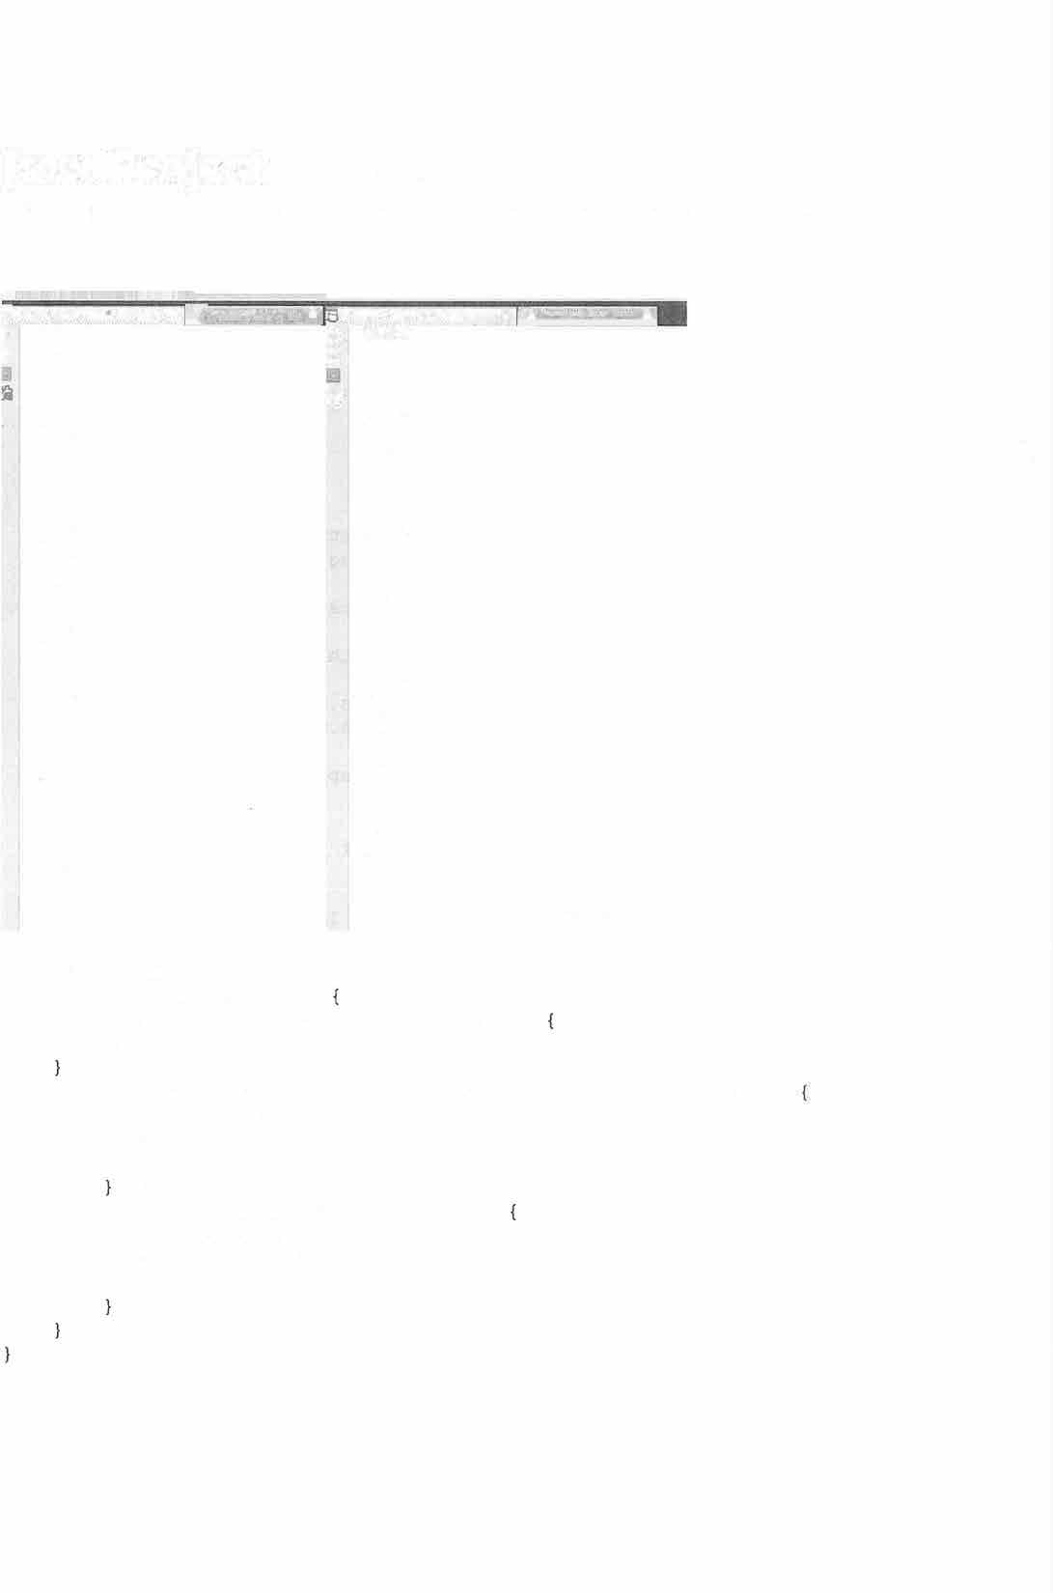

package permutations; public class Permutations

public static void main(String[] args) permutation ("", "abcdef");

private static void permutation(String prefix, String str) int n = str.length();

if (n == 0) {

System.out.println(prefix); else {

for (inti= 0; i < n; i++)

permutation(prefix + str.charAt(i), str.substring(0, i) + str.substring(i + 1, n));

}

43

**Java Project: NumberGuessingGame**

**Description:** Guess a hidden number between 1 and 1000. The program uses a do while loop to keep the iteration going until the user gets the correct number. The program gives the user a "higher/lower" hint after each guess.

**Sample Output:**

run:

Enter a guess (1-1000): 500

Your guess is greater than the secret number. Enter a guess (1-1000): 250

Your guess is smaller than the secret number. Enter a guess (1-1000): 325

Your guess is smaller than the secret number. Enter a guess (1-1000): 400

Your guess is smaller than the secret number. Enter a guess (1-1000): 450

Your guess is smaller than the secret number. Enter a guess (1-1000): 475

Your guess is greater than the secret number. Enter a guess (1-1000): 457

Your guess is greater than the secret number. Enter a guess (1-1000): 453

Your guess is smaller than the secret number. Enter a guess (1-1000): 455

Your guess is smaller than the secret number. Enter a guess (1-1000): 456

Your guess is correct. Congratulations!

BUILD SUCCESSFUL (total time: 1 minute 1 second)

44

package numberguessinggame; import java.util.Scanner; public class NumberGuessingGame

public static void main(String[J args)

int secretNumber;

secretNumber = (int) (Math.random() * 999 + 1); Scanner keyboard= new Scanner(System.in);

int guess; do {

System.out.print("Enter a guess (1-1000): "); guess = keyboard.nextint();

if (guess = = secretNumber) System.out.println("Your guess is correct.

Congratulations!");

else if (guess< secretNumber)

System.out.println("Your guess is smaller than the secret number.");

else if (guess> secretNumber)

System.out.println("Your guess is greater than the secret number.");

} while (guess != secretNumber);

45

##### Java Project: ComputeGrades

**Description:** Help a teacher grade the students. The user enters the students' names and scores and the program computes their letter grades and other statistics.

**Sample Output:**

_ Output- ComputeGr.a.des {run) **r)** I®**ComputeGra(jc.s.java �**

run:

Cl>

How many students? 3

Please enter their names:

Name: 1: john jones Name: 2: mary mack Name: 3: peter paul

Now, please enter their scores: john jones's score: 45

mary mack's score: 90 peter paul's score: 32 Average score: 55.67

Hightest score: mary mack: 90

Lowest score: peter paul: 32 Names: Grades:

john jones: F mary mack: A peter paut: f

BUILD SUCCESSFUL (total time: 16 seconds)

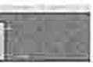

package computegrades; import java.util.Scanner; public class ComputeGrades

public static void main(String[] args) String[) names = getNames();

int[] scores= getscores(names);

double average= computeAverage(scores); int highestindex = getHighest(scores); int lowestindex = getLowest(scores);

System.out.format("Average score: %3.2f\n 1 , average); System.out.println("Hightest score: "+ names[highestindex)

+ 1 1 : 11 + scores[highestindex]);

System.out.println("Lowest score: 1 + names[lowestindex] +

1

" · 11 + scores[lowestindex]);

System. out. println ("Names: Grades: ") ;

46

System.out.print(""); printLetterGrades(names, scores);

public static void printLetterGrades(String(] names, int() scores) {

for (inti= 0; i < names.length; i++) { if (scores(i] >= 90) {

System.out.println(names(i) +"·A"); else if (scores [i) >= 80) {

System.out.println(names[i) + "· B"); else if (scores [i) >= 70) {

System.out.println(names[i] + "· C"); else if (scores[i) >= 60) {

System.out.println(names(i] + "· D"); else {

System.out.println(names[i] + "· F");

public static String(] getNames()

Scanner input= new Scanner(System.in); System.out.println("How many students?"); int n = input.nextint();

System.out.println("Please enter their names:"); String(] names= new String[n);

for (inti= 0; i < names.length; i++) System.out.print("Name: "+ (i + 1) + ": "); names[i] = input.next() +" "+ input.next();

return names;

public static int[] getscores(String(] names) { System.out.println("Now, please enter their scores:"); Scanner input= new Scanner(System.in);

int[] scores= new int[names.length]; for (inti= O; i < names.length; i++)

System.out.print(names(i] + "'s "); System.out.print("score: ");

while (!input.hasNextint()) { input.next();

System.out.println("Please enter an integer for the

score.");

scores(il = input.nextint(); return scores;

public static double computeAverage(int[] scores) {

47

double sum = O;

for (inti= O; i < scores.length; i++) { sum+= scores[i];

return sum/ scores.length;

public static int getHighest(int[J scores) int highestindex = Integer.MIN_VALUE; int highestScore = Integer.MIN_VALUE; for (inti= O; i < scores.length; i++)

if (scores[i] > highestScore)

{

highestScore = scores[i]; highestindex = i;

return highestindex;

public static int getLowest(int[] scores) int lowestindex = Integer.MAX_VALUE; int lowestScore = Integer.MAX_VALUE; for (inti= 0; i < scores.length; i++)

if (scores[i] < lowestScore) { lowestScore = scores[i]; lowestindex = i;

return lowestindex;

48

**Java Project:** RandomDrawings

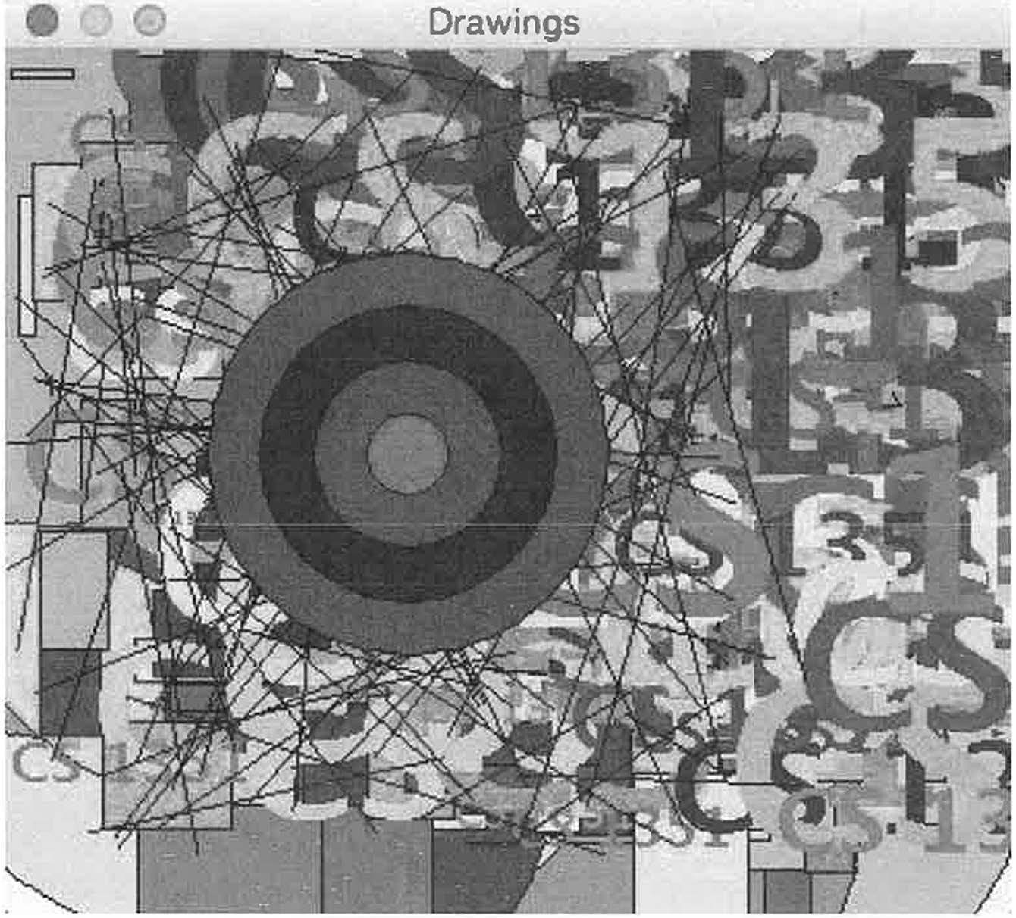

**Description:** Draw a variety of objects to a drawing panel. This program is a demonstration of how to use Jave to draw Characers, Lines, Rectangles and circles.

**Sample Output:**

49

package randomdrawings;

import java.awt.Color; import java.awt.Font; import java.awt.Graphics; import javax.swing.JFrame; import javax.swing.JPanel;

public class RandomDrawings extends JFrame { public static int W = 300;

public static int H = 300;

public RandomDrawings() {

DrawingPanel drawingPanel = new DrawingPanel(); this.add(drawingPanel);

static class DrawingPanel extends JPanel { public static double radius;

public static double **x;** public static double y; public static Color color;

public DrawingPanel() radius= W / 8;

X = W / 2;

y = H / 2;

color= new Color(lOO, 250, 10);

@Override

protected void paintComponent(Graphics g) super.paintComponent(g); drawCircles(g);

drawRectangels(g); drawLetters(g); drawLines(g); drawConcentricCircles(g);

//drawGrid (g);

public void drawGrid(Graphics g) { int cellW 100;

int cellH = 100;

for(int i = 0; i < H/cellH; i++) { for(int j = O; j < W/cellW; j++)

color= getRandomColor(); g.setColor(color);

g.fillRect(j*cellW, i*cellH, cellW, cellH); g.setColor(Color.black);

so

g.drawRect(j*cellW, i*cellH, cellW, cellH);

public void drawConcentricCircles(Graphics g) { int minRadius = 0;

int maxRadius = W/4; int centerX W/2; int centerY = H/2; int delta= 20;

for(int radius= maxRadius; radius> minRadius

radius

= delta) {

color= getRandomColor(); g.setColor(color); g.fillOval(

centerX - radius, centerY - radius, 2*radius, 2*radius

) ;

g.setColor(Color.black); g.drawOval(

centerX - radius, centerY - radius, 2*radius, 2*radius

) ;



public Color getRandomColor() { return color= new Color(

|  |  |  |
| --- | --- | --- |
| (int) | (256 | * Math.random()), |
| (int) | (256 | * Math.random()), |
| (int) | (256 | * Math.random()) |

) ;

public void drawLines(Graphics g) { int n = 100;

int xl, yl, x2, y2;

for (int i = O; i < n; i++) { color= getRandomColor();

//g.setColor(color);

xl = (int) (Math.random() * W);

yl = (int) (Math.random() * H);

x2 (int) (Math.random() * W);

y2 (int) (Math.random() * H); g.drawLine(xl, yl, x2, y2); g.setColor(Color.black);

51

public void drawLetters(Graphics g) {

fontSize);

int maxFontSize 100; int n = 100;

for (int i = 0; i < n; i++) {

int fontSize = (int) (maxFontSize * Math.random()); Font font= new Font("New Courier", Font.BOLD,

g.setFont(font);

String text= "CS 1351"; getRandomColor();

g.setColor(color);

x = (int) (W * Math.random());

y = (int) (H * Math. random ());

g.drawString(text, (int) x, (int) y);

public void drawRectangels(Graphics g) { int maxRectWidth = W / 4;

int maxRectHeight H / 4; int n = 100;

for (inti= 0; i < n; i++)

int rectWidth (int) (maxRectWidth *

Math.random());

Math.random());

int rectHeight = (int) (maxRectHeight * getRandomColor();

x = (int) (W * Math.random());

y = (int) (H * Math. random()); g.setColor(color);

g.fillRect((int) x, (int) y, rectWidth, rectHeight); g.setColor(Color.black);

g.drawRect((int) x, (int) y, rectWidth, rectHeight);



public void drawCircles(Graphics g) { int maxRadius = W / 4;

int n = 50;

for (int i = O; i < n; i++) { radius= W / 2 *Math.random(); getRandomColor();

x = (int) (W * Math.random());

y = (int) (H * Math.random()); g.setColor(color);

g.fillOval(

52

(int) (x - radius),

(int) (y - radius),

(int) (2 * radius), (int) (2 * radius)

);

g.setColor(Color.black);

g.drawOval(

(int)

(int)

(int)

(int)

);

(x - radius),

(y - radius), (2 * radius),

(2 * radius)



public static void main(String[] args) { RandomDrawings frame= new RandomDrawings(); frame.setTitle("Drawings");

frame.setDefaultCloseOperation(JFrame.EXIT_ON_CLOSE); frame.setSize(W, H);

frame.setVisible(true);

53

#### Java Project: Grid

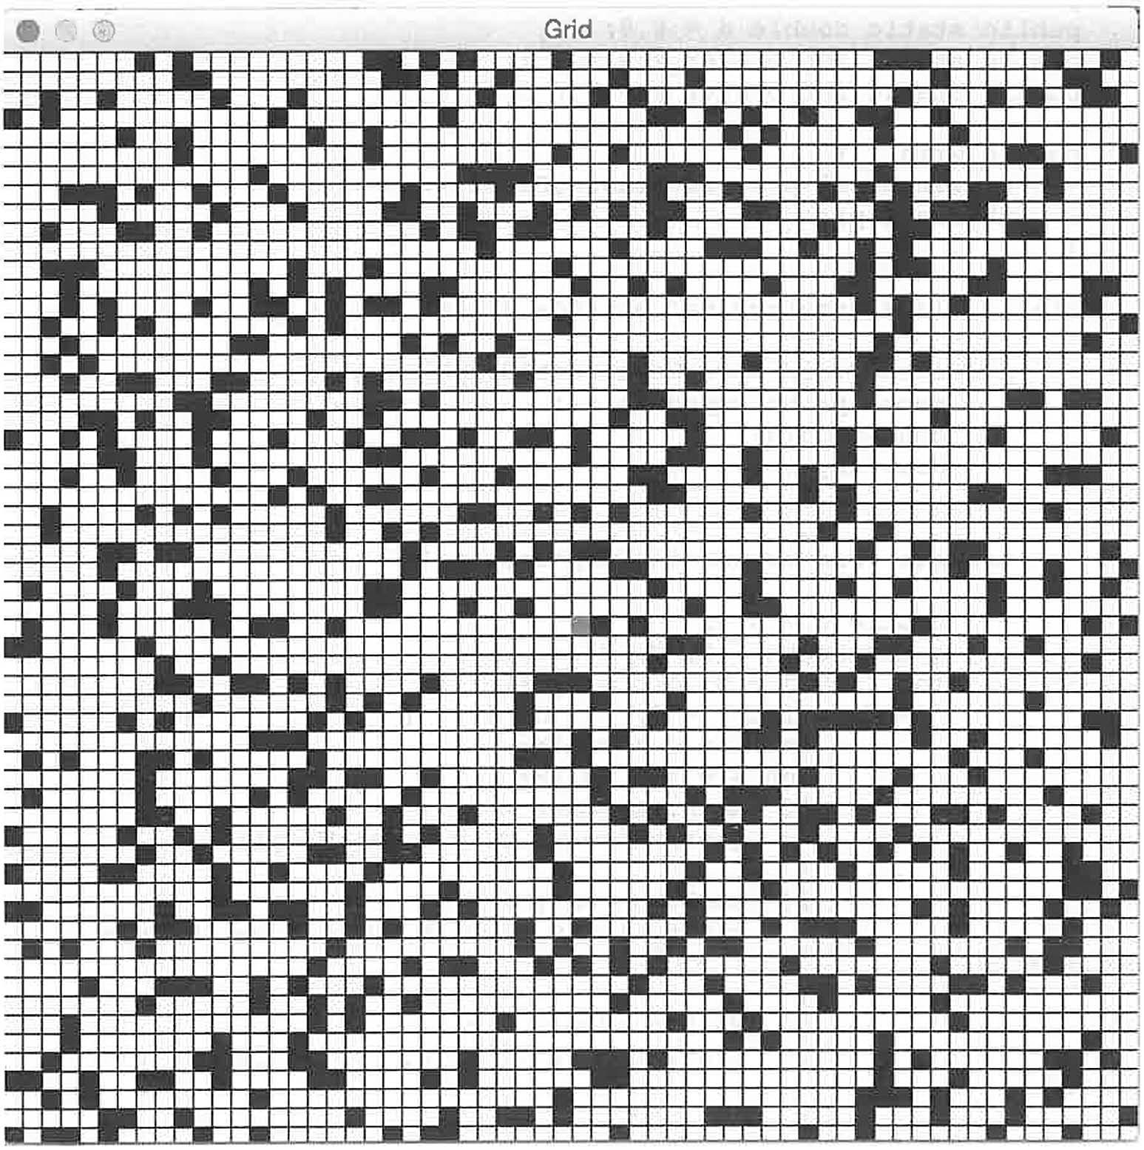

**Description:** Draw a grid of boxes/cells that are filled, or not filled, depending on a random variable. Make one red cell to be the "player". There is no game play in this project but it is easy to imagine the red cell as a player moving around the grid (maybe with enemies moving around as well).

**Sample Output:**

54

package grid;

import java.awt.Color; import java.awt.Graphics; import javax.swing.JFrame; import javax.swing.JPanel;

public class Grid extends JFrame

public static int w = 600; public static int H = 600; public static int cellW = 10; public static int cellH = 10; public static int n = w *I* cellW; public static int m = H *I* cellH; public static double d **=** 0.8;

public static int player_x = w *I* 2;

public static int player_y = H *I* 2;

public Grid ()

DrawingPanel p this.add(p);

new DrawingPanel();

static class DrawingPanel extends JPanel { protected void paintComponent(Graphics g) {

super.paintcomponent(g); drawGrid3(g); drawPlayer(g);

cellH) ;

cellW);

private void drawGridl(Graphics g) { doubled= 0.8;

g.drawRect(O, 0, W, H);

for (int j = 0; j < m; j++)

for (inti= 0; *i* < n; i++) int X = i * cellW;

int y = j * cellH;

if (Math.random() > d) { g.drawLine(x, y, x + cellW, y);

if (Math.random() > d) {

g.drawLine(x + cellW, y, x + cellW, y +

if (Math.random() > d) {

g.drawLine(x + cellW, y + cellH, x, y +

if (Math.random() > d) { g.drawLine{x, y + cellW, x, y);



55



private void drawGrid2(Graphics g) {

g.drawRect(0, 0, W, H);

for (int j = 0; j < m; j++)

for (inti= 0; i < n; i++) int x = i * cellW;

int y = j * cellH;

//g.drawRect(x, y, cellW, cellH); if (Math.random() > d)

g.drawLine(x, y, x + cellW, y);

if (Math.random() > d) g.drawLine(x, y + cellW, x, y);

private void drawGrid3(Graphics g) { g.setColor(Color.black); g.drawRect(0, 0, W, H);

for (int j = 0; j < m; j++)

for (inti= 0; i < n; i++) int X = i * cellW;

int y = j * cellH;

g.drawRect(x, y, cellW, cellH); if ( Math.random() > d) {

g.fillRect(x, y, cellW, cellH);

public static void drawPlayer(Graphics g) g.setColor(Color.red);

g.fillRect(player_x, player_y, cellW, cellH);

public static void main(String[] args) { Grid frame= new Grid(); frame.setTitle("Grid"); frame.setSize(W, H); frame.setLocationRelativeTo(null);

frame.setDefaultCloseOperation(JFrame.EXIT_ON CLOSE); frame.setVisible(true);

56

**Java Project: MouseClickDraw**

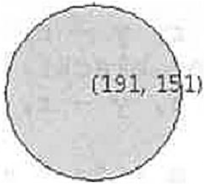

**Description:** Interactive circle/square drawing program. When the user clicks (left) in the drawing window a circle is draw of random radius and color. If the user right-clicks the circle changes to another random color. A middle-click turns the circle into a square.

**Sample Output:**

l ,_".,..,+ -' -.. ,.._,.. . , •.-"♦ u._,., .... A-1-s..-.+•• •

* **Draw st Mouse CIiek**

package mouseclickdraw;

import java.awt.Color; import java.awt.Graphics;

import java.awt.event.MouseAd pter; import java.awt.event.MouseEvent; import java.util.Random;

import javax.swing.JFrame; import javax.swing.JPanel;

public class MouseClickDraw extends JFrame { public boolean draw = false;

public int x; public int y; public int r; public Color color;

58

public boolean circle= true;

public MouseClickDraw()

JPanel panel = new DrawingPanel(); panel.addMouseListener(new myMouseListener()); panel.setFocusable(true);

add(panel);

public class DrawingPanel extends JPanel {

protected void paintComponent(Graphics g) { super.paintcomponent(g);

if (draw) **{**

g.setColor(color);

if (circle)

**{**

g.fillOval(x - r, y - r, 2 * r, 2

g.setColor(Color.black); g.drawOval(x - r, y - r, 2 * r, 2

else **{**

- -

g.fillRect(x r, y r, 2 * r, 2

g.setColor(Color.black); g.drawRect(x - r, y - r, 2 * r, 2

* r);

* r) ;

* r);

* r);

g.drawString("(" + x + ", "+ y + ")", x, y); draw = false;

class myMouseListener extends MouseAdapter { @Override

public void mouseClicked(MouseEvent e)

if (e.getButton() == e.BUTTONl) draw= true;

x = e.getX ();

y = e.getY();

r = (int) (100 *Math.random());

repaint();

if (e.getButton() draw = true; if (circle) {

e.BUTTON2)

circle else {

circle repaint();

false; true;



**59**

if (e.getButton() == e.BUTTON3) draw= true;

color= getRandomColor(); repaint();

public Color getRandomColor() Random random= new Random(); int red= random.nextint(256);

int green= random.nextint(256); int blue= random.nextint(256); return new Color(red, green, blue);

public static void main(String[] args) MouseClickDraw frame= new MouseClickDraw(); frame.setTitle("Draw at Mouse Click"); frame.setSize(S00, 400); frame.setLocationRelativeTo(null);

frame.setDefaultCloseOperation(JFrame.EXIT_ON CLOSE); frame.setVisible(true);

60

#### Java Project: Sierpinski

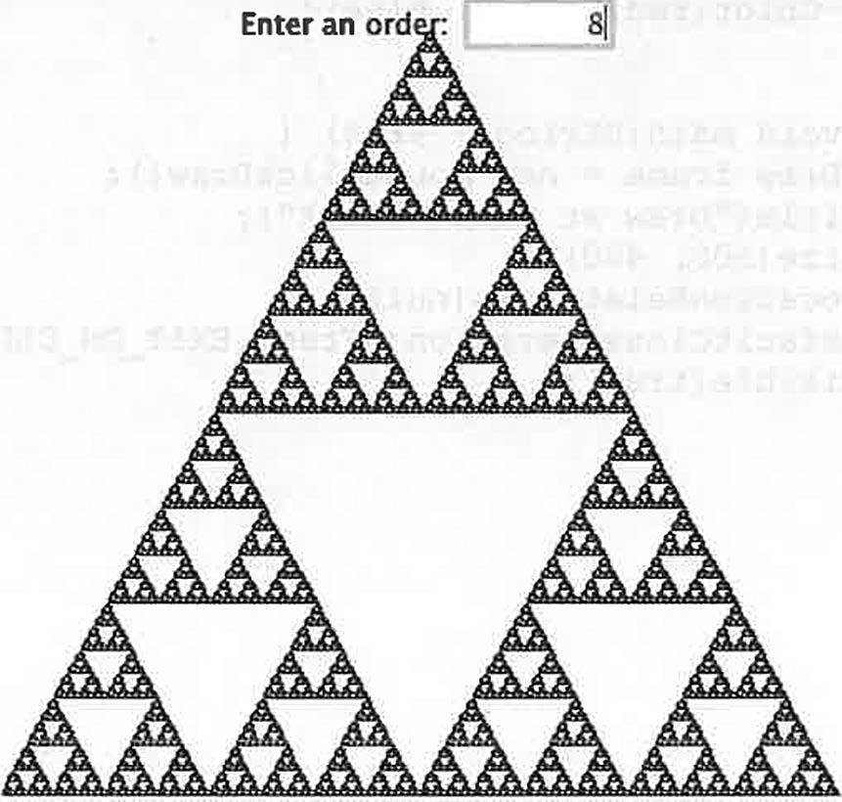

**Description:** Draw a triangle-fractal by sequentially drawing triangles based on the halfway point on the sides of a give triangle.

**Sample Output:**

* 0 Sierpinksi Triangle

61

package sierpinski;

import java.awt.BorderLayout; import java.awt.Graphics; import java.awt.Point;

import java.awt.event.ActionEvent; import java.awt.event.ActionListener; import javax.swing.JFrame;

import javax.swing.JLabel; import javax.swing.JPanel; import javax.swing.JTextField;

import javax.swing.SwingConstants; public class Sierpinski extends JFrame

public Sierpinski()

JPanel panel= new SierpinskiPanel(); add(panel, new BorderLayout() .CENTER);

static class SierpinskiPanel extends JPanel { public static int order = 0;

private JTextField orderField

SierpinskiPanel()

new JTextField("0", 5);

add(new JLabel("Enter an order:")); add(orderField);

orderField.setHorizontalAlignment(SwingConstants.RIGHT);

orderField.addActionListener(new ActionListener() public void actionPerformed(ActionEvent e) {

setOrder(Integer.parseint(orderField.getText()));

}

} ) ;

public void setOrder(int order) { this.order= order;

repaint();

protected void paintComponent(Graphics g) super.paintComponents(g);

//the ''20" is a padding so the drawing deosnt go to the edge of the window

Point pl= new Point(getWidth() / 2, 20); Point p2 = new Point(l0, getHeight() - 20);

Point p3 new Point(getWidth() - 20, getHeight() - 20); displayTriangles(g, order, pl, p2, p3);

62

private static void displayTriangles(Graphics g, int order, Point pl, Point p2, Point p3) {

if (order = = 0) {

g.drawLine(pl.x, pl.y, p2.x, p2.y);

g.drawLine(p2.x, p2.y, p3.x, p3.y);

g.drawLine(p3.x, p3.y, pl.x, pl.y); else {

Point p12 = midpoint(pl, p2); Point p13 = midpoint(pl, p3); Point p23 midpoint(p2, p3);

displayTriangles(g, order - 1, pl, p12, p13); displayTriangles(g, order - 1, p2, pl2, p23); displayTriangles(g, order - 1, p3, p13, p23);

public static Point midpoint(Point pl, Point p2) {

return new Point((pl.x + p2.x) / 2, (pl.y + p2.y) / 2);

public static void main(String[] args) { Sierpinski sierpinski = new Sierpinski(); sierpinski.setSize(400, 400); sierpinski.setTitle("Sierpinksi Triangle'');

sierpinski.setDefaultCloseOperation(JFrame.EXIT_ON CLOSE); sierpinski.setLocationRelativeTo(null); sierpinski.setVisible(true);

**63**

###### Java Project: Asteroids

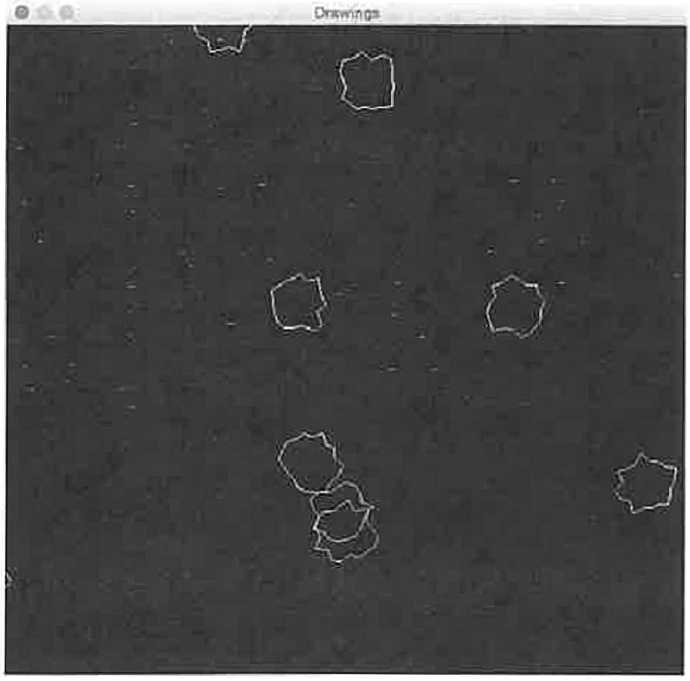

Description: Creates black/white asteroid environment. Great start for a shooting game similar to the original asteroids game.

**Sample Output:**

package asteroids;

import java.awt.Color; import java.awt.Font; import java.awt.Graphics;

import java.awt.event.ActionEvent; import java.awt.event.ActionListener; import javax.swing.JFrame;

import javax.swing.JPanel; import javax.swing.Timer;

public class Asteroids extends JFrame { public static int W = 600;

public static int H = 600;

public Asteroids() {

DrawingPanel drawingPanel = new DrawingPanel(); drawingPanel.setBackground(Color.black); this.add(drawingPanel);

static class DrawingPanel extends JPanel {

64

private Timer timer= new Timer(30, new TimerListener() ); int m = 20; //points per poly

int n = 10; // number of polys double[][] x = new double[n] [m];

double[][] y = new double[n] [m]; double[] dx = new double[n]; double[] dy = new double[n]; double[] speed= new double[n]; double maxRadius = 30;

double minRadius = 20;

double[] xCenter new double[n); double[] yCenter = new double[n]; public Color(] color= new Color[n); public double maxSpeed 5;

public DrawingPanel() { initializePolygons(); timer.start();

private void initializePolygons() double theta;

for (inti= 0; i < n; i++) { color[i] = randomColor(); xCenter[i] Math.random() * W; yCenter[i] = Math.random() * H; for (int k = 0; k < m; k++) {

theta = k * 2.0 *Math.PI/ m;

doubler= minRadius + (maxRadius - minRadius) *

Math.random();

//use this line if you want regular polygons:

//doubler= maxRadius;

**x[i]** [k] = r * Math.cos(theta);

y[i] [k] = r * Math.sin(theta);

speed[i] = maxSpeed;

dx[i] 2 * speed[i] * Math.random() - speed(i]; dy[i] = 2 * speed[i] * Math.random() - speed[i];



protected void paintComponent(Graphics g) { super.paintcomponent(g); updatePositions();

checkBoundary(); drawPolygons(g);

public void checkBoundary(} { for (inti = 0; i < n; i++}

if (xCenter[i] + maxRadius < 0} { xCenter[i] = getWidth(} + maxRadius;

65

//dx(i) = Math.abs(dx(il);

if (xCenter[i) - maxRadius > getWidth()) xCenter[i] = -maxRadius;

//dx(il = -Math.abs(dx[il);

if (yCenter(il + maxRadius < 0) yCenter[il = getHeight() + maxRadius;

//dy[il = Math.abs(dy[il);

if (yCenter[i] - maxRadius > getHeight()) ycenter[i] = -maxRadius;

//dy[il = -Math.abs(dy(il);

private void updatePositions() { double alpha= 0.1;

for (int i = 0; i < n; i++) {

|  |  |  |  |  |  |
| --- | --- | --- | --- | --- | --- |
| for (int k | = 0; | k | < m; | k++) |  |
| double | newX | = | (x[il | [kl) | * Math.cos(alpha) + |

(y[i) [kl) * Math.sin(alpha);

double newY = -(x[il (kl) * Math.sin(alpha) + (y(i)(kl) * Math.cos(alpha);

X [il [k) y [il [kl

newX; newY;



xCenter(il += dx[il; yCenter(il += dy[il;

class TimerListener implements ActionListener { public void actionPerformed(ActionEvent e) {

repaint();

private void drawPolygons(Graphics g) { for (int i = O; i < n; i++) {

int[] polyX = new int(m]; int(] polyY = new int[ml;

//Color color= randomColor(); g.setColor(color[i] );

for (int k = 0; k < m; k++) {

polyX [kl (int) (x [i) (kl + xCenter [i]);

polyY[k) = (int) (y[i](kl +yCenter[i]);

66

//g.fillPolygon(polyX, polyY, m); g.setColor(Color.white); g.drawPolygon(polyX, polyY, m);

private Color randomColor() { Color color= new Color(

(int) (256 * Math.random()),

(int) (256 * Math.random()), (int) (256 *Math.random())

) ;

return color;

public static void main(String[] args) Asteroids frame = new Asteroids(); frame.setTitle("Drawings");

frame.setDefaultCloseOperation(JFrame.EXIT_ON_CLOSE); frame.setSize(W, H);

frame.setvisible(true);

67

**Java Project: RockPaperScissors**

**Description:** Play rock-paper-scissors against the computer. The user can program various strategies for the computer to use when playing a human. Several pictures are needed: rong.png, paper.png, scissors.png etc.

Sample Output:

**information**

**l0, 1, 0, 2, 2. 2, 2, I. 1, I,** !J

[2, 1, I. l, I, I, 0, 0, 0. 0, 21

**01(**

**Round: 12**

**Man: 7**

**Computer: 3 Show History**

Need images:

**Round:l**

**Man: 7 Computr. 3**

**Show History**

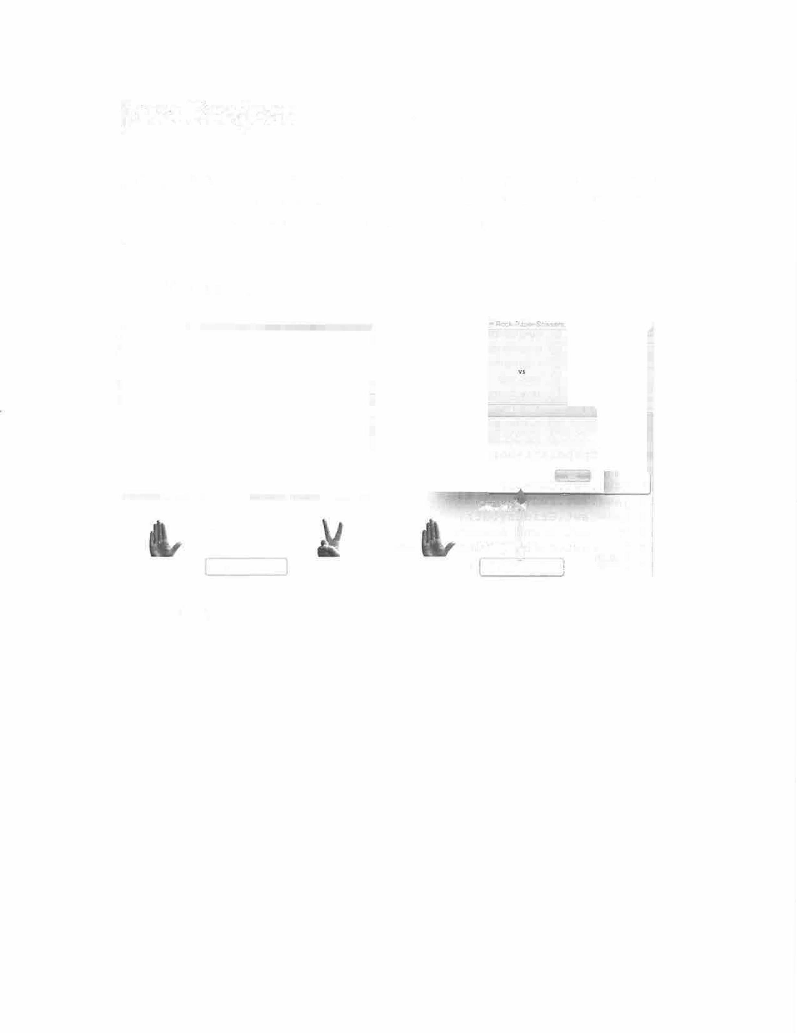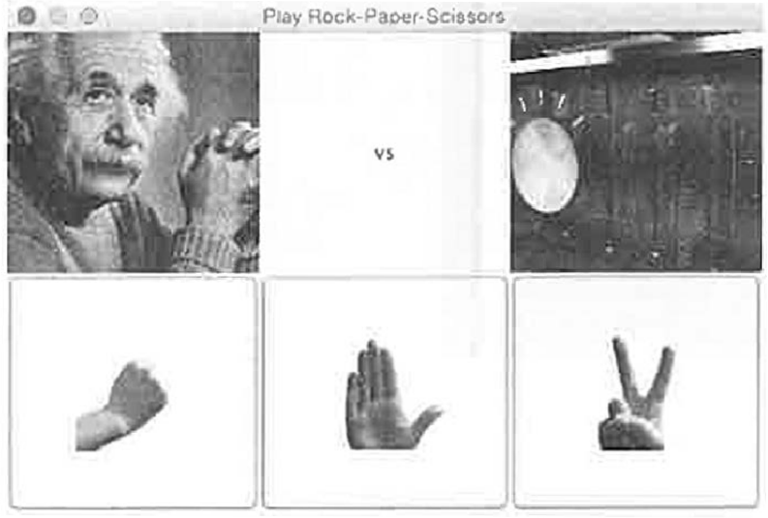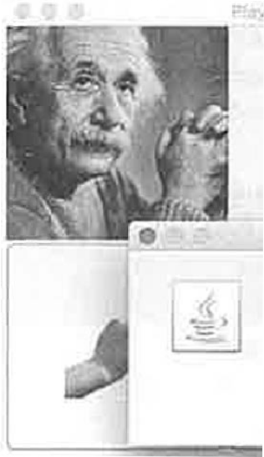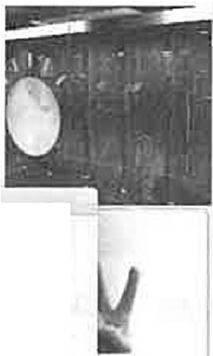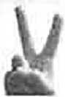

68

**ProJe«itS Flies 0**

L - - , ; ; c _ _ _ - - ' - - ' - - - - - - - - ' - ' - - - - - -

L ReadWriteQuizQuestions T **L** RockPaperScissors

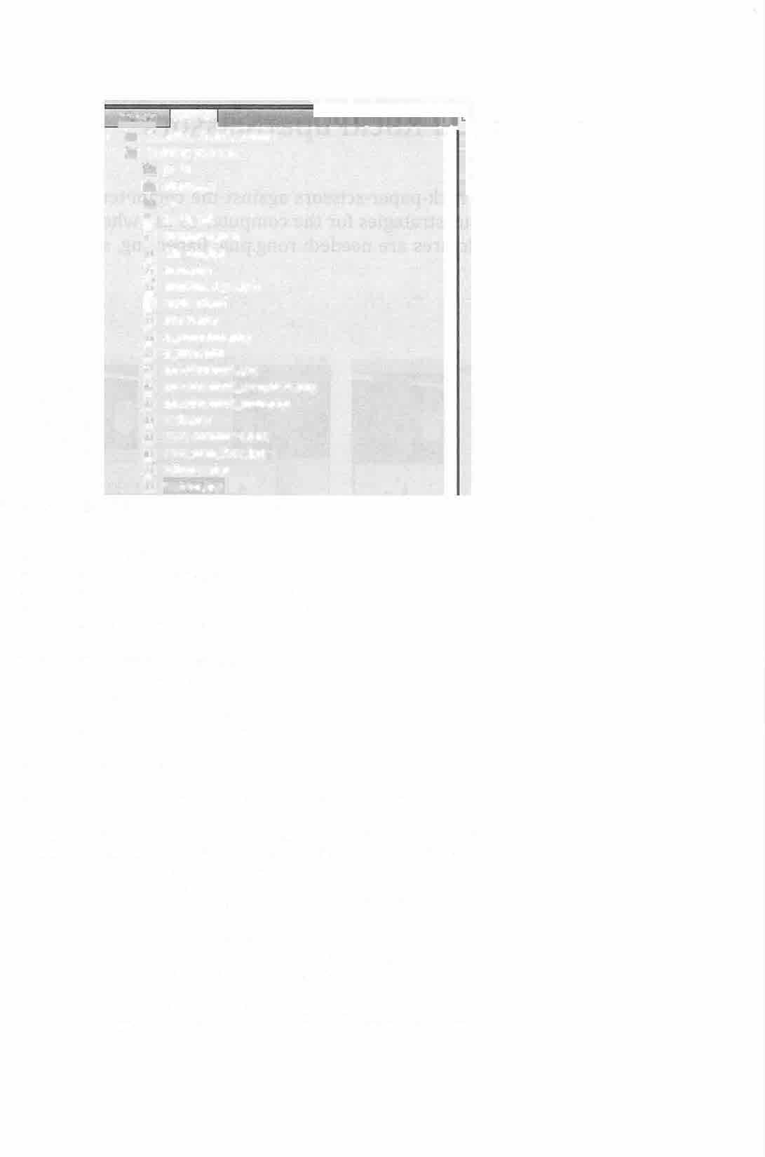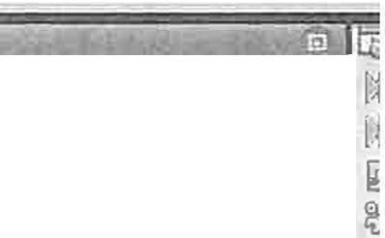

r" 7 build

lJ nbproject

CJ src

**BJ** build.xml

computer.png

g) einstein.jpg

g) man.png

**191**manvmachine.jpg

@I manlfest.mf paper.png

**jg}** q_computer.png

q_man.png

lg} questionmark.jpg

jg) questionmark_computer.png lg} questionmark_man.png

**J9l** rock.png

lg} save_computer.png save_man_face.Jpg

igJ scissors.png

!g} watson.jpg

package rockpaperscissors;

import java.awt.Cursor; import java.awt.Font; import java.awt.GridLayout;

import java.awt.event.ActionEvent; import java.awt.event.ActionListener; import java.util.ArrayList;

import java.util.Random; import javax.swing.Imageicon; import javax.swing.JButton; import javax.swing.JFrame; import javax.swing.JLabel;

import javax.swing.JOptionPane; import javax.swing.JPanel;

public class RockPaperScissors extends JFrame {

Imageicon rockimage = new Imageicon("rock.png"); Imageicon paperimage = new Imageicon("paper.png"); Imageicon scissorsimage = new Imageicon("scissors.png"); Imageicon manimage = new Imageicon("einstein.jpg"); Imageicon cornputerimage = new Imageicon("watson.jpg");

JButton rock= new JButton(rockimage); JButton paper= new JButton(paperimage);

JButton scissors= new JButton(scissorsimage);

JLabel manLabel = new JLabel(manimage);

JLabel computerLabel = new JLabel(computerimage);

69

JLabel middlel = new JLabel("vs");

JLabel new manMove = new JLabel("(man move)");

JLabel new_computerMove = new JLabel("(computer move)");

int playerMove = -1; int computerMove = -1;

int [] [) payoff = new int [3] [3] ; int result= 0;

int total= 0; int n = 1;

int manCount = O;

int computerCount = O; String historyString = ""; ArrayList resultsHistory; ArrayList playerHistory; ArrayList computerHistory;

JLabel round= new JLabel("Round: "+ n);

JLabel manScore = new JLabel("Man: "+ manCount);

JLabel computerScore = new JLabel("Computer: "+ computerCount); JButton history= new JButton("Show History");

public RockPaperScissors() { resultsHistory = new ArrayList<>(); playerHistory = new ArrayList<>(); computerHistory = new ArrayList<>();

JPanel newPanel = new JPanel(new GridLayout(3, 3)); newPanel.setCursor(new Cursor(Cursor.HAND_CURSOR));

newPanel.add(manLabel); newPanel.add(middlel); newPanel.add(computerLabel); newPanel.add(rock); newPanel.add(paper); newPanel.add(scissors);

RPSListener rpsListener = new RPSListener(); rock.addActionListener(rpsListener); paper.addActionListener(rpsListener); scissors.addActionListener(rpsListener);

initializePayoff(payoff);

middlel.setHorizontalAlignment(JLabel.CENTER); new_manMove.setHorizontalAlignment(JLabel.CENTER); new_computerMove.setHorizontalAlignment(JLabel.CENTER);

//This is the lower, middle, panel:

JPanel middle2 = new JPanel(new GridLayout(4, 1)); Font f = new Font("New Courier", Font.BOLD, 18); round.setFont(f);

manScore.setFont(f); computerScore.setFont(f); history.setFont(f);

70

middle2.add(round); middle2.add(manScore); middle2.add(computerScore); middle2.add(history);

HistoryListener historyListener = new HistoryListener(); history.addActionListener(historyListener);

newPanel.add(new_manMove); newPanel.add(middle2); newPanel.add(new_computerMove);

this.add(newPanel);

class HistoryListener implements ActionListener { public void actionPerformed(ActionEvent e)

JOptionPane.showMessageDialog(null, historyString, "information", JOptionPane.INFORMATION_MESSAGE);

class RPSListener implements ActionListener public void actionPerformed(ActionEvent e)

new_manMove.setText(""); new_computerMove.setText(""); if (e.getSource() == rock) {

playerMove = O; new_manMove.seticon(rockimage);

if {e.getSource() == paper) playerMove = 1; new_manMove.seticon(paperimage);

if (e.getSource() == scissors) { playerMove = 2; new_manMove.seticon(scissorsimage);

//Get the computer's move:

computerMove = getComputerMove2(playerHistory); if (computerMove == 0) {

new_computerMove.seticon(rockimage);

if (computerMove == 1) new_computerMove.seticon(paperimage);

if (computerMove == 2) { new_computerMove.seticon(scissorsimage);

result= payoff[playerMove) [computerMove];

71

if (result== 1)

//Man wins:

manCount++;

if (result == -1) {

//Computer wins:

computerCount++;

playerHistory.add(playerMove); computerHistory.add(computerMove); historyString = playerHistory.toString();

historyString += "\n" + computerHistory.toString(); resultsHistory.add(result);

total+= result; n++;

round.setText("Round: "+ n); manScore.setText("Man: "+ manCount);

computerScore.setText("Computer: "+ computerCount);

private static void initializePayoff(int[) [) payoff)

//player move: Rock

payoff[O) [OJ = O; payoff(O) (1) = -1;

payoff (0) (2] l;

//player move: Paper

//computer move: Rock

//computer move: Paper

//computer move: Scissors

payoff(l) (0) l; //computer move: Rock payoff(l) (1) O; //computer move: Paper payoff (1) (2) = -1; //computer move: Scissors

//Player move: Scissors

payoff[2) [OJ -1; //computer move: Scissors payoff [2) [l] = l; //computer move: Scissors payoff[2)(2] = 0; //computer move: Scissors

private static int getComputerMovel()

//The computer is making a random move: Random rand= new Random();

return rand.nextint(3);

private static int getComputerMove2(ArrayList<Integer> playerHistory) {

//The computer is trying to be intelligent.

//It looks at the player history and calcuates the most

frequent move

//player move, and then assumes the player will make that



72

//and plays against it. Random rand= new Random(); int mostCommonMove;

int[] counter= new int[3];

for (inti= O; *i* < playerHistory.size(); i++) { counter[playerHistory.get(i))++;

if (counter[O] == counter[l) && counter(l] == counter[2])

// if all counts are equal, random move: return rand.nextint(3);

else {

mostCommonMove = getMaxindex(counter);

switch (mostCommonMove) {

case 0: //if most common move is Rock return 1; //play Paper

case 1: //if most common move is Paper return 2; //play Scissors

case 2: //if most common move is Scissors return O; //play Rock

return O;

private static int getMaxindex(int[] counter)

//This does not account for ties.

//if there is a tie, it returns the first one found. int max= -1, max_index = -1;

for (inti= 0; i < counter.length; i++) if (counter[i] > max) {

max= counter[i); max index= i;

return max index;

public static void main(String() args) { JFrame frame= new RockPaperScissors(); frame.setTitle( Play Rock-Paper-Scissors''); frame.setSize(SOO, 500);

frame.setDefaultCloseOperation(JFrame.EXIT_ON_CLOSE); frame.setLocationRelativeTo(null); frame.setVisible(true);

**73**

**Java Project:** ArithmeticGUI

**Description:** Solve arithmetic problems as fast as you can, with a GUI to help layout the problems in a graphical grid.

**Sample Output:**

* .:;- .A/;rt'imet,c T""8 Trial Ent tr it number or dlgiu :.nd cllt� 'stc problems'

• i.:,,· - � � n . • J , i a l inlt'f �nurnber of digits and cJlc.k •ut.problGnu'

2 1Pr;-blent r--z7

J2

SB *71* 0 **sa**

229

77 43

**29** --- J3

--68

**29** n **68**

87 110 Ill

I 87

110 7

111 1

41 77 73 **41**

*71* 73

**94** 19 -

3S - 94

**19 3S**

u s I 113s · 96

108 1

•• 96 **79**

-B - -**27** J I

J

53

I **97**

I,-

**96**

**27**

123 li

**79**

**31**

110 i

Ben · Submit rtuu!u 9 229 Subml, Resutu

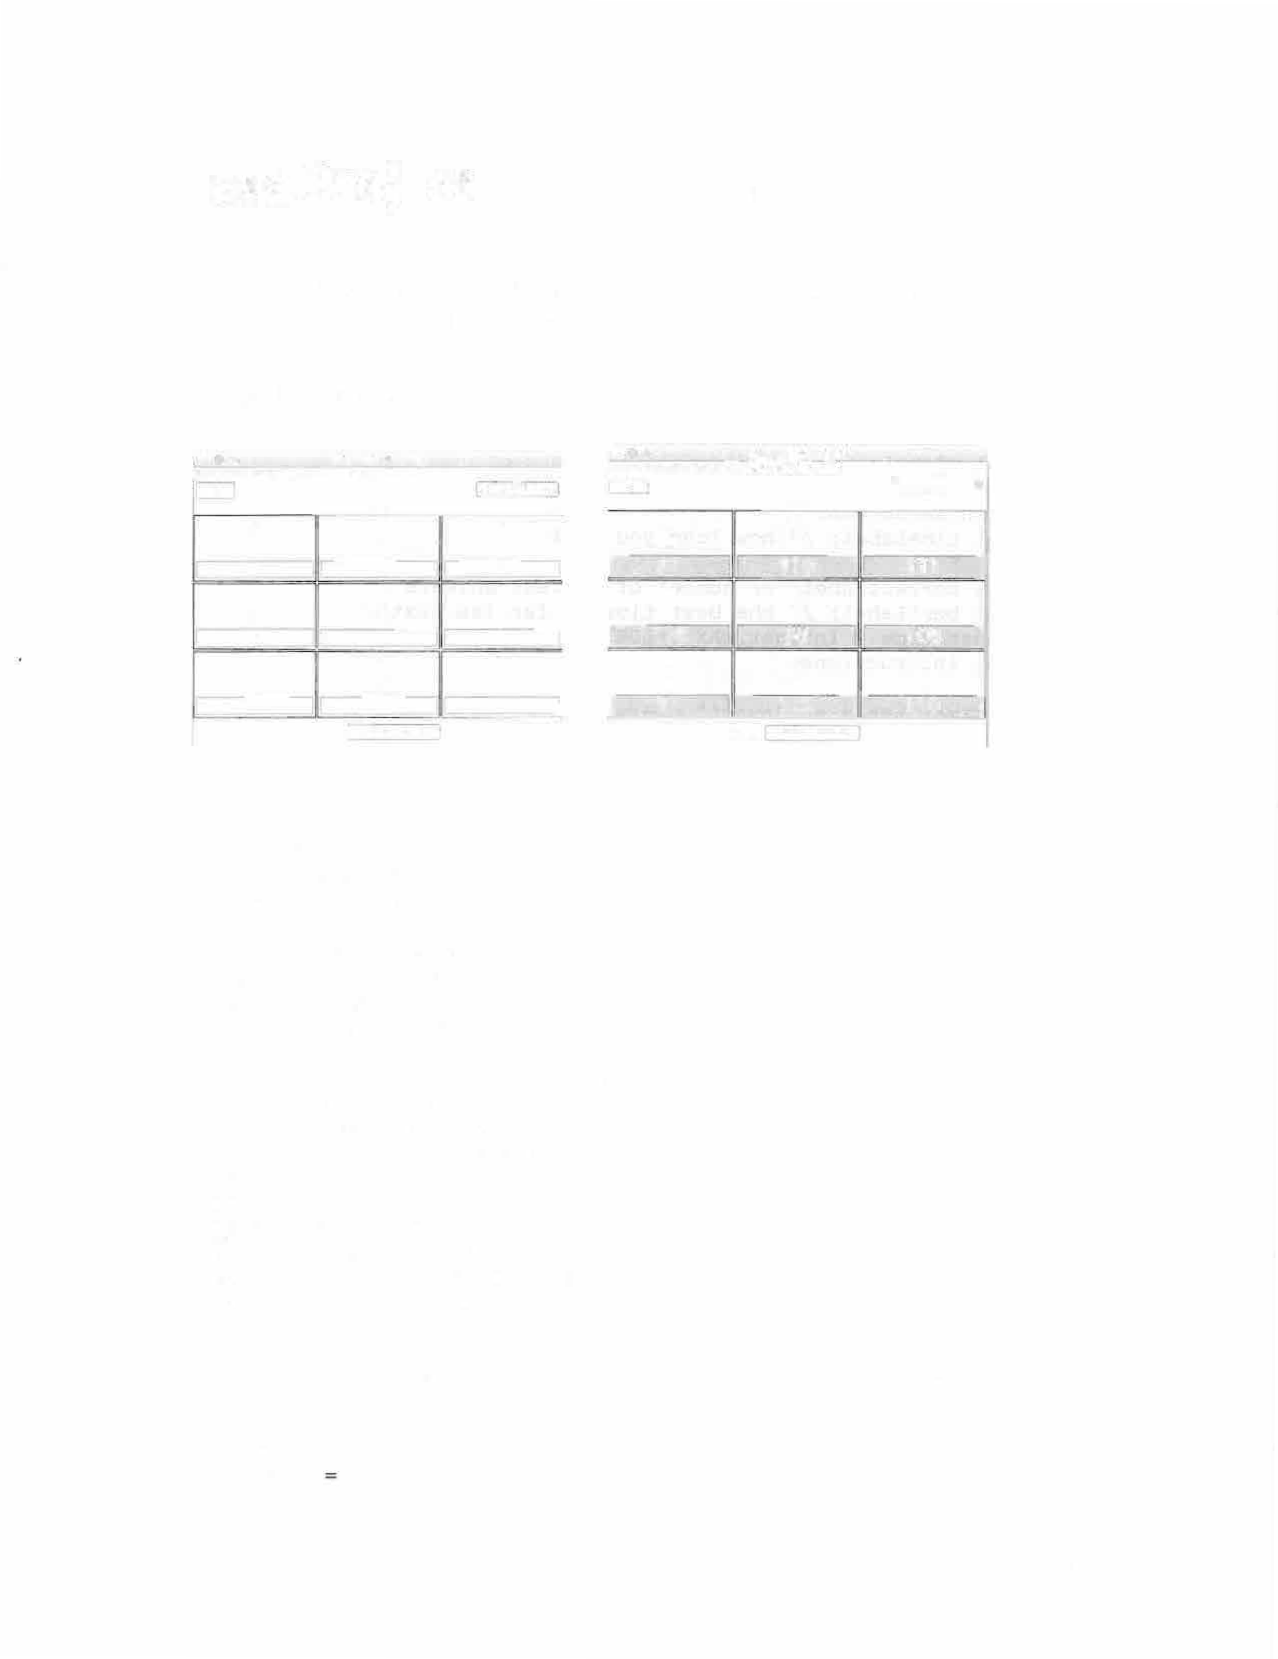

//Melissa Wood

//CS 1351 D10

//Arithmetic GUI package arithmeticgui;

import java.awt.BorderLayout; import java.awt.Color;

import java.awt.FlowLayout; import java.awt.Font; import java.awt.GridLayout;

import java.awt.event.ActionEvent;' import java.awt.event.ActionListener; import javax.swing.BorderFactory; import javax.swing.JButton;

import javax.swing.JFrame; import javax.swing.JLabel; import javax.swing.JPanel; import javax.swing.JTextField;

import javax.swing.SwingConstants; import javax.swing.Timer;

public class ArithmeticGUI extends JFrarne implements ActionListener

{

int p = 3; // problems are p x q int q 3;

**74**

int m = 3; *II* number of digits, default value

long start= System.currentTimeMillis(); JButton submit;

JLabel[l [] addl = new JLabel[p] [q]; *II* the first number to add JLabel[] [] add2 = new JLabel[p] [q]; *II* the second number to add JTextField[] [] result= new JTextField[p] [q]; *II* your answer in

the text field

int(][] correct ans= new int[p] [q]; *II* correct answer int[)[) your_ans = new int[p) [q); *II* your answer

JLabel mLabel;

JTextField mTextField; *II* for the number of digits JButton setButton;

JLabel timeLabel; *II* how long you took

JLabel correctLabel; *II* number of correct answers JLabel bestLabel; *II* the best time so far (as text)

int best_time = Integer.MA.X_VALUE; *II* best time so far (int)

JLabel instructions;

*II* this timer sends an "event" every 1000 milliseconds (1 second) to TimerListener

Timer timer = new Timer(l000, new TimerListener());

public ArithmeticGUI() {

*II* BorderLayout for the JFrame:

this.setLayout(new BorderLayout());

*II* add three panels:

createTopPanel(); *II* the "settings" panel createMiddlePanel(); *II* the "problems" panel createBottomPanel(); *II* the "results" panel

public void createBottomPanel() {

*II* for the "results" panel (Bottom Panel):

JPanel resultsPanel = new JPanel(new FlowLayout()); resultsPanel.setBackground(Color.white); correctLabel = new JLabel("Number Correct"); bestLabel = new JLabel("Best");

submit= new JButton("Submit Results");

submit.addActionListener(this); resultsPanel.add(correctLabel); resultsPanel.add(bestLabel); resultsPanel.add(submit); this.add(resultsPanel, BorderLayout.SOUTH);

public void createTopPanel() {

*II* for the "settings" panel (Top Panel):

JPanel settingsPanel = new JPanel(new BorderLayout()); settingsPanel.setBackground(Color.white);

75

mTextField = new JTextField(); mTextField.setHorizontalAlignment(SwingConstants.CENTER); mTextField.setColumns(4);

setButton = new JButton("Set Problems"); setButton.addActionListener(this);

timeLabel = new JLabel("", SwingConstants.CENTER); Font f = new Font("Courier", Font.BOLD, 18); timeLabel.setFont(f); timeLabel.setForeground(Color.red); timeLabel.setText("0");

String instructions= "Enter a number of digits and click 'set problems'";

JLabel instructionsLabel = new JLabel(instructions, SwingConstants.LEFT);

settingsPanel.add(instructionsLabel, BorderLayout.NORTH); settingsPanel.add(mTextField, BorderLayout.WEST); settingsPanel.add(setButton, BorderLayout.EAST); settingsPanel.add(timeLabel, BorderLayout.SOUTH); this.add(settingsPanel, BorderLayout.NORTH);

2) ) ;

0) ) ;

public void createMiddlePanel()

// This is the Middle panel

JPanel problemsPanel = new JPanel(new GridLayout(q, p, 2,

for (inti= 0; i < p; i++)

for (int j = 0; j < q; j++)

JPanel problem= new JPanel(new GridLayout(3, 1, 0,



problem.setBorder(BorderFactory.createLineBorder(Color.black) );

addl[i] [j] = new JLabel("**", SwingConstants.CENTER);

problem.add(addl[i] [j]);

add2 [i] [j] = new JLabel ("**", SwingConstants.CENTER);

problem. add (add2 [i] [j) );

result[i] [j] = new JTextField(3); result [i) [jJ•setHorizontalAlignment (JTextField. CENTER);

problem.add(result[i) [j)); problemsPanel.add(problem);

problemsPanel.setBackground(Color.yellow);

76

this.add(problemsPanel, BorderLayout.CENTER);

public static int getRandomint(int a, int b) { return (int) ((b + 1 - a) * Math.random() +a);

@Override

public void actionPerformed(ActionEvent e) { if (e.getSource() == submit) {

timer.stop();

long stop= System.currentTimeMillis(); timeLabel.setText("" + (stop - start) / 1000); int count= 0; // number right

Color correctColor = new Color(200, 200, 255); Color wrongColor = **new** Color(255, 200, 200); for (int i = 0; i < p; i++) {

for (int j = 0; j < q; j++) {

your_ans [i) [j) = getintValue (result [i] [j]); if (your_ans [i] [j) == correct_ans [i) [j)) {

result [i] [j]. setBackground (correctColor); result[i) [j) .setFont(new Font("Geneva",

Font.BOLD, **24));**

count++; else {

result [i] [j].setBackground (wrongColor) ;

best_time))

correctLabel.setText("" +count);

if ((Integer.parseint(correctLabel.getText()) == p * q) && (Integer.parseint(timeLabel.getText()) <

best_time = Integer.parseint(timeLabel.getText()); bestLabel.setText ("" + best_time);

}

if (e.getsource() setButton) { resetProblems();

public void resetProblems() {

m = getintValue(roTextField);

correctLabel.setText(""); tiroeLabel.setText("");

int a

int b

= (int) Math.pow(lO, m - 1);

(int) Math.pow(lO, m) - 1;



for (int *i* = 0; *i* < p; i++) { for (int j = 0; j < q; j++) int xl = getRandomint(a, b);

77

addl [i] [j]. set Text (11 11 + xl); int x2 = getRandomint(a, b);

1

add2[i] [j] .setText( " + x2);

correct_ans [i] [j] = xl + x2; result[i] [j] .setText("");

result[i] [j] .setBackground(Color.white); // added to reset fields to white for new set of problems.

}

start= System.currentTimeMillis(); timer.start();

public int getintValue(JTextField in) { Strings= in.getText();

int out= 0;

if (!s.equals( 11 ) && s.matches("\\d*"))

out= Integer.parseint(s); else {

in. set Text ("0");

out= 0; // default to O if input is not an integer

return out;

}

class TimerListener implements ActionListener { public void actionPerformed(ActionEvent e) {

tirneLabel.setText((System.currentTimeMillis() - start) /

1000 + 1 1 1 1 ) ;

public static void main(String[) args) { ArithmeticGUI frame = new ArithrneticGUI(); frame.setTitle( 1Arithmetic Time Trial"); frame.setSize(S00, 400); frame.setLocationRelativeTo(null);

1

frame.setDefaultCloseOperation(JFrame.EXIT_ON CLOSE); frame.setVisible(true);

78

### Java Project: HangmanNew

**Description:** Play hangman using a challenging set of words.

**Sample Output:**

•

File

HANGMAN

**LJLJ�**

□ □

**lJLJLJLJLJLJ LJLJLJLJ-Q LJ LJLJLJl�lJL**

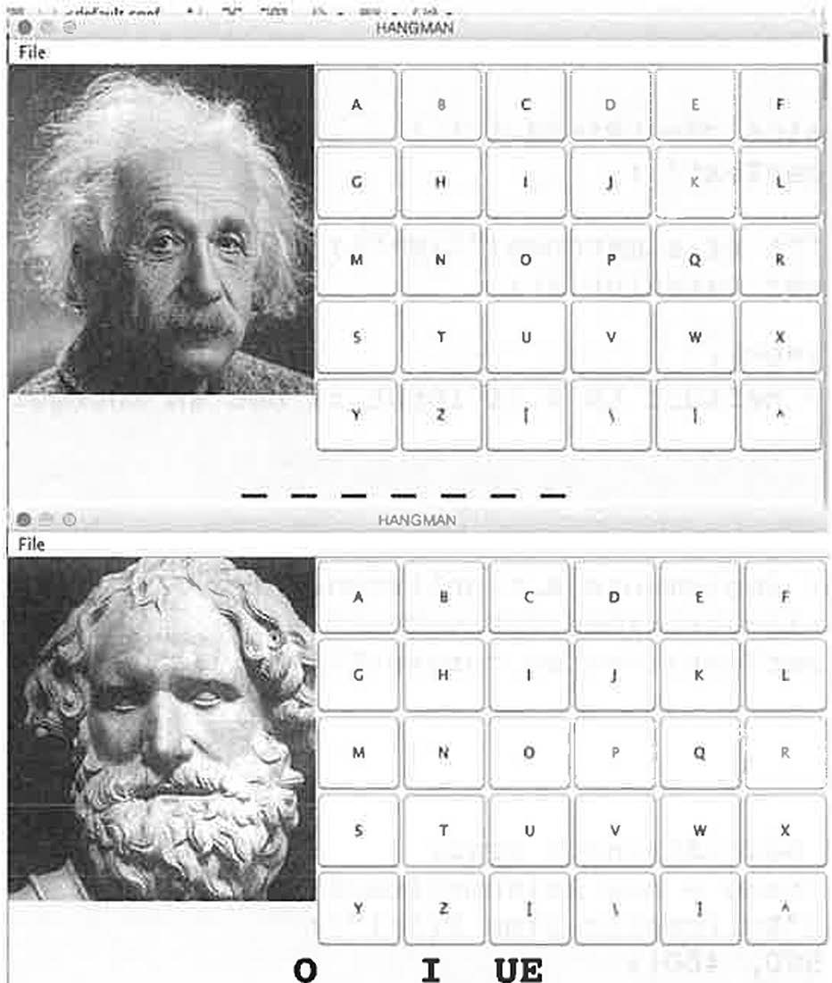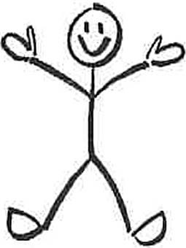

**LJLJI_JLJLJLJ**

**OBLIQUE**

Need to include images in an images directory, named imageO.jpg, imagel.jpg, ....., imagel2.jpg. Also, images for the "win" and "lose"

79

state: HappyStickman2.jpg and RIP.jpg. (HappyStickman2.jpg is shown below). More conventionally, the images would be of successive stages of the hanging of stickman, but I decided to substitute pictures of famous scientists, geek that I am .

Pto.)«u AIM 0 ubrolJlle.JP Cl l,i:rppyStJclllnaj)tJJ!Q bl HappySt

* **@!I HangmanNew**

**build**

**mm**

nbprojtct

* + **l!!!I src**
    - **b hangrm1nnew**

**Counter.Java**

**Hangma.nNew.Java**

* **E5) buOd.xml [i) manifest mf**

**Cl rnosLdlffkult_words.txt**

**Cl rnost_dlffkult.words_deflned.txt**

@!II HelloWorlcl

II!! lnsertlonSort

**b JavaAppllcatlOnl**

* **JavaAppllallon2**

!!!I **JavaAppllcationl**

**!!iii JavaApplicallon32**

* **!!I JavaAppllcatlon39**

**!m JavaAppllcatlon40**

� **Kaahln**

� **Lab_lO**

� Lab_ll

� **t.ab_l2**

� **Lab_13 [!l Lab_U [!) Lab_lS r!] Lab_l6**

□

**Lab_l7**

� Llb_18

t3) **Lab_2**

- 1.1 1:3 1:5 1:7 I I3:1 I S·I j1:1 j fx-v' '1J

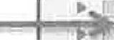

Notice also, the Counter.java class that is included with the HangmanNew.java main class.

Also, need the files: most_difficult_words_defined.txt, as shown in the next image:

80

._jav @) flilln SY,ffper.Javu tJ most_difficult_wor s_ efiried.txt O. Q most_dlfficulr_words.txt

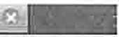

pourciJ I History ! 1 • 1W• j **le).** 13 4 j i? 'i:b \ 2J © 0

1. bjure (vl to reject, renounce (v) to abolish, usually by authority
2. abrogate (vl to abolish, usually by authority
3. acerbic {ailll biting, bitter *in* tone or taste
4. acrimony (n) bitterness, discord
5. acumen (n) keen insight
6. adumbrate (v) to sketch out in a vague way
7. alacrity (n) eagerness, speed
8. anathema (n) a cursed, detested person
9. antipathy (nl a strong dislike, repugnance
10. approbation (n) praise
11. arrogate (vl to take without justification
12. ascetic (.iliJj.l practicing restraint/self-discipline, usually religious
13. aspersion (n) a curse, expression of ill-will
14. assiduous (.arLJJ hard-working, diUgent
15. blandish (v) to coax by using flattery
16. boon (n) a gift or blessing
17. brusque ( jJ short, abrupt, dismissive
18. buffet (v) to strike with force;{n) an arrangement of food
19. burnish (v) to polish, shine
20. buttress (v) to support, hold up;(n) something that offers support
21. cacophony (n.) tremendous noise, disharmonious sound
22. cajole (v.) to urge, coax
23. calumny (n.) attempt to spoil someone else\'s reputation/spreading lies
24. capricious (aJtj_. l subject to whim, fickle 25 1 clemency (n. l mercy
25. cogent (m.) intellectually convincing
26. concomitant {m,J accompanying in a subordinate fashion
27. conflagration {n.) great fire

<m,l

1. contrite penitent, eager to be forgiven
2. conundrum (n.) puzzle, problem
3. credulity {n.J readiness to believe
4. cupidity (n.) greed, strong desire
5. cursory {a.dj_.) brief to the point of being superficial
6. decry (v.) to criticize openly
7. defile (v.J to make unclean, impure
8. deleterious (.a,ru..) harmful
9. demure (l!Jlj,.) quiet, modest, reserved

The program will read the first word of each line of the file and use them as the possible words for the Hangman game. At the end of the game, the program will display the rest of the line (i.e.: the definition of the word) that the hidden word was chosen from.

This shows up at the bottom of the panel.

You can make up a list of words, keeping in mind that the program will read the first word in each line of your file as a candidate hidden word, and will display the rest of the line at the end of the game.

81

package hangmannew;

import java.awt.BorderLayout; import java.awt.Color;

import java.awt.Dimension; import java.awt.Font; import java.awt.Graphics; import java.awt.GridLayout; import java.awt.Image;

import java.awt.event.ActionEvent; import java.awt.event.ActionListener; import java.io.FileNotFoundException; import java.util.ArrayList;

import java.util.Scanner; import java.util.logging.Level;

import java.util.logging.Logger; import javax.swing.Imageicon; import javax.swing.JButton; import javax.swing.JFrame; import javax.swing.JLabel; import javax.swing.JMenu;

import javax.swing.JMenuBar; import javax.swing.JMenuitem; import javax.swing.JOptionPane; import javax.swing.JPanel;

public class HangrnanNew extends JFrame {

private static private static private static private static private static private static private static private static private static private static private static private static private static private static private static private static

String used_string = ""; String state_string = ""; String state_display ""; String choice " "; JLabel used;

JLabel state; boolean win= false; int random_index;

final int max_guesses = 13;

Counter counterl = new Counter("counterl", 1000); String hidden_word =" ";

String hidden_definition;

final int n = 30; // number of letters JButton[] letters= new JButton[n];

String[] fileitems = new String[] {"New", "Quit"}; char [] fileShortcuts = {'N', **1**Q **1};**



public HangmanNew() throws FileNotFoundException {

//set the secret word, randomly chosen from a file setWord();

//set up this JFrarne's menu bar and options: JMenuBar rnyMenuBar = new JMenuBar();

JMenu fileMenu = new JMenu("File");

for (inti= 0; *i* < fileitems.length; i++) {

82

JMenuitem item= new JMenuitem(fileitems[i], fileShortcuts[i]);

item.addActionListener(new menuListener()); fileMenu.add(item);

myMenuBar.add(fileMenu); this.setJMenuBar(myMenuBar);

//Three JPanels added to the JFrame

Drawing drawing= new Drawing(); //hangman gallows drawing LetterButtons buttons= new LetterButtons();//letters to

choose from

LetterLabels labels = new LetterLabels();//ongoing results

add(drawing, BorderLayout.CENTER); add(buttons, BorderLayout.EAST); add(labels, BorderLayout.SOUTH);

public static void setWord() throws FileNotFoundException {

//The text file "most difficult words defined.txt" must be in the project directory

//In this case it contains the 250 most commonly missed SAT

words.

java.io.File words_file = new

java.io.File("most_difficult_words_defined.txt"); Scanner input= new Scanner(words_file);

ArrayList<String> defined_list = new ArrayList<String>(); while (input.hasNextLine()) {

String line= input.nextLine(); defined_list.add(line);

random_index = (int) (defined list.size() *Math.random()); hidden_definition = defined_list.get(random_index);

String parts[] = hidden_definition.split(" "); hidden word= parts[0J;

public static void restart() throws FileNotFoundException ( win= false;

setWord(); used_string = ""; state_string = ""; state_display = "";

for (inti= 0; i < hidden_word.length(); i++) { state_string +=" ";

state_display += "_ 1 1 ;

state.setText(state_display); used. set Text (11 1 1 ) ; counterl.setValue(O);

choice = " ";

for (int i = 0; i < n; i++) {

83

letters[i] .setBackground(Color.white); letters[i] .setForeground(Color.black);

class LetterButtons extends JPanel public LetterButtons() {

setLayout(new GridLayout(S, 6, 0, 0)); for (int i = O; i < n; i++) {

letters[i] = new JButton("" + (char) (i + 65)); add(letters[i]);

letters[i] .addActionListener(new buttonListener());

class LetterLabels extends JPanel { LetterLabels()

for (inti= O; i < hidden_word.length(); i++)

state_string +=" "; state_display += "_ ";

state= new JLabel(state_display.toUpperCase()); Font fontl = new Font("Courier", Font.BOLD, 36); state.setForeground(Color.black); state.setFont(fontl); state.setHorizontalAlignment(JLabel.CENTER);

used= new JLabel(state_string); used.setForeground(Color.black);

Font font2 = new Font("Courier", Font.BOLD, 26); used.setFont(font2); used.setHorizontalAlignment(JLabel.CENTER);

this.setLayout(new BorderLayout()); add(state, BorderLayout.NORTH); add(used, BorderLayout.SOUTH);

class Drawing extends JPanel {

protected void paintComponent(Graphics g) super.paintComponent(g);

Image image= new Imageicon("images/image" +

counterl.value() + ".jpg") .getimage();

g.drawimage(image, O, 0, image.getHeight(null), image.getHeight(null), this);

84

if (counterl.value() >= 13 && !win) { Image imageRIP = new

Imageicon("images/RIP.jpg") .getimage();

int width= getWidth(); int height= getHeight();

g.drawimage(imageRIP, 0, 0, width, height, this);

Image imageWin = new Imageicon("images/HappyStickman2.jpg") .getimage();

if (win) {

g.drawimage(imageWin, 0, 0, getWidth(), getHeight(),

this) ;

class menuListener implements ActionListener { @Override

public void actionPerformed(ActionEvent e) { System.out.println(" action command="+

e.getActionCommand() );

if (e.getActionCommand() .equals("Quit")) System.exit(0);

if (e. getActionCommand () .equals ("New")) try {

restart();

} catch (FileNotFoundException ex) {

Logger.getLogger(HangmanNew.class.getName()) .log(Level.SEVERE, null,

**ex);**

class buttonListener implements ActionListener { @Override

public void actionPerformed(ActionEvent e) { choice= e.getActionCommand();

for (int i = 0; i < n; i++) { if

(letters[i] .getActionCommand() .equals(e.getActionCommand()))

letters[i] .setForeground(Color.RED);

if (used_string.indexOf(choice) < 0) { used_string += choice;

} else {

85

JOptionPane.showMessageDialog(null, "Letter"+ choice+" is already used");

choice= choice.toLowerCase();

char[] char_choice = choice.toCharArray(); char[] char_hidden = hidden_word.toCharArray(); char[] char_state = state_string.toCharArray(); boolean hit= false;

for (inti= O; i < char_hidden.length; i++) if (char_hidden[i) == char_choice(OJ) {

char_state[i] char_hidden[i]; hit= true;

if (!hit) counterl.incrernent();

state_string = ""; state_display = "";

for (inti= 0; i < char_state.length; i++) { state_string += char state(i);

if (char_state[i] -- ' ') state display+=" ";

else {

state_display += char_state[i] + n" •

*f*

playing!)");

state.setText(state_display.toUpperCase()); if (counterl.value() >= rnax_guesses) {

used.setForeground(Color.white); used.setOpaque(true); used.setBackground(Color.gray);

Font font3 = new Font("Courier", Font.BOLD, 18); used.setFont(font3);

used.setText(" Sorry, You Lose! (But, keep

**}**

int hit count= 0;

for (inti= 0; i < char_hidden.length; i++) if (char_hidden[i) char_state [i)) {

hit_count++;

if (hit_count == hidden_word.length()) win= true; used.setForeground(Color.black); used.setOpaque(true); used.setBackground(Color.white);

Font font3 = new Font("Courier", Font.BOLD, 18); used.setFont(font3);

used.setText(" 11 + hidden definition+" ");

86

repaint();

public static void main(String[] args) throws FileNotFoundException {

HangmanNew hangman= new HangmanNew(); hangman.setTitle("HANGMAN"); hangman.setSize(new Dimension(700, 400));

hangman.setDefaultCloseOperation(JFrame.EXIT_ON_CLOSE); hangman.setLocationRelativeTo(null); hangman.setVisible(true);

*I//////////I//III////II/II/I/I/I//II///*

package hangmannew;

public class Counter implements Comparable<Counter>

private final String name; private final int maxCount; private int count;

// counter name

// maximum value

// current value

// create a new counter with the given parameters public Counter(String *id,* int max) {

name= id; maxCount = max; count= 0;

// increment the counter by 1 public void increment() {

if (count< maxcount) count++; assert count>= 1;

// return the current count public int value() {

return count;

// return a string representation of this counter public String toString() {

return name+": "+ count;

// compare public int if

two Counter objects based on their count compareTo(Counter that) {

(this.count< that.count) return -1;

else else

if (this.count> that.count) return +1;

return O;



87



public void setValue{int n) { count= n;

88

### Java Project: Minesweeper

**Description: Play Minesweeper. Left-click to open a cell. Right-click to mark the cell a bomb. Find all the bombs and win.**

**Sample Output:**

* Min,:Swee r -

[□J□[□J□[□J[□J□[□J□[J[

8

[□]8□L□J□[□J□[J[J[J

[□J

LJ

□LJ

L:J

□L□:

[ J_ l_:J

# □JLJ[JLJ

LJLJL:J

L:JL:J□L[JJLLJLJ:LLJ:JJ

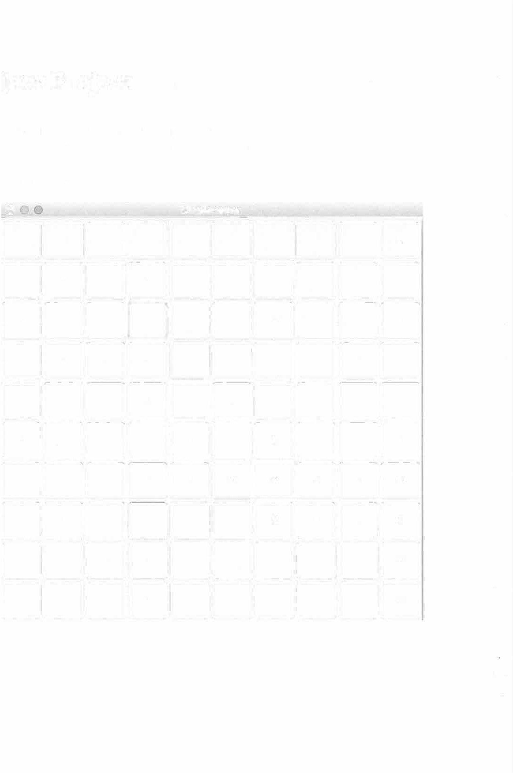

LJLJLJLJ□□□□

□□□□□□□□□□

□□□□□□□□□□

89

package minesweeper;

import java.awt.Color; import java.awt.Dimension; import java.awt.Font; import java.awt.GridLayout;

import java.awt.event.ActionEvent; import java.awt.event.ActionListener; import java.awt.event.MouseAdapter; import java.awt.event.MouseEvent; import java.util.Scanner;

import javax.swing.JButton; import javax.swing.JOptionPane; import javax.swing.JFrame; import javax.swing.JPanel;

public class Minesweeper extends JFrame { final int N = 10;//NxN grid of cells 100 int [] [] grid = new int [NJ [NJ;

int[] (J cover= new int[N] [NJ;

JButton[J [J buttons= new JButton[NJ [NJ; int colClick;

int rowClick;

boolean game_over = false;

Font f2 = **new** Font("New Courier", Font.BOLD, 12); int bombs marked= O;

int bombs actual;

public Minesweeper() initializeButtons(); initializeBombs(); initializeNbhds();

public void initializeButtons() {

JPanel panel= new JPanel(new GridLayout(N, N)); Font fl= new Font("New Courier", Font.PLAIN, 6); for (int j = 0; j < N; j++) {

for (inti= O; i < N; i++) buttons[i] [jJ = new JButton(); buttons[i] [jJ .setFont(fl);

buttons[i] [jJ .setText(i + " " + j); buttons [i] [jJ.set Visible (true) ;

buttons[i] **[jJ** .addActionListener(new buttonListener() ); buttons[i] **[jJ** .addMouseListener(new myMouseListener(i,

j ));

buttons[iJ **[jJ** .setOpaque(true); panel.add(buttons[i] [jJ);

add(panel);



public void initializeNbhds() { for (int j = O; j < N; j++)

90

for (int i = 0; i < N; i++) { if (grid[i] [j] != -1) {

grid[i] [j] = getSum(i, j);

public int getSum(int i, int j) { int sum= 0;

for (int q = j - 1; q <= j + l; q++) { for (int p = i - 1; p <= i + 1; p++)

if (p >= 0 && p< **N** && q >= 0 && q < **N)** { if (grid[p] [q] == -1) {

sum++;

return sum;

public void initializeBombs()

for (int i = 0; i < N; i++) { for (int j = 0; j < N; j++)

int number= (int) ( 0.5 * N * Math.random());

System.out.println("number ="+number); if (number = 0) {

grid[i] [j] = -1; bombs_actual++;

else{

grid[i) [j) = 0; cover [i J [j J = 0;

class buttonListener implements ActionListener { @Override

public void actionPerformed(ActionEvent e) {

Scanner scanner = new Scanner(e.getActionCommand()); if (scanner.hasNextint());{

colClick = scanner.nextint();

if (scanner.hasNextint()) { rowClick = scanner.nextint();

over") ;

if (grid[colClick) [rowClick] == -1) game_over = true;

JOptionPane.showMessageDialog(null, "KaBoom -- game

else {

cover [colClick] [rowClick] 1;



91

buttons[colClick] [rowClick] .setFont(f2); buttons[colClick] [rowClick] .setBackground(Color.white); buttons [colClickJ [rowClick]. setText ("" +

grid[colClick] [rowClick]);

*if* (grid[colClick] [rowClick] == 0) { uncoverNbhd(colClick, rowClick);

public void uncoverNbhd(int *i,* int j) { for (int q = j - 1; q <= j + 1; q++)

for (int p = i - 1; p <= i + 1; p++)

if (p >= 0 && p < N && q >= 0 && q < N) { if (cover[p][q] ==0) {

if (grid[p] [q] != -1) cover [pl [q] = 1;

but tons [p] [q] .setFont (f2) ;

buttons[p] [q] .setBackground(Color.white);

buttons[p] [q].setText("" + grid[p] [q]);

if (grid [pl [ql == 0) {

uncoverNbhd(p, q);

class myMouseListener extends MouseAdapter { private inti, j;

public myMouseListener(int i, int j) {

**this.i** = ***i;***

this.j = j;

@Override

public void mouseClicked(MouseEvent e) { if(e.getButton() == e.BUTTON3) {

Color this_color = new Color(238, 238, 238);

if (buttons[i] [j] .getBackground() .equals(this_color)) buttons[i] [j] .setBackground(Color.red);

else {

buttons[i] [j] .setBackground(this_color);

bombs marked= 0;

for (int ii = 0; ii < N; ii++) { for (int jj = 0; jj < N; jj++)

if

(buttons[ii] [jj] .getBackground() .equals(Color.red))

92

if (gr ict[ii l [jjl == -1 ) { bombs_marked++;

else {

bombs marked--;

System.out.println("bornbs_marked =" + bombs_marked); System.out.println("bombs_actual ="+bombs actual); if (bombs_marked == bombs_actual) {

JOptionPane.showMessageDialog(null, "You Win!!");

public static void main(String[] args) { Minesweeper minesweeper= new Minesweeper(); minesweeper.setSize(new Dimension(600, 600)); minesweeper.setTitle("MineSweeper");

minesweeper.setDefaultCloseOperation(JFrame.EXIT_ON_CLOSE); minesweeper.setLocationRelativeTo(null); minesweeper.setVisible(true);}

93

**Java Project:** ClockAnimation

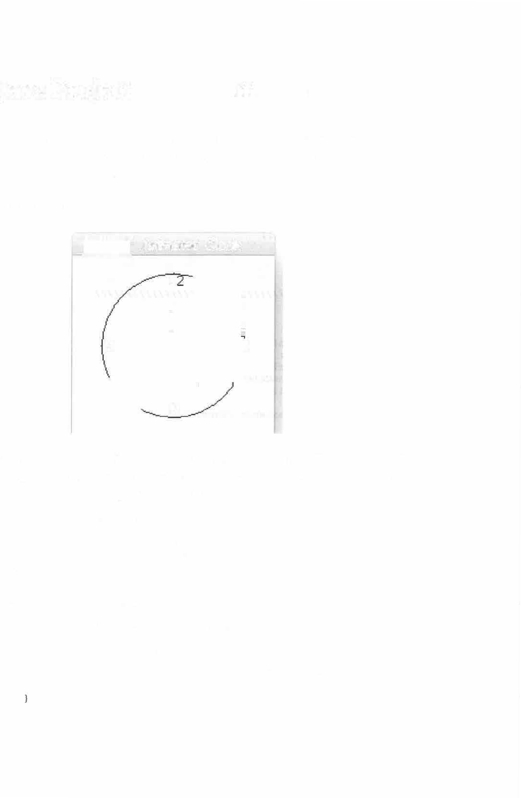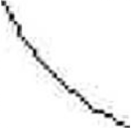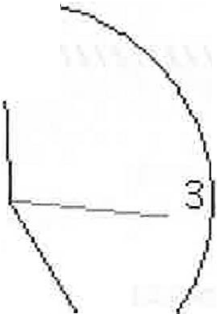

**Description:** Shows a simulated clock, with hour, minute and second hand, with accurate time. It uses a StillClock.java class in addition to the main class ClockAnimation.java

**Sample Output:**

Animated Clock

1

9

6

There are two java files: ClockAnimation.java and StillClock.java. The program could use some embellishments, such as a better drawing of the clock and better/more numbers etc.

package clockanimation;

import java.awt.event.ActionEvent; import java.awt.event.ActionListener; import javax.swing.JFrame;

import javax.swing.Timer;

public class ClockAnimation extends JFrame {

private StillClock clock= new StillClock(); public ClockAnimation() {

this.add(clock);

Timer timer= new Timer(lOOO, new TimerListener()); timer.start();

94

public static void main(String[] args) { JFrame frame = new ClockAnimation(); frame.setTitle("Animated Clock");

frame.setDefaultCloseOperation(JFrame.EXIT_ON_CLOSE);

//frame.setLocationRelativeTo(null); frame.setSize(200, 200); frame.setVisible(true);

public class TimerListener implements ActionListener public void actionPerformed(ActionEvent e) {

clock.setCurrentTime(); clock.repaint();

*II/II/////II/I/I///III/I///III/II/II//I//III/I/I///I//*

package clockanimation;

import java.awt.Color; import java.awt.Dimension; import java.awt.Graphics; import java.util.Calendar;

import java.util.GregorianCalendar; import javax.swing.JPanel;

public class StillClock extends JPanel { private int hour;

private int minute; private int second;

public StillClock() setCurrentTime();

public StillClock(int hour, int minute, int second) { this.hour= hour;

this.minute minute; this.second = second;

public int getHour() return hour;

public int getMinute() return minute;

public int getSecond() return second;

95

public void setHour(int hour) { this.hour= hour;

public void setMinute(int minute) { this.minute= minute;

public void setSecond(int second) { this.second= second;

protected void paintComponent(Graphics g) { super.paintComponent(g);

int clockRadius = (int) (Math.rnin(getWidth(), getHeight()) *

0.8 * 0.5);

int xCenter = getWidth() / 2; int yCenter = getHeight() / 2;

g.setColor(Color.black);

g.drawOval(xCenter - clockRadius, yCenter - clockRadius,

2 * clockRadius, 2 * clockRadius);

g.drawstring("l2'', xCenter - 5, yCenter - clockRadius + 12); g.drawString("9'', xCenter - clockRadius + 3, yCenter + 5); g.drawString("3'', xCenter + clockRadius - 10, yCenter + 3); g.drawString("6'', xCenter - 3, ycenter + clockRadius - 3);

//Draw second hand:

//Note: it may appear that the sin and cos should be reversed,

//but careful analysis shows we are dealing with cos(pi/2 -

theta)

//which *is* equal to sin(theta), so the sin and cos get

exchanged.

int sLength = (int)

(clockRadius * 0.8);

int xSecond = (int) (xCenter + sLength * Math.sin(second * 2

*Math.PI/ 60));

int ySecond

*Math.PI/ 60));

(int) (yCenter - sLength * Math.cos(second * 2

g.setColor(Color.red);

g.drawLine(xCenter, yCenter, xSecond, ySecond);

//Draw minute int mLength int xMinute

*Math.PI/ 60));

hand:

(int) (clockRadius * 0.65);

(int) (xCenter + rnLength * Math.sin(minute * 2

int yMinute (int) (yCenter - rnLength * Math.cos(minute * 2

*Math.PI/ 60));

g.setColor(Color.black);

g.drawLine(xCenter, yCenter, xMinute, yMinute);

96

//Draw hour hand:

int hLength = (int) (clockRadius * 0.5);

int xHour = (int) (xCenter + hLength * Math.sin(hour * 2 *

Math.PI/ 12));

int yHour (int) (yCenter hLength * Math.cos(hour * 2 *

Math.PI/ 12));

g.setColor(Color.black); g.drawLine(xCenter, yCenter, xHour, yHour);

public void setCurrentTime() {

Calendar calendar= new GregorianCalendar(); this.hour= calendar.get(Calendar.HOUR_OF_DAY); this.minute= calendar.get(Calendar.MINUTE); this.second= calendar.get(Calendar.SECOND);

public Dimension getPreferredSize() return new Dimension(400, 400);

97

**Java Project:** SimpleAnimation

**Description: This program shows a single ball (randomly generated size, direction and color) bouncing in the drawing panel.**

**Sample Output:**

* **Anlmatod 8al**

0

/*

* + To change this license header, choose License Headers in Project Properties.
  + To change this template file, choose Tools I Templates
  + and open the template in the editor.

*/

package simpleanimation;

import java.awt.Color; import java.awt.Graphics;

import java.awt.event.ActionEvent; import java.awt.event.ActionListener; import java.util.Random;

import javax.swing.JFrame; import javax.swing.JPanel; import javax.swing.Timer;

/**

*

* + @author Adrian

*/

public class SimpleAnimation extends JFrame {

public static final int W = 600; public static final int H = 600; public static double radius;

98

public static double maxRadius w *I* 2; public static double dx;

public static double dy; public static double **x;** public static double y; public static Color color;

public static double maxSpeed 20;

public SimpleAnimation() {

MovingBallPanel panel= new MovingBallPanel(); this.add(panel);

initializeBall();

private void initializeBall() { Random rand= new Random();

//create a radius between O and max radius= maxRadius * Math.random();

//start the ball in the center of window

x = W *Math.random(); y = H * Math.random();

color= new Color(rand.nextint(256), rand.nextint(256), rand.nextint(256));

//start ball with random dx and dy between +maxspeed/2 and - maxspeed/2

dx maxSpeed * Math.random() - maxSpeed / 2;

dy maxSpeed * Math.random() maxSpeed / 2;

static class MovingBallPanel extends JPanel

//sends an event ever 30 milliseconds

//timer listener reacts to each

//of these events by calling the method repaint(); private Timer timer= new Timer(30, new TimerListener());

public MovingBallPanel() { timer.start();

//must be called in order to draw to any JPanel

//Graphics object g is from the OS protected *void* paintComponent(Graphics g) {

super.paintComponent(g);

checkBoundary(); updateXYPosition(); drawBall (g);

private void checkBoundary() { if(x +radius> getWidth()) {

dx = -Math.abs(dx);

if (x - radius< 0) { dx = Math.abs(dx);

}

if( y +radius> getHeight()) {

99

dy = -Math.abs(dy);

if(y - radius< 0) { dy = Math.abs(dy);

private void updateXYPosition() {

**x =x** + dx; y = y + dy;

private void drawBall(Graphics g) { g.setcolor(color);

g. fillOval ((int) (x - radius), (int) (y - radius) , (int) (2 * radius), (int) (2 * radius));

g.setColor(Color.black);

g.drawOval((int) (x - radius), (int) (y - radius) ,

(int) (2 * radius), (int) (2 * radius));

}

class TimerListener implements ActionListener{

//this metho, action performed is called at each

event

public void actionPerformed(ActionEvent e) { repaint();



public static void main(String[) args) { SimpleAnimation frame= new SimpleAnimation(); frame.setTitle("Animated Ball");

frame.setDefaultCloseOperation(JFrame.EXIT_ON_CLOSE);

frame.setSize(W,H); frame.setVisible(true);

100

**Java Project:** AnimatedBalls

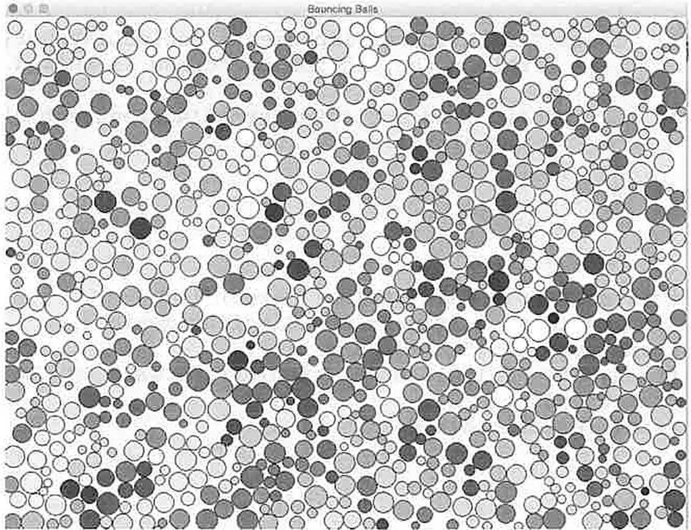

**Description:** This program shows many balls bouncing in the ddrawing panel. You can change the number of balls, their size, speed and color. You can also change what happens when they collide. The default code just has them bounce off each other and change color in a certain way (look at the code to see how/when a ball's color changes), but you can invent other things happens such as explosions etc.

**Sample Output:**

101

package animatedballs;

import java.awt.Color; import java.awt.Graphics;

import java.awt.event.ActionEvent; import java.awt.event.ActionListener; import java.awt.event.MouseAdapter; import java.awt.event.MouseEvent; import java.util.Random;

import java.util.Vector; import javax.swing.JFrame; import javax.swing.JPanel; import javax.swing.Timer;

public class AnimatedBalls extends JFrame {

public static public static public static public static public static public static public static public static public static public static public static public static public static public static public static public static

int W 900;

int H 700; int n = 1000; int m = 6;

double[] radius= new double[n]; double minRadius = 5;

double maxRadius = 15; double[) dx = new double[n]; double[] dy = new double[n]; double[] x = new double[n]; double[] y = new double[n]; Color[] color= new Color[n]; double speed= 1;

int[] active= new int[n); int[] score= new int[n);

int [] [] gene = new int [n] [m];



public AnimatedBalls{)

MovingBallPanel panel= new MovingBallPanel(); this.add(panel);

initializeBalls{}; printBalls(};

public static void printBalls(} for (inti= 0; i < n; i++}

System.out.print(i}; System.out.print(" "};

for (int g = O; g < m; g++} System.out.print(gene[i] [g)};

System.out.println{"");

private void initializeBalls() { Random rand= new Random();

**102**

int r = 0; int g = O; int b 0;

for (inti= 0; radius[i]

Math.random();

i < n; i++)

minRadius + (maxRadius - minRadius) *

x[i] = radius[i] + (W 2 * radius[i)) * rand.nextDouble();

y[i] = radius[i) + (H - 2 * radius[i]) * rand.nextDouble();

//x[i] = W/2;

//y[i] = H/2;

//color[i] = new Color(rand.nextint(256), rand.nextint(256), rand.nextint(256));

active[i] = l;

for (int k = O; k < m; k++)

gene[i][k] = (int) (2 * Math.random());

r = setColor(i, gene[i] [O], gene[i] [l]);

g = setColor (i, gene [i] [2], gene [i] [3]);

b setColor(i, gene[i] [4], gene[i] [SJ); color[i] new Color(r, g, b);

score[i] = setScore(i);

dx[i]

dy[i]

= score[i] * Math.random() score[i] * Math.random()

score[i) / 2;

score[i) / 2;



}

//color[n-1) Color.GRAY;

public static int setScore(int i) int sum= 0;

for (int k = 0; k < m; k++) { sum += gene [i) [k);

return sum;

public static int setColor(int i, int vl, int v2) { if (vl == 0 && v2 == 0) {

return (int) (64 * Math.random());

//return 0;

else if (vl O && v2 == 1) {

return 64 + (int) (64 * Math.random()); else if (vl == 1 && v2 == 0) {

return 128 + (int) (64 *Math.random()); else if (vl == 1 && v2 == 1) {

return 192 + (int) (64 * Math.random());

//return 255; return O;

**103**

static class MovingBallPanel extends JPanel

private Timer timer= new Timer(30, new TimerListener()); public boolean timer_stop = false;

public MovingBallPanel() { timer.start();

this.addMouseListener(new MouseAdapter() { public void mouseClicked(MouseEvent e)

int delay= timer.getDelay();

if (e.getButton() == MouseEvent.BUTTONl) if (timer_stop) {

timer.start(); timer_stop = false;

else {

timer.stop(); timer_stop = true;

5000);

//timer.setDelay(delay > 5? delay - 5 : 5); else if (e.getButton() == MouseEvent.BUTTON3)

timer.setDelay(delay < 5000? delay+ 5 :



} ) ;

protected void paintComponent(Graphics g) { super.paintComponent{g); checkBoundary();

checkCollisions(); updateXYPositions();

//pumpVelocities(); drawBalls(g);

//printBalls () ;

private *void* checkBoundary() { for (inti= 0; i < n; i++)

if **(x[i]** + radius[i] > getWidth())

**dx[i]** = -Math.abs(dx[i]);

if (x [i] - radius [i) < 0) {

**dx[i]** = Math.abs(dx[i]);

if **(y[i]** + radius[i) > getHeight()) dy[i] = -Math.abs(dy[i]);

**104**

if (y[i] - radius[i] < 0) {

dy[i] = Math.abs(dy[i]);

private

for

void updateXYPositions(} { (int *i* = 0; *i* < n; i++) {

X [i l = X [ i] + dx [*i* l;

y[i] = *y* [i] + dy [*i* l;

private void drawBalls(Graphics g} for (int i = 0; i < n; i++) {

if (active[i] == 1} {

|  |  |  |  |  |
| --- | --- | --- | --- | --- |
| g.setColor(color[i]); | | | | |
|  |  | g.fillOval((int) | (x[i] - radius[i]), (int) | (y[i] |
| - radius [i]), | (int) | (2 * radius [i]), | (int) (2 * radius [i])); |  |
| g.setColor(Color.black}; | | | | |
|  |  | g.drawOval((int) | **(x[i]** - radius[i]), (int) | (y[i] |
| - radius [i]}, | (int) | (2 * radius [i]), | (int} (2 * radius [i])); |  |

(y[i]));

/lg.drawstring('"'+ i, (int) **(x[i]),** (int)

private void checkCollisions() { for (int i = O; i < n; i++) {

for (int j = i + 1; j < n; j++) {

double dist= Math.sqrt(Math.pow(x[j] - **x[i],** 2)

+ Math.pow(y[j] - y[i], 2)};

if (active[i] 1 && active[j] == l} { if (dist> 0 && dist<= (radius[i] +

radius[j])} {

gene [j ] [1] }; gene [j J [3 l);

gene [j ] [5 l);

if (score[i] > score[jl) {

/*for (int k = 0; k < m; k++) gene [j] [kl = gene [i] [k];

int r = setColor(j, gene[j] [0], int g setColor(j, gene[j] [2], int b = setColor(j, gene[j] [41,

color[j] = new Color(r, g, b) ;

score[j) = setScore(j};

* /

color[j] = color[i];



**105**

gene(i] [1]);

/* else

for (int k = 0; k < m; k++) { gene [i] [kl = gene [j] [kl ;

int r = setColor(i, gene[i] [OJ,

gene[i] [3]);

gene [i] [5] );

int g

int b

setColor(i, gene[i] [2],

setColor(i, gene[i] [4],

color[i] = new Color(r, g, b); score[i] = setScore(i);

//color[i] = color[j];

*\*I*

elasticCollision(i, j);

public void pumpVelocities() { double epsilon = 0.5;

for (inti= 0; i < n; i++)

if (Math.abs(dx[i]) < epsilon) dx [i] *= 1. 0;

if (Math.abs(dy[i]) < epsilon) { dy[i] *= 1.0;

private void checkCollissions2() {

public void elasticCollision(int i, int j) {

// get the mtd

double delta **x** = **x[i]** - x[j]; double delta_y = y[i] - y[j];

doubled= Math.sqrt( (delta_x * delta x + delta_y *

delta_y) );

delta x;

double mtd x = ((radius[i) + radius[j] - d) / d) *



**106**

delta_y; mtd_y);

double mtd_y = ((radius[i) + radius[j) - d} / d} *

double mtd_length Math.sqrt(mtd_x * mtd_x + mtd_y *

double mtd_norm_x = mtd x / mtd_length; double mtd_norm_y = mtd_y / mtd_length;

double iml double im2

1.0 / radius[i);

1.0 *I* radius[j);



*IIIII/IIII//I/I/III//I/IIIII//I/I///I*

|  |  |  |  |
| --- | --- | --- | --- |
| x[i) | += | (iml / (iml + | im2)) * mtd x; |
| y[i) | += | (iml / (iml + | im2)) * mtd_y; |
| x[j) | += | -(im2 / (iml | + im2}) * mtd_x; |
| y[j] | += | -(im2 / (iml | + im2}) * mtd y; |

double v x dx[i) dx[j); double v_y = dy[i] - dy[j);

double vn = v x * mtd norm x + v_y * mtd_norm_y; if (vn > 0.0)

return;

double elastic_constant = 1.0;

double impulse_x mtd norm x * (-(1 + elastic_constant}

* vn} / (iml + im2};

double impulse_y = mtd_norm_y * (-(1 + elastic constant}

* vn} / (iml + im2};

**dx[i)** += iml * impulse_x; dy[i] += iml * impulse_y;

dx[j] += -im2 * impulse_x; dy[j) += -im2 * impulse_y;

class TimerListener implements ActionListener { public void actionPerformed(ActionEvent e) {

repaint(};

public static void main(String[] args} { AnimatedBalls frame= new AnimatedBalls(}; frame.setTitle("Bouncing Balls"};

frame.setDefaultCloseOperation(JFrame.EXIT_ON CLOSE}; frame.setSize(W, H);

frame.setVisible(true);

**107**

###### Java Project: BouncingSticks

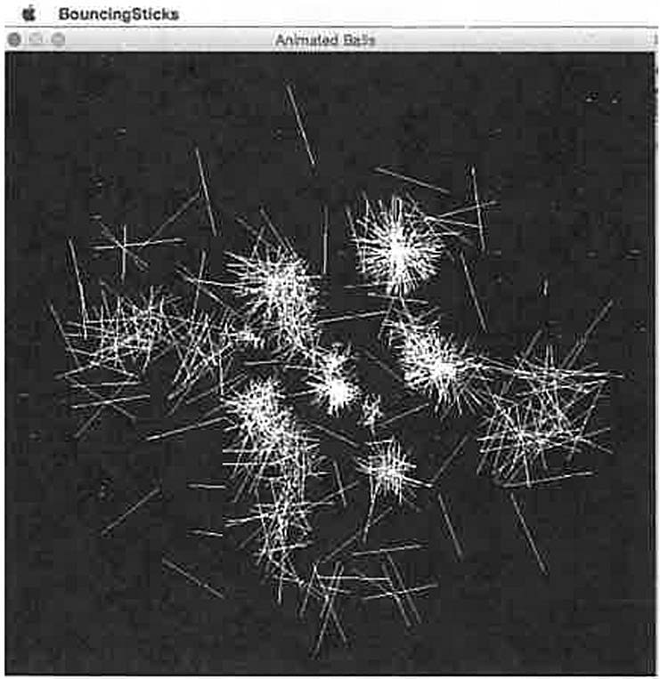

**Description: Displays randomly generating rotating sticks.**

**Sample Output:**

package bouncingsticks;

import java.awt.Color; import java.awt.Graphics;

import java.awt.event.ActionEvent; import java.awt.event.ActionListener; import java.awt.event.MouseAdapter; import java.awt.event.MouseEvent; import java.util.Random;

import javax.swing.JFrame; import javax.swing.JPanel; import javax.swing.Timer;

public class BouncingSticks extends JFrame { public static int W 600;

public static int H 600;

public BouncingSticks() {

MovingBallPanel ml= new MovingBallPanel(); this.add(ml);

public static void main(String[) args) {

**109**

BouncingSticks frame= new BouncingSticks(); frame.setTitle("Animated Balls"); frame.setDefaultCloseOperation(JFrame.EXIT_ON_CLOSE); frame.setSize(W, H);

frame.setVisible(true);

static class MovingBallPanel extends JPanel { public static int n = 800;

public static double[] a = new double[n];

public static double[] da = new double[n]; public static double[] r = new double[n]; public static double[] dx = new double[n]; public static double[] dy = new double[n]; public static double[] x = new double[n]; public static double[] y = new double[n]; public static Color[] color = new Color[n];

private Timer timer= new Timer(30, new TimerListener() );

public MovingBallPanel() {

this.setBackground(Color.black); initializeBalls(); timer.start();

this.addMouseListener(new MouseAdapter() { public void mouseClicked(MouseEvent e)

int delay= timer.getDelay();

if (e.getButton() = = MouseEvent.BUTTONl) timer.setDelay(delay > 5? delay - 5 5);

else if (e.getButton() == MouseEvent.BUTTON3)

timer.setDelay(delay < 5000? delay+ 5 :

5000);

} ) ;

private void initializeBalls () { Random rand= new Random(); double maxBallRadius = 40; double minBallRadius = 2; double maxBallSpeed = 10; double maxRotSpeed = 1.0;

for (inti= O; *i* < n; i++)

r[i] minBallRadius + (maxBallRadius *

Math.random());

x[i] W / 2;

y[i] H/2;

int red= rand.nextint(256); int green= rand.nextint(256); int blue= rand.nextint(256);



**110**

*I* 2;

*I* 2;

2;

color[i) **=** new Color(red, green, blue); color[i] = new Color(255,255,255);

dx[i) = maxBallSpeed * Math.random() - maxBallSpeed

dy[il maxBallSpeed * Math.random() - maxBallSpeed a[i] **=** 2.0 *Math.PI* Math.random();

da[i] = maxRotSpeed * Math.random() - maxRotSpeed /

protected void paintComponent(Graphics g) { super.paintComponent(g);

checkBoundary() ;//check ball at window boundary checkCollisions();//check for collisions between balls checkZeroVelocity(); // want ALL the balls to move. updateXYPositions();//use dx, dy to get new x, y drawBalls(g);//draw all the balls

private void checkBoundary() { for (inti= 0; i < n; i++)

if **(x[i]** + r[i) > getWidth())

dx[i] = -Math.abs(dx[i]);

if (x[i) - r[i] **<** 0) {

dx[i) **=** Math.abs(dx[i));

if (y[i] + r[i) > getHeight())

dy[i) = -Math.abs(dy[i));

if (y[i) - r[il **<** 0) {

dy[i] **=** Math.abs(dy[i));

private

for

void updateXYPositions() { (int i **=** 0; i < n; i++) { x[i) x[il + dx[i);

y[i) y[i) + dy [i];

a[i] **=** a[il + da [i) ;



private void drawBalls(Graphics g) for (int i = 0; i **<** n; i++) {

g.setColor(color[i)); g.drawLine(

(int) (x[i) + r[i] * Math.cos(a[i) +

Math.PI)),

***111***

Math.PI)),

(int) (y [i) + r [il * Math.sin(a[i] +

(int) (x [i] + r [i]

(int) (y [i] + r[i]

}

* Math.cos(a[i])),
* Math.sin(a[i])));

private void checkCollisions() { double[] unit= new double[2]; double length= 0.0;

double iLength = 0.0; double jLength = 0.0; double temp= 0.0;

for (int i = 0; i < n; i++) {

for (int j = i + 1; j < n; j++) {

//check to see if ball i has collided with ball

j :

double dist= Math.sqrt(

Math.pow(x[j] - **x[i],** 2)

+ Math.pow(y[j] - **y[i], 2));**

if (dist> 0 && dist<= r[i] + r[j]) unit[O] = (x[j] - **x[i])** / dist;

unit[l] = (y[j] - y[i]) / dist; length= Math.sqrt(

Math.pow(unit[O], 2)

+ Math.pow(unit[l], 2));

iLength jLength

dx [i]

dy[i]

Math.sqrt( Math.pow(dx[i], 2)

+ Math.pow(dy[i], 2) );

= Math.sqrt( Math.pow(dx[j], 2)

+ Math.pow(dy[j], 2));

-jLength * unit[O];

-jLength * unit[l];

**dx**[j J dy[j]

temp a[i]

a[j]

= iLength * unit[OJ;

= iLength * unit[l];

a [i l ;

a [ j l ;

temp;



}.

private void checkZeroVelocity() { for (int i = O; i < n; i++) {

if ((dx[il * **dx[i]** + dy[il * dy[i]) <= 0.1)

System.out.println("zero vel at"+ i);

**dx[i]** = 1 + **(4** * Math.random() - 2);

dy[i] = 1 + (4 * Math.random() - 2);

**112**



class TimerListener implements ActionListener { public void actionPerformed(ActionEvent e) {

repaint();

**113**

**Java Project: RotatingPolygon**

**Description: Draw randomly placed polygons, and have them rotate in place.**

**Sample Output:**

package rotatingpolygon;

import java.awt.Color; import java.awt.Font; import java.awt.Graphics;

import java.awt.event.ActionEvent; import java.awt.event.ActionListener; import javax.swing.JFrame;

import javax.swing.JPanel; import javax.swing.Timer;

public class RotatingPolygon extends JFrame ( public static int W = 600;

public static int H = 600;

public RotatingPolygon() {

DrawingPanel drawingPanel this.add(drawingPanel);

new DrawingPanel();

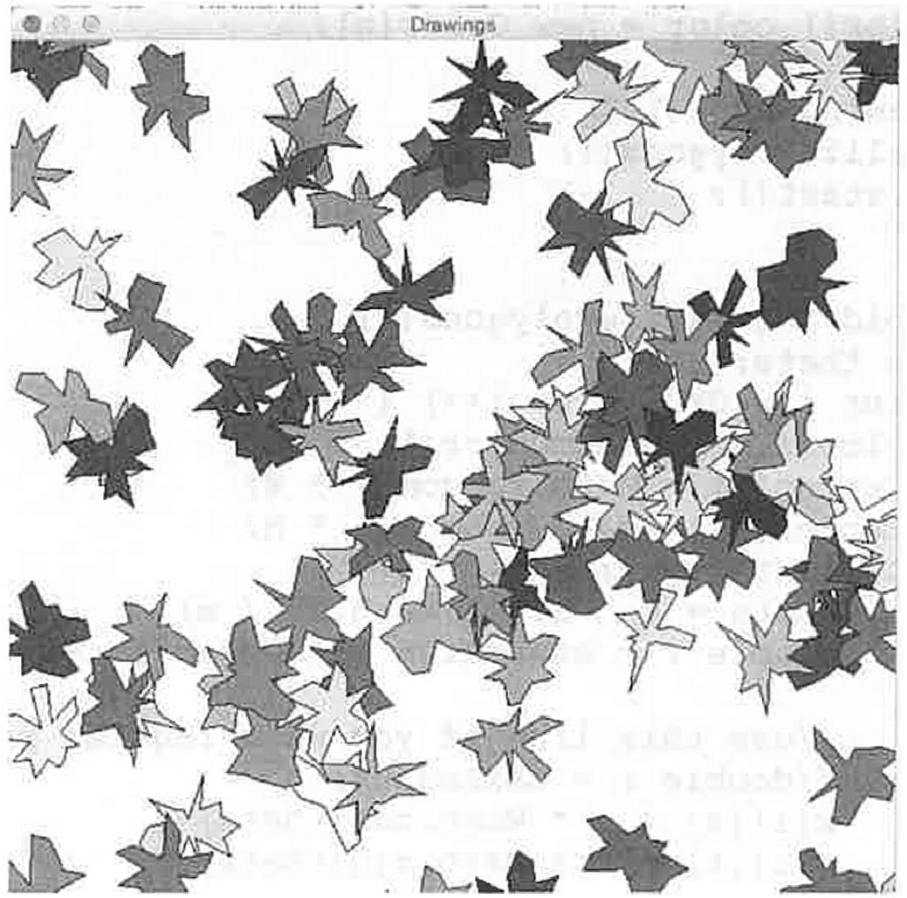

114

static class DrawingPanel extends JPanel {

private Timer timer= new Timer(30, new TimerListener()); int m = 20; //points per poly

int n = 100; *II* number of polys double[)[] x = new double[n] [m);

double[)[] y = new double[n] [m); double maxRadius = 40;

double minRadius = 5;

double[) xCenter = new double[n]; double[] yCenter = new double[n]; public Color[) color = new Color[n];

public DrawingPanel() { initializePolygons(); timer.start();

private void initializePolygons() { double theta;

for (inti = O; *i* < n; i++) { color[i) = randomColor(); xCenter[i) = Math.random() * W; yCenter[i) = Math.random() * H; for (int k = 0; k < m; k++) {

theta= k * 2.0 *Math.PI/ m;

doubler = minRadius + (maxRadius - minRadius) *

Math.random();

//use this line if you want regular polygons:

//doubler = maxRadius;

**x[i]** [kl = r * Math.cos(theta)

**y[i]** (kl = r * Math.sin(theta)

protected void paintComponent(Graphics g) { super.paintComponent(g); updatePositions();

drawPolygons(g);

private void updatePositions() double alpha = 0.1; for(int *i* = 0; *i* < n; i++)

for(int k = 0; k < m; k++)

double newX (y[i] [kl) * Math.sin(alpha);

double newY (y[i] [k)) * Math.cos(alpha);

(x[i] [k]) * Math.cos(alpha) +

-(x[il [kl) * Math.sin(alpha) +



**115**

|  |  |  |
| --- | --- | --- |
| x[i][k) | **=** | newX |
| y [i] [kl | = | newY |

**}**

//xCenter[i] += 1.0;

//yCenter[i] += 1.0;

class TimerListener implements ActionListener { public void actionPerformed(ActionEvent e) {

repaint();

private void drawPolygons(Graphics g) { for (int i = O; i < n; i++) {

int[] polyX = new int[m]; int[] polyY = new int[m];

//Color color = randomColor(); g.setColor(color[i]);

for(int **k** = 0; k < m; **k++)** {

polyX[k] (int) **(x[i] [kl** + xCenter[i]);

polyY[k] = (int) (y[i] **[k]** + ycenter[i]);

g.fillPolygon(polyX, polyY, m); g.setColor(Color.black); g.drawPolygon(polyX, polyY, m);

private Color randomColor() { Color color= new Color(

(int) (256 * Math.random()),

(int) (256 * Math.random()), (int) (256 * Math.random())

) ;

return color;

public static void main(String[] args) { RotatingPolygon frame = new RotatingPolygon(); frame.setTitle("Drawings");

frame.setDefaultCloseOperation(JFrame.EXIT_ON_CLOSE); frame.setSize(W, H);

frame.setVisible(true);

**116**

## Java Project: Life

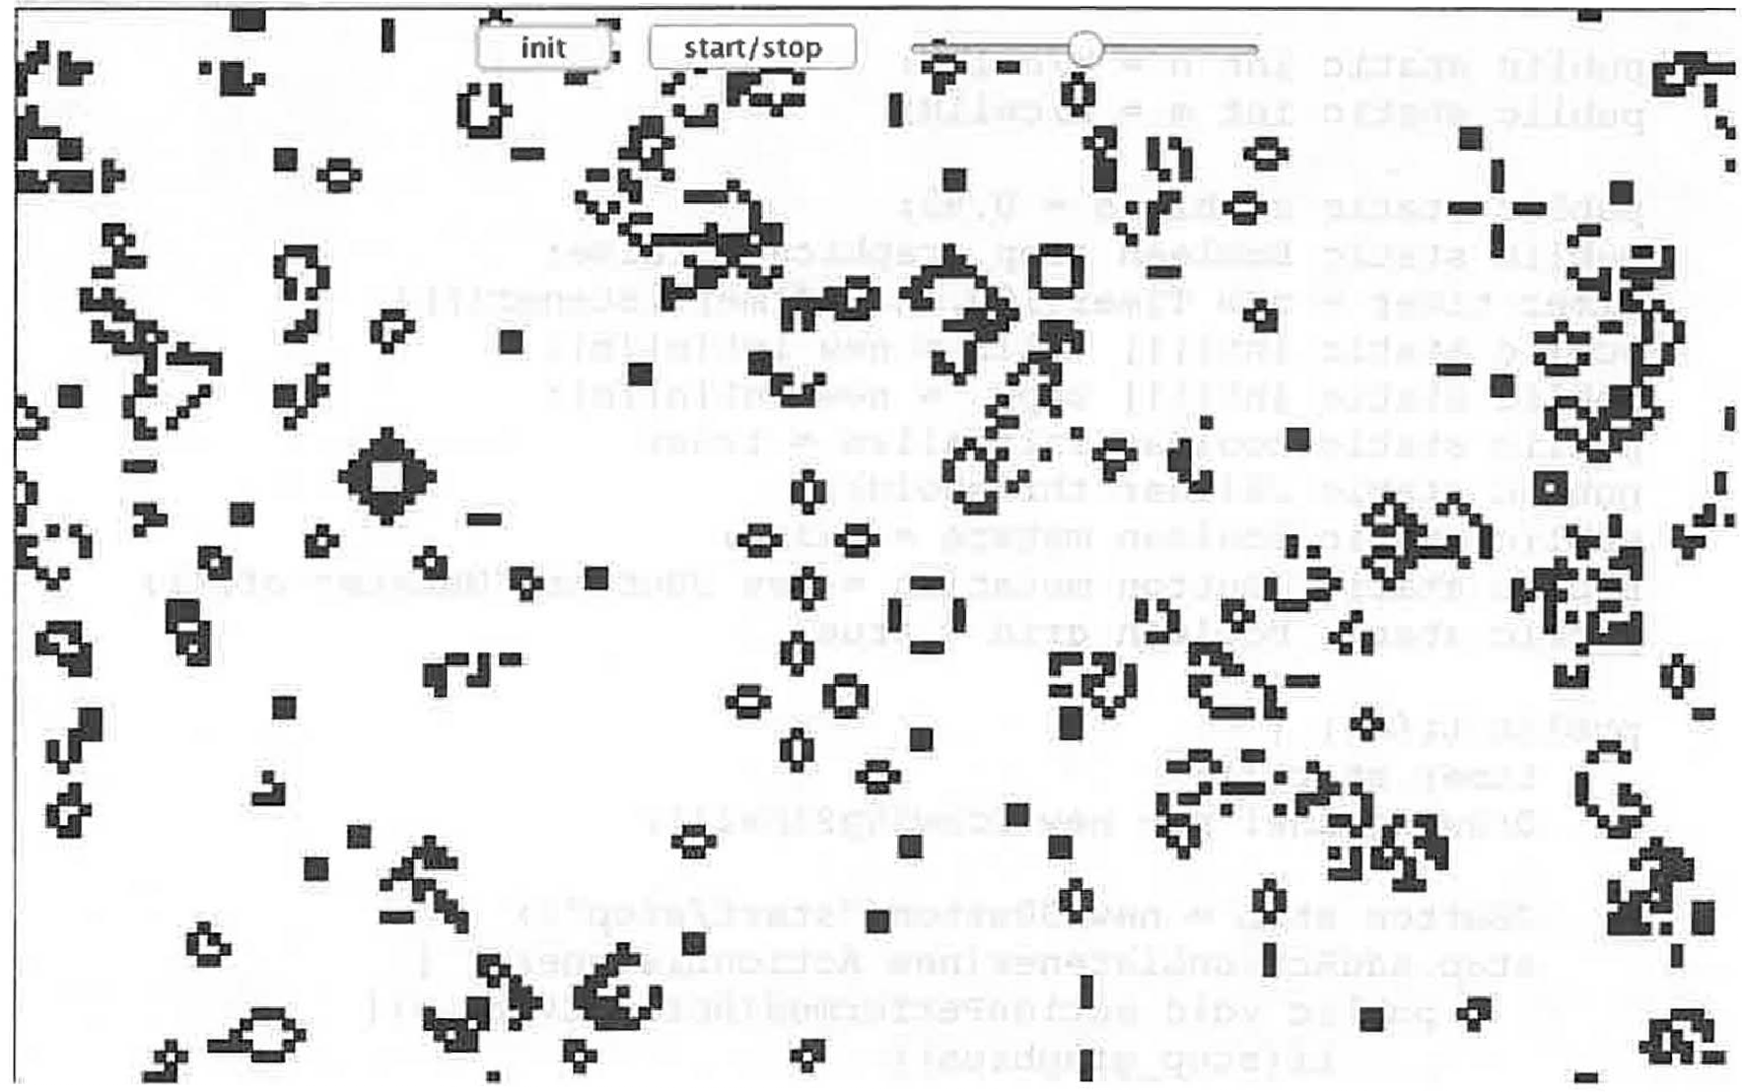

**Description:** This program simulates Conway's Game of Life. Using relatively simple rules, the cells change between black and white giving the impression of motion and other life-like activity. Various patterns emerge - very thought provoking. The program has a few settings that can be played with to get different effects, in particular a slide bar that allows for the density of white vs. black at the start of the simulation and "init" and "stop/start" buttons to restart or pause the simulation.

**Sample Output:**

* **Conway's Game of Life**

/*

* To change this license header, choose License Headers in Project Properties.
* To change this template file, choose Tools I Templates
* and open the template in the editor.

*/

package life;

import java.awt.Color; import java.awt.Graphics;

import java.awt.event.ActionEvent; import java.awt.event.ActionListener;

118

import java.util.Random; import javax.swing.JButton; import javax.swing.JFrame; import javax.swing.JPanel; import javax.swing.JSlider; import javax.swing.Timer;

/**

*

* @author wwolfe3

*/

public class Life extends JFrame

public static int W = 800; public static int H 500;

public static int cellW 5;

public static int cellH = 5;

public static int n = W/cellW; public static int m H/cellH;

public static doubled= 0.92;

public static boolean stop_graphics = false;

Timer timer= new Timer(l00, new TimerListener()); public static int [] [] cells = new int [n] [m]; public static int [] [] copy = new int [n] [m]; public static boolean initialize= true;

public static JSlider threshold; public static boolean mutate= false;

public static JButton mutation = new JButton("Mutate: off"); public static boolean grid= true;

public Life ()

timer.start();

DrawingPanel p = new DrawingPanel();

JButton stop = new JButton("start/stop"); stop.addActionListener(new ActionListener() {

public void actionPerformed(ActionEvent e) { if(stop_graphics) {

stop_graphics = false; else {

stop_graphics true;

} ) ;

JButton init = new JButton("init"); init.addActionListener(new ActionListener()

public void actionPerformed(ActionEvent e) initialize= true;

stop_graphics = true;

***119***

} ) ;

threshold= new JSlider(JSlider.HORIZONTAL, 0, 100, 50);

p. add (init);

p. add (stop) ; p.add(threshold); this.add(p);

static class DrawingPanel extends JPanel { public DrawingPanel ()

initializeCells();

public void initializeCells() { for(int j = 0; j < m; j++) {

for(int i = O; i < n; i++) { if(Math.random() > d) {

cells[i)[j] 1; else {

cells [i] [j 1 = O;

protected void paintComponent(Graphics g) { super.paintComponent(g);

if (initialize) {

d = threshold.getValue()/100.0; initializeCells();

initialize= false; if (grid) {

drawGrid (g) ;

else {

if(!stop_graphics) createCopy(); updateGrid();

private void updateGrid() { for(int j = O; j < m; j++)

for(int i = 0; i < n; i++) { cells [i) [j J = copy [i] [jl;

**120**

private void createCopy() { for(int j = 0; j < m; j++)

for(int i = 0; i < n; i++) { copy [i] [jJ = cells [iJ [jJ;

int count= getNeighborCount(i,j); if (cells [i] [j) == 1 && count < 2)

copy [iJ [j) = 0;

}

if(cells[i) [j) -- 1 &&

) {

copy[i) [j) = 1;

if(cells[i) [j) -- 1 &&

copy [i) [j) = 0;

if(cells[i) [j] -- 0 &&

copy[i) [j) = 1;

(count

count

count

-- 2

> 3) {

-- 3)

11 count -- 3)

**{**



private void drawGrid(Graphics g) Random rand= new Random(); g.drawRect(0,0,W,H);

for(int j = 0; j < m; j++) { for(int i 0; i < n; i++)

int x = i * cellW; int y = j * cellH; if (cells [i) [j] == 1)

//Color color= new Color(rand.nextint(256), rand.nextint(256), rand.nextint(256));

//g.setColor(color); g.fillRect(x,y, cellW, cellH); g.setColor(Color.BLACK); g.drawRect(x,y, cellW, cellH);

}else {

//g.drawRect(x,y, cellW, cellH);

if (cells [i) [j) == 0)

if (Math.random() < 0.0001) cells[i) [j) = 1;

public static int getNeighborCount(int i, int j) { inti minus= (i - 1) % n;

if(i_minus == -1) { i minus n - 1;

**121**



int i_plus = (i + 1) % n;

int j_minus = (j - 1) % m; if(j_minus == -1) {

j_minus = m-1;

int j_plus = (j + 1) % m;

int sum cells[i_minus) [j_minus]

+ cells [i] [j_minus]

+ cells[i_plus) [j_minus]

+ cells[i_minus) [j)

+ cells [i_plus] [j]

+ cells[i_minus] [j_plus]

+ cells [i) [j_plus)

+ cells[i_plus] [j_plus); return sum;

public class TimerListener implements ActionListener public void actionPerformed(ActionEvent e) {

repaint();

public static void main(String[) args) { Life frame= new Life(); frame.setTitle("Conway's Game of Life");

frame.setDefaultCloseOperation(JFrame.EXIT_ON CLOSE); frame.setSize(W, H);

frame.setVisible(true);

**122**

## Java Project: Pong

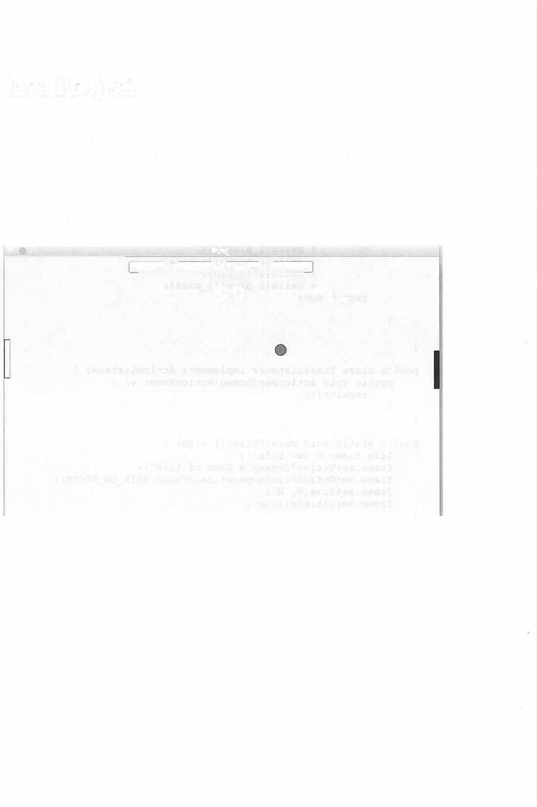

**Description:** This programs simulates the game of Pong. It has controls to pause and speed up or slow down the speed of the ball. The P and L keys control the right paddle and the Q and *A* keys to control the left paddle.

**Sample Output:**

* • **Pong**

**faster** I I **slower j J pause** I I **resume**

**9 5.0 12**

package pong;

import java.awt.Color; import java.awt.Dimension; import java.awt.Font;

import java.awt.FontMetrics; import java.awt.Graphics;

import java.awt.event.ActionEvent; import java.awt.event.ActionListener; import java.awt.event.KeyAdapter; import java.awt.event.KeyEvent; import java.io.File;

import java.io.FileinputStream; import java.io.InputStream; import javax.swing.JButton; import javax.swing.JFrame;

123

import javax.swing.JPanel; import javax.swing.Timer; import sun.audio.AudioPlayer; import sun.audio.AudioStream;

public class Pong extends JFrame

public static int W 800; public static int H 500;

public Pong()

JPanel canvas= new PongCanvas(); canvas.requestFocus(); add(canvas);

class PongCanvas extends JPanel

4.0;

double ballRadius = 10; double ballX W / 2; double ballY = H / 2;

double theta= (Math.PI/ 2.0) * Math.random() - Math.PI/

int toggle= 1; double ballSpeed = 5;

double ballDx = ballSpeed * Math.cos(theta); double ballDy = ballSpeed * Math.sin(theta);

double paddleW = 10; double paddleH = 70;

double paddleLeftX = paddleW / 2; double paddleLeftY = H / 2;

double paddleRightX = W - paddleW / 2; double paddleRightY = H / 2;

double paddleLeftSpeed = 0; double paddleRightSpeed = 0; double paddleMaxSpeed = 4;

private Timer timer= new Timer(lO, new TimerListener()); int playerLeftCount = 0;

int playerRightCount = 0; char keyChar = 'A'; private InputStream in;

JButton faster= new JButton("faster"); JButton slower= new JButton("slower"); JButton pause= new JButton("pause"); JButton resume= new JButton("resume");

public PongCanvas()

addKeyListener(new KeyAdapter() {

public void keyPressed(KeyEvent e) { System.out.println("keyCode "+

e.getKeyCode() );

e.getKeyChar() );

System.out.println("keyChar =" + switch (e.getKeyChar())



**124**

case 'q':

paddleLeftSpeed = -paddleMaxSpeed; break;

case 'a':

paddleLeftSpeed +paddleMaxSpeed; break;

case 'p':

paddleRightSpeed = -paddleMaxSpeed; break;

case 'l':

paddleRightSpeed = +paddleMaxSpeed; break;

default:

keyChar e.getKeyChar();

public void keyReleased(KeyEvent e) { switch (e.getKeyChar())

case 'q':

paddleLeftSpeed = 0; break;

case 'a':

paddleLeftSpeed 0; break;

case 'p':

paddleRightSpeed = 0; break;

case 'l':

paddleRightSpeed 0; break;

default:

keyChar = e.getKeyChar();

} ) ;

faster.addActionListener(new FasterListener()); faster.setFocusable(false);

this.add(faster);

slower.addActionListener(new SlowerListener()); slower.setFocusable(false);

this.add(slower);

pause.addActionListener(new PauseListener()); pause.setFocusable(false);

this.add(pause);

resume.addActionListener(new ResumeListener()); resume.setFocusable(false);

this.add(resume); this.setFocusable(true);

125

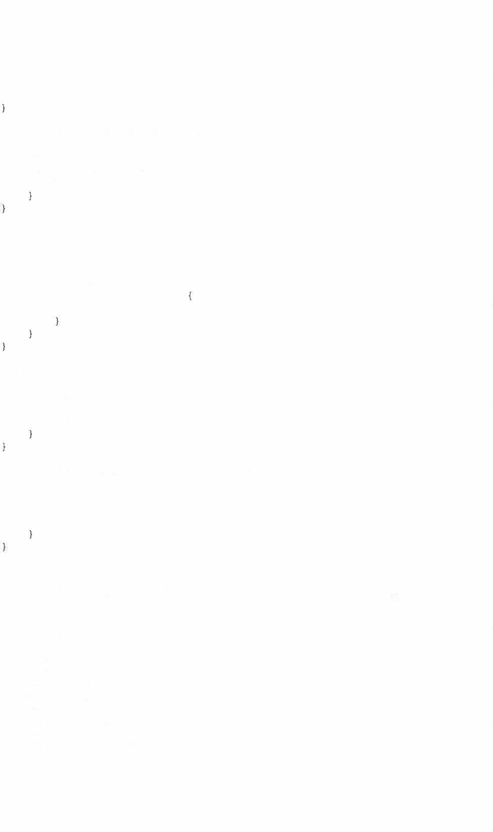

timer.start();

class FasterListener implements ActionListener { @Override

public void actionPerformed(ActionEvent e) {

ballSpeed++;

class SlowerListener implements ActionListener { @Override

public void actionPerformed(ActionEvent e) { ballSpeed--;

if (ballSpeed <= 1) ballSpeed = 1;

class PauseListener implements ActionListener { @Override

public void actionPerformed(ActionEvent e) {

timer.start();

class ResumeListener implements ActionListener { @Override

public void actionPerformed(ActionEvent e) { timer.stop();

protected void paintComponent(Graphics g) { super.paintComponent(g);

theta= (Math.PI/ 2.0) * Math.random() - Math.PI/ 4.0;

leftWallHi t () ; rightWallHit{); bottomHit (); topHit {); paddleLeftHit(); paddleRightHit{); updateBall {); drawBall (g); updateLeftPaddle(); drawLeftPaddle{g);

updateRightPaddle(); drawRightPaddle(g);

**126**

Font font= new Font("New Courier", Font.BOLD, 36); g.setFont(font);

FontMetrics metris = g.getFontMetrics(font); int hgt= metris.getHeight();

String textLeft, textRight, textCenter; int adv;

textLeft = "" + playerLeftCount; textRight = "" + playerRightCount; textCenter = "" + ballSpeed;

adv = metris.stringWidth(textLeft);

Dimension size= new Dimension(adv + 2, hgt+ 2); g.drawString(textLeft, getWidth() / 4 - size.width/ 2,

getHeight() / 8 +size.height/ 2);

g.drawString(textCenter, getWidth() / 2 - size.width/ 2, getHeight() / 8 +size.height/ 2);

g.drawString(textRight, 3 * getWidth() / 4 - size.width

I 2, getHeight() / 8 +size.height/ 2);

}

private void updateLeftPaddle() { paddleLeftY += paddleLeftSpeed;

if (paddleLeftY > getHeight() - paddleH / 2) paddleLeftY = getHeight() - paddleH / 2;

if (paddleLeftY < paddleH / 2) paddleLeftY paddleH / 2;

private void updateRightPaddle() { paddleRightY += paddleRightSpeed;

if (paddleRightY > getHeight() - paddleH / 2) paddleRightY = getHeight() - paddleH / 2;

**if(** paddleRightY < paddleH/2) paddleRightY = paddleH/2;

private void leftWallHit() {

if (ballX - ballRadius <= 0) playerRightCount++; playSound("miss2.wav"); resetBall();

private void rightWallHit() {

**127**

if (ballX + ballRadius >= getWidth()) playerLeftCount++; playsound("miss2.wav"); resetBall();

private void bottomHit() {

if (ballY >= getHeight() - ballRadius) { ballDy = -ballDy; playSound("hit2.wav");

private void topHit() {

if (ballY - ballRadius < 0) ballDy = -ballDy; playSound("hit2.wav");

private void resetBall() { ballX = getWidth() / 2; ballY = getHeight() / 2; toggle= -1 * toggle;

theta= (Math.PI/ 2.0 * Math.random() - Math.PI/ 4.0);

if (toggle== -1) { theta+= Math.PI;

ballDx = ballSpeed * Math.cos(theta); ballDy = ballSpeed * Math.sin(theta);

private void paddleLeftHit() {

if ((ballX < paddleW + ballRadius)

&& (ballY < paddleLeftY + paddleH / 2) && (ballY > paddleLeftY - paddleH / 2))

ballDx = -ballDx;

ballDy += 2.0 * Math.random() - 1.0; playSound("hit2.wav");

private void paddleRightHit() {

if ((ballX > getWidth() - paddleW - ballRadius) && (ballY < paddleRightY + paddleH / 2) && (ballY > paddleRightY - paddleH / 2))

ballDx = -ballDx;

ballDy += 2.0* Math.random() - 1.0; playSound("hit2.wav");

**128**

private void playsound(String fileName) { try

in = new FileinputStream(new File(fileName) ); AudioStream audioStream = new AudioStream(in); AudioPlayer.player.start(audioStream);

fileName);

catch (Exception e) {

System.out.println("problem withsound effect: "+



private void drawBall(Graphics g) { g.setColor(Color.red);

g.fillOval((int) (ballX - ballRadius), (int) (ballY - ballRadius), (int) (2 * ballRadius), (int) (2 * ballRadius));

g.setColor(Color.black);

g.drawOval((int) (ballX - ballRadius), (int) (ballY - ballRadius), (int) (2 * ballRadius), (int) (2 * ballRadius));

}

private void drawLeftPaddle(Graphics g) {

g.drawRect(0, (int) (paddleLeftY - paddleH / 2), (int) paddleW, (int) (paddleH));

}

private void drawRightPaddle(Graphics g) { g.fillRect((int) (getWidth() - paddleW), (int)

(paddleRightY - paddleH / 2), (int) paddleW, (int) (paddleH) );

}

private void updateBall() ballX += ballDx;

ball Y += ball Dy;

class TimerListener implements ActionListener { public void actionPerformed(ActionEvent e) {

repaint();

public static void main(String[J args) { JFrame frame = new Pong(); frame.setTitle("Pong"); frame.setSize(W, H);

frame.setDefaultCloseOperation(JFrame.EXIT_ON CLOSE); frame.setLocationRelativeTo(null); frame.setVisible(true);

**129**

###### Java Project: ShootingGameNew

**Description:** This is a simple target shooting game. The player gets a shooter at the bottom of the screen. The player shoots with the up arrow key. Left and right arrows change the angle of the gun's turret. Targets are spawned, one at a time, from the top of the screen. If a bullet hits a target there is a simulated explosion and the player gains points.

Need a few files to make this work:

Ball.java: A simple class to define the targets in the game.

Particle.java: A class to model the bits and pieces that emerge when a target is hit and explodes.

ParticleSystem.java: A class to manage the many particles that are spawned at an explosion.

ShootingGameN ew.java: The main class.

**Sample Output:**

•

**Misses= O Hits= 1**

**Passes= 3**

**Shoo!Jng !lam•** ~~•~~ **ShoowgGam•**

**Misses= 4**

•

**Hits= 14**

**Passes= 43** •

**2S hits wins!**

**25 hits wins!**

.• •



###### o.

l

131



package shootinggamenew;

import java.applet.AudioClip; import java.awt.Color;

import java.awt.Font; import java.awt.Graphics;

import java.awt.event.ActionEvent; import java.awt.event.ActionListener; import java.awt.event.KeyAdapter; import java.awt.event.KeyEvent; import java.io.File;

import java.io.FileinputStream; import java.io.Inputstream; import java.util.Random;

import javax.swing.JFrame; import javax.swing.JOptionPane; import javax.swing.JPanel; import javax.swing.Timer; import sun.audio.AudioPlayer; import sun.audio.AudioStream;

/**

* @author william wolfe -- idea from Liang's text, Chapter 16 A

ball falls from

* above. you have an arrow-controlled gun at bottom of screen.

left-arrow:

* swivel left right-arrow: swivel right up-arrow fires a shot in direction gun
* is pointing -- added a few variations: changing ball

size/color/speed --

* **"win"** particle system -- "explosion" particle system

*/

public class ShootingGameNew extends JFrame {

public static final int W = 500; public static final int H = 600; public static boolean shoot;

public ShootingGameNew() {

JPanel game= new GameCanvas(); game.setFocusable(true); add(game);

class Gamecanvas extends JPanel { public double gunW;

public double gunH;

public double theta;//gun pointing public double dTheta;//gun rotation rate public double speed;

public boolean shot; *II* true when bullet in motion

**132**

public Ball target; public Ball bullet;

public double maxTargetSpeed = 20; public double maxTargetRadius = 30;

public int misses = 0; public int hits = O; public int passes = 0; public int bounce = 0;

Timer timer= new Timer(lO, new TimerListener() );

//sound:

AudioClip clip;

//particle system for explosions: ParticleSystem particleSystem; ParticleSystem particleSystemWin;



start

2. 0);

2);

public GameCanvas() {

//initialize the gun parameters:

gunW = 35;

gunH = 5;

theta= Math.PI/ 2.0; //gun pointing straight up at

dTheta = 0.1;//gun rotation rate speed= 20.0;//gun speed (or "power") shot= false;

//initialize the traget parameters:

target= new Ball();

target.setRadius(25); resetTarget();

//initialize the bullet parameters:

bullet= new Ball(); bullet.setRadius(5); resetBullet();

//initialize the explosion particle system: particleSystem = new ParticleSystem(30, w / 2.0, H /

//initialize the "win" particle system: particleSystemWin = new ParticleSystem{500, W / 2, H /

particleSystemWin.name = "WIN"; particleSystemWin.reset(W / 2, H / 2);

particleSystemWin.maxR = 50; timer.start();

this.addKeyListener(new KeyAdapter() { public void keyPressed(KeyEvent e)

if (e.getKeyCode() == KeyEvent.VK_LEFT)

133

theta+= dTheta;

if (theta>= Math.PI) { theta= Math.PI - 0.01;

if (e.getKeyCode() -- KeyEvent.VK_RIGHT) theta-= dTheta;

if (theta<= 0.0)

theta= 0.01;

if (e.getKeyCode() == KeyEvent.VK_UP) if (!shot) {

InputStream in; try {

in= new FileinputStream(new

File("audio/bullet.wav")); AudioStream (in) ;

AudioStream audioStream = new

AudioPlayer.player.start(audioStream);

} catch (Exception soundException) { JOptionPane.showMessageDialog(null,

soundException);

bullet.setVelocityPolar(theta, speed); shot= true;

} ) ;

public void updateGun()

//this does nothing right now -- for future mods

public void drawGun(Graphics g) { g.drawLine(

getWidth() / 2, getHeight(),

(int) (getWidth() / 2 + gunW * Math.cos(theta)), (int) (getHeight() - gunw * Math.sin(theta))

) ;

g.drawOval( (int) (getWidth() / 2 - bullet.r), (int) (getHeight() - bullet.r), (int) (2 * bullet.r), (int) (2 * bullet. r) );

}

public boolean collision() {

134

if (target.distanceTo(bullet) < target.r + bullet.r) { InputStream in;

try {

in= new FileinputStream(new File("audio/hit2.wav"));

AudioStream audioStream = new AudioStream(in); AudioPlayer.player.start(audioStream);

catch (Exception e) { JOptionPane.showMessageDialog(null,

e.toString());

return true; else {

return false;

public void drawScore(Graphics g) {

Font font= new Font("New Courier", Font.BOLD, 20); g.setFont(font);

g.setColor(Color.black); g.drawString("Misses ="+misses, 5, 25);

g.drawString("Hits ="+hits, 5, 50);

g.drawString("Passes ="+passes, 5, 75);

g.drawString("25 hits wins!", 5, 100);

public void resetTarget() {

//target.r = Math.random() * maxTargetRadius; if (getWidth() > 0) {

target.x getWidth() / 2.0; else {

target.x = W / 2.0;

target.y = target.r;

target.dx = maxTargetSpeed * Math.random() maxTargetSpeed / 2;

target.dy maxTargetSpeed / 2 * Math.random();

Random rand= new Random();

target.color= new Color(rand.nextint(256), rand.nextint(256), rand.nextint(256));

**}**

public void resetBullet() { if (getWidth() > 0) {

bullet.setPosition(getWidth() / 2.0, getHeight() ); else {

bullet.setPosition(W / 2.0, H);

bullet.setVelocityPolar(theta, 0); shot= false;

135



public int checkBounce(Ball ball) {

//check target against East wall: if (ball.x >= getWidth() - ball.r)

return -1;

}

//check target against West wall: if (ball.x <= ball.r)

return +1;

return 0;

public void checkPass(Ball target) {

//Check target against South wall:

if (target.y >= getHeight() + target.r) passes++;

resetTarget();

public void checkMiss(Ball bullet) {

//Check bullet against the North wall if (bullet.y - bullet.r < 0) {

misses++; resetBullet();

protected void paintComponent(Graphics g) { super.paintComponent(g);

//check for target bounce off the side walls: bounce = checkBounce(target);

if (bounce = = -1) {

target.dx = -Math.abs(target.dx); else if (bounce = = +1) {

target.dx = +Math.abs(target.dx);

checkPass(target); target.move();

//check for bullet bounce off side walls: bounce = checkBounce(bullet);

if (bounce = = -1) {

bullet.dx = -Math.abs(bullet.dx); else if (bounce = = +1) {

bullet.dx = +Math.abs(bullet.dx);

checkMiss(bullet); bullet.move();

updateGun();

136

particleSystem.update();

if (collision()) {

//initiate explosion at target.x, target.y: particleSystem.reset(target.x, target.y); particleSystem.setColor(target.color);

//reset Target and Bullet: resetTarget(); resetBullet();

//bullet hit the target:

hits++;

//make the target harder it hit: target. r -= 1. 0;

target.draw(g); bullet.draw(g); drawGun (g);

particleSystem.draw(g); drawScore(g);

//check for win:

if (hits== 25) { particleSystemWin.setColor(Color.black); particleSystemWin.update(); particleSystemWin.draw(g); setBackground(Color.red);

target.r = 25;

class TimerListener implements ActionListener { public void actionPerformed(ActionEvent e) {

repaint();

public static void main(String[] args) { JFrame frame= new ShootingGameNew(); frame.setTitle("Shooting Game"); frame.setVisible(true);

frame.setDefaultCloseOperation(JFrame.EXIT_ON CLOSE); frame.setSize(W, H);

*////////////////////////////////////////////////*

package shootinggamenew;

import java.awt.Color; import java.awt.Graphics;

public class Ball {

**137**

public double x; public double y; public double r; public double dx; public double dy; public Color color;

public Ball() { this.x = 0;

this.y = 0; this.dx = O; this.dy = O; this.r = 25;

this.color = Color.black;

|  |  |  |  |  |  |  |  |
| --- | --- | --- | --- | --- | --- | --- | --- |
| public void draw(Graphics g) | { |  | | | | | |
| g.setColor(color); |  |
| g.fillOval((int) (x - r), |  | (int) | (y | - r), | (int) | (2 | * r), |
| (int) (2 * r) ); |  |  |  |  |  |  |  |
| g.setColor(Color.black); |  |  |  |  |  |  |  |
| g.drawOval((int) (x - r), |  | (int) | (y | - r), | (int) | (2 | * r), |
| (int) (2 * r) ); |  |  |  |  |  |  |  |

**}**

public void move() x += dx;

y += dy;

public void move(double dx, double dy) { X += dx;

X += dy;

public void moveTo(double x, double y) { this.x = x;

this.y == y;

public void setPosition(double x, double y) { this.x x;

this.y == y;

public void setColor(Color color) { this.color= color;

public *void* setRadius(double r) { this.r == r;

138

public double distanceTo(Ball b) {

double distance= Math.sqrt(Math.pow(this.x - b.x, 2.0) + Math.pow(this.y - b.y, 2.0));

return distance;

public void setVelocityCartesian(double dx, double dy) { this.dx = dx;

this.dy = dy;

public void setVelocityPolar(double theta, double speed) { this.dx speed* Math.cos(theta);

this.dy =-speed* Math.sin(theta);

*////////////////////////////////////////////////////*

package shootinggamenew;

import java.awt.Color; import java.awt.Graphics;

public class Particle

public double x; public double y; public double dx; public double dy; public double speed; public Color color; public double r;

public boolean isActive; public String name;

public Particle() X = 0;

y = O;

dx *=* O;

dy *=* 0;

speed= 0;

color= new Color( (int) (256 * Math.random()), (int) (256*Math.random()), (int) (256*Math.random()));

r *=* 1;

isActive = false; name= *"".*

public void draw(Graphics g) { g.setColor(color);

g.fillOval((int) (x - r), (int) (y - r), (int) (2 * r), (int) (2 * r));

g.setColor(Color.BLACK);

**139**

g.drawoval((int) (x - r), (int) (y - r), (int) (2 * r), (int) (2 * r));

g.drawString(name, (int)x, (int)y);

public void reset() { isActive = false;

public void update(} x += dx;

y += dy;

public void setColor(Color color) { this.color= color;

public String toString() String out="";

out = " [" + x + ", " + y + ", " + dx + " " + dy + " " +

color.toString() + "]";

return out;

/////////////////////////////////////////////////

package shootinggamenew;

import java.awt.Color; import java.awt.Graphics;

public class ParticleSystem

Particle[] particles; public double maxR = 5; public double maxSpeed = 5; public int n;

public String name = "";

ParticleSystem(int n, double x, double y} { this.n = n;

particles= new Particle[n]; for (int i = 0; i < n; i++} {

particles[i] = new Particle(); particles[i] .isActive = false; particles[i] .x = x; particles[i] .y = y;

particles[i] .dx = 2 * maxSpeed * Math.random(}

maxSpeed;

maxspeed;

particles[i] .dy 2 * maxSpeed * Math.random()



**140**

particles[i] .r = maxR * Math.random(); particles[i] .name= this.name;

public void setColor(Color c) { for (inti= 0; i < n; i++)

particles[i) .color= c;

public void draw(Graphics g) { for (inti= 0; i < n; i++)

if (particles[i] .isActive) particles[i] .draw(g);

public void reset(double x, double y) { for (int i = 0; i < n; i++) {

particles[i] = new Particle(}; particles[i] .isActive = true; particles[i] .x = x; particles[i] .y = y;

particles[i] .dx 2 * maxSpeed * Math.random() -

maxSpeed; maxSpeed;

particles[i] .dy = 2 * maxSpeed * Math.random() -

particles[i] .r = maxR * Math.random(); particles[i] .name= this.name;



public void update() {

for (Particle p : particles) p.update();

public String toString() { String out="";

for (int i O; i < n; i++) {

out+=" "+ particles[i] .toString(); return out;

**141**

**Java Project: SideScrollGame**

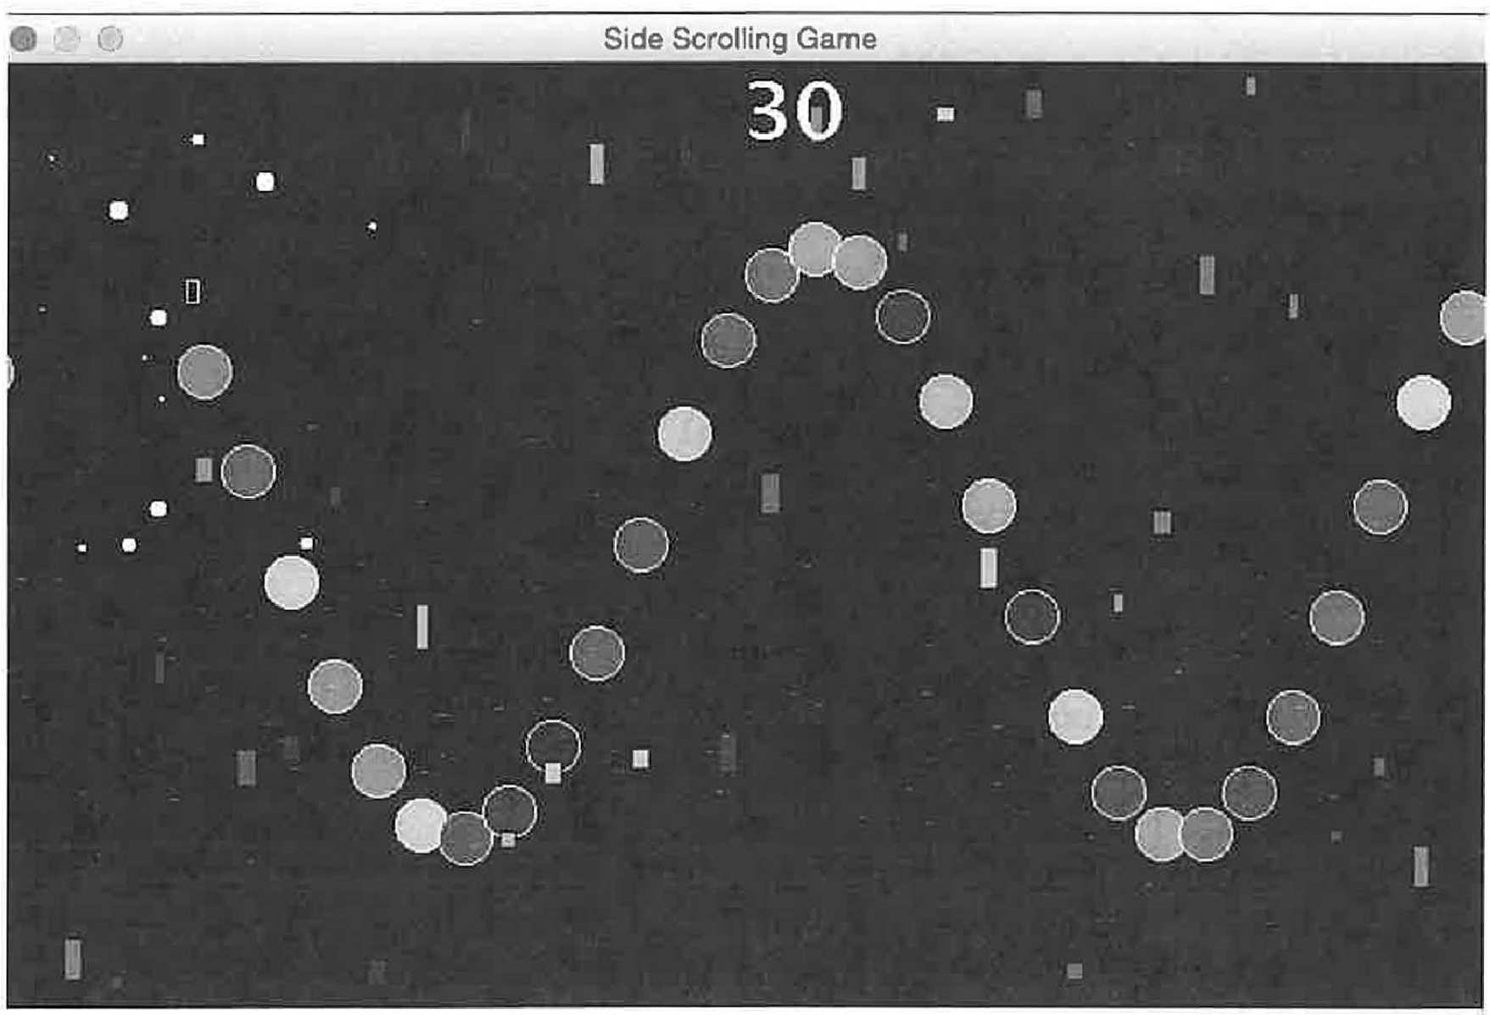

**Description:** This sidescroll game challenges the player to collect certain objects while avoiding the obstacles. The added feature of the game is that it automatically gets harder as the player's score increases and gets correspondingly easier as the player's score goes down.

The collectables are colored balls, and the obstacles are rectangles. They change in size as the player earns or loses points.

The player is a small white, hollow, rectangle, controlled by the arrow keys.

**Sample Output:**

142

package sidescrollgame;

import java.awt.Canvas; import java.awt.Color; import java.awt.Font; import java.awt.Graphics;

import java.awt.event.ActionEvent; import java.awt.event.ActionListener; import java.awt.event.KeyAdapter; import java.awt.event.KeyEvent; import java.io.File;

import java.io.FileinputStream; import java.io.InputStream; import java.util.ArrayList; import java.util.Random;

import javax.swing.JFrame; import javax.swing.JPanel; import javax.swing.Timer; import sun.audio.AudioData; import sun.audio.AudioPlayer; import sun.audio.AudioStream;

import sun.audio.ContinuousAudioDataStream; public class SideScrollGame extends JFrame {

public final int W public final int H =

400;

400;

public int nEvents = O;

public SideScrollGame()

JPanel canvas = new Canvas(); add(canvas);

public class Canvas extends JPanel

public ArrayList<Ball> balls= new ArrayList<Ball>(); public ArrayList<Obstacle> obstacles = new

ArrayList<Obstacle>();

public Player player; public int timerRate = 10;

public int spawnSpacing = 20; public double maxBallRadius = 12.0; public double minBallRadius = 12.0; public int minObstacleW 5;

public int maxObstacleW = 10; public int minObstacleH = 5; public int maxObstacleH = 20; public double speed= 1.0;

public double f = 0.3; private InputStream in; public int score= 0; int ballHitPoints = 10;

143

int obstacleHitPoints = 20;

//for the esplosion, we need "debris":

public int nDebris = 20;

public Color debrisColor = Color.WHITE;

public double[] debrisX = new double[nDebris]; public double[] debrisY = new double[nDebris]; public double[] debrisDX = new double[nDebris]; public double[] debrisDY = new double[nDebris]; public double[] debrisR = new double[nDebris]; public boolean[] isActive = new boolean[nDebris);

public Canvas() { initializeBalls(); initializePlayer(); resetDebris();

Timer timer= new Timer(timerRate, new TimerListener());

timer.start();

//playes an audo file: playSound("audio/DeadlySkirmish(loop) **.wav");**

addKeyListener(new KeyAdapter() {

public void keyPressed(KeyEvent e) { switch (e.getKeyCode()) {

case 37://left arrow player.dx = -player.speed; break;

case 39://right arrow player.dx = +player.speed; break;

case 38://up arrow

player.dy = -player.speed; break;

case 40: //down arrow player.dy = +player.speed; break;

default:

// keyChar e.getKeyChar();

public void keyReleased(KeyEvent e) **{**

switch (e.getKeyCode()) case 37:

player.dx **=** 0;

player.dy 0; break;

case 39:

player.dx 0;

player.dy **=** 0;

break; case 38:

player.dy **=** O;

player.dx 0;

**144**

break; case 40:

player.dy O; player.dx *=* 0; break;

default:

//keyChar *=* e.getKeyChar();

})*;*

setFocusable(true);

protected void paintComponent(Graphics g) { super.paintComponent(g); setBackground(Color.black);

if (nEvents % spawnSpacing 0) { spawnBall();

spawnObstacle();

setMaxObstacleHeight(); updatePlayer(); updateBalls(); updateObstacles(); updateDebris();

if (collision()) explosion();

drawPlayer(g); drawBalls (g); drawObstacles(g); drawDebris(g); drawScore(g);

public void setMaxObstacleHeight() {

//an ad-hoc way to make the game harder as the player get more points:

if (score **<** 100) {

maxObstacleH *=* getHeight() / 20; setBallRadius(maxBallRadius);

if (score < 0) {

maxObstacleH = minObstacleH **+** l; setBallRadius(2 * maxBallRadius);

if (score **<** -50) {

maxObstacleH *=* minObstacleH + l; setBallRadius(4 * maxBallRadius);

if (score **>** 100) (

maxObstacleH = getHeight() / 10; setBallRadius(maxBallRadius / 2);

**145**

if (score = = 100) {

//playSound("audio/Coin Pick Up 03.wav");

//playSound("audio/bull t.wa-;;.");

if (score > 200) {

maxObstacleH = getHeight() / 5; setBallRadius(maxBallRadius / 3);

if (score = = 200) {

//playSound("audio/Coin Pick Up 03.wav");

//playSound("audio/miss2.wav") ;-

if (score > 300) {

maxObstacleH = getHeight() / 2; setBallRadius(maxBallRadius / 4);

**if** (score = = 300) {

//playSound("audio/Coin Pick Up 03.wav");

//playSound("audio/hit2-:-wav"); -

if (score> 400) {

maxObstacleH = getHeight() / 2; setBallRadius(maxBallRadius / 6);

if (score = = 400) {

//playSound("audio/Coin_Pick Up 03.wav"); playSound("audio/hit2.wav");

public void drawScore(Graphics g) {

Font f = new Font("New Courier", Font.BOLD, 36); g.setColor(Color.white);

g.setFont(f);

g.drawString("" + score, getWidth() / 2, f.getSize());

public boolean collision() { boolean return_value = false;

for (inti= balls.size() - 1; i > -1; i--) double distance= Math.sqrt((player.x -

balls.get(i) .x) * (player.x - balls.get(i) .x)

+ (player.y - balls.get(i) .y) * (player.y -

balls.get(i) .y));

**if** (distance<= player.h / 2 + balls.get(i) .r) { return value = true;

balls.remove(i); playSound("audio/hit2.wav"); score+= ballHitPoints;

146

for (inti= obstacles.size() - 1; i > -1; i--) {

boolean xAxis = intervalOverlap( player.x - player.w / 2, player.x + player.w / 2,

obstacles.get(i) .x - obstacles.get(i) .w / 2,

obstacles.get(i) .x + obstacles.get(i) .w / 2

);

boolean yAxis = intervalOverlap( player.y - player.h / 2, player.y + player.h / 2,

obstacles.get(i) .y - obstacles.get(i) .h / 2, obstacles.get(i) .y + obstacles.get(i) .h / 2

) ;

if **(xAxis** && yAxis) { return_value = true; obstacles.remove(i); playSound("audio/miss2.wav"); score-= obstacleHitPoints;

return return_value;

public boolean intervalOverlap(double a, double b, double c, double d) {

if ((c > a && c < b) II (d > a && d < b)) {

return true;

else if (c < a && d > b) return true;

else {

return false;

private void playSound(String fileName) { try {

in = new FileinputStream(new File(fileName)); AudioStream audioStream = new AudioStream(in); AudioPlayer.player.start(audioStream);

catch (Exception e) {

System.out.println("problem with sound effect: "+

fileName);

private void playBackgroundSound(String fileName) { sun.audio.ContinuousAudioDataStream loop = null; AudioStream audioStream;

**147**

file:

fileName);

AudioData AD;

try {//note: this dooes not work with a larger than 1MB

//It will not make a data object from audio streams

//using a file larger than 1 MB.

//input stream:

in= new FileinputStream(new File(fileName)); audioStream = new AudioStream(in);

AD= audioStream.getData();

loop= new ContinuousAudioDataStream(AD);

catch (Exception e) {

System.out.println("problem with sound effect: "+ System.out.println("error: "+ e.toString());

AudioPlayer.player.start(loop);

public void drawPlayer(Graphics g) { g.setColor(player.color);

g.drawRect((int) (player.x - player.w / 2), (int) (player.y - player.h / 2), (int) player.w, (int) player.h);

**}**

public void updatePlayer()

player.x += player.dx; player.y += player.dy;

if (player.x < player.w / 2) player.x = player.w / 2;

if (player.x > getWidth() - player.w / 2) player.x getWidth() - player.w / 2;

if (player.y < player.h *I*

player.y = player.h *I*

if (player.y > getHeight() player.y = getHeight()

public void initializePlayer() player= new Player(); player.w 5;

player.h = 10;

player.x player.w / 2.0; player.y H / 2.0; player.dx = 0;

player.dy = 0;

2)

2;

- player.h *I* 2)

player.h *I* 2;



148

player.speed= player.color

1;

Color.white;

public void spawnBall() { Ball b = new Ball();

doublet= nEvents * timerRate / 1000.0; double A= getHeight() / 3.0 - maxBallRadius;

b.r minBallRadius + (maxBallRadius - minBallRadius) * Math.random();

b.x getWidth ();

1. ;

b.y = getHeight() / 2.0 - A* Math.sin(2 *Math.PI* f *

b.speed = speed; b.dx = -b.speed; b.dy = 0.0;

b.color = getRandomColor(); balls.add(b);



public void spawnObstacle() {

Obstacle obstacle= new Obstacle(); obstacle.x = getWidth();

obstacle.y = getRandom(O, getHeight()); obstacle.color= getRandomColor(); obstacle.speed= speed;

obstacle.dx = -obstacle.speed; obstacle.dy = 0;

obstacle.w = (double) getRandom(minObstacleW, maxObstacleW);

obstacle.h = (double) getRandom(minObstacleH, maxObstacleH);

obstacles.add(obstacle);

public Color getRandomColor() { Random r = new Random();

return new Color(r.nextint(256), r.nextint(256), r.nextint(256));

}

public void drawBalls(Graphics g) { for (Ball b : balls) {

g.setColor(b.color);

g.fillOval((int) (b.x - b.r), (int) (b.y - b.r),

(int) (2 * b.r), (int) (2 * b.r));

g.setColor(Color.white);

g.drawoval((int) (b.x - b.r), (int) (b.y - b.r),

(int) (2 * b.r), (int) (2 * b.r));

}

public void setBallRadius(double r) { for (Ball b : balls) {

**149**

b.r r;

public void drawObstacles(Graphics g) { for (Obstacle obstacle : obstacles)

g.setColor(obstacle.color); g.fillRect(

(int)

(int)

(int)

(int)

);

(obstacle.x -

(obstacle.y - obstacle.w, obstacle.h

obstacle.w / 2),

obstacle.h / 2),

g.setColor(Color.black); g.drawRect(

(int) (obstacle.x - obstacle.w / 2),

(int) (obstacle.y - obstacle.h / 2), (int) obstacle.w,

(int) obstacle.h

);

public void updateBalls() {

for (inti= balls.size() - l; i > -1; i--) ( balls.get(i) .x += balls.get(i) .dx;

if (balls.get(i) .x <= -balls.get(i) .r) { balls.remove(i);

public void updateObstacles() {

for (inti= obstacles.size() - l; i > -1; i--) { obstacles.get(i) .x += obstacles.get(i) .dx;

if (obstacles.get(i) .x <= -obstacles.get(i) .w) obstacles.remove(i);

public void initializeBalls() Ball b = new Ball();

b.r maxBallRadius;

b.x = W;

b.y *=HI* 2.0; b.speed = 5.0; b.dx = -b.speed; b.dy = 0.0; balls.add(b);

public void initializeObstacles() { Obstacle obstacle= new Obstacle();

**150**

obstacle.x = getWidth();

obstacle.y = getRandom(0, getHeight() ); obstacle.speed = 5.0;

obstacle.dx = -obstacle.speed; obstacle.dy = 0.0;

obstacle.w (double) getRandom(minObstacleW, maxObstacleW);

obstacle.h = (double) getRandom(minObstacleH, maxObstacleH);

obstacle.color = Color.black; obstacles.add(obstacle);

public void explosion() {

for (inti= 0; *i* < nDebris; i++) { isActive[i) = true;

for (inti= 0; i < nDebris; i++) { debrisX[i) = player.x; debrisY[i) = player.y;

debrisDX[i) = 10 * Math.random() - 5; debrisDY[i] = 10 * Math.random() - 5; debrisR[i] = 5 *Math.random();

public void resetDebris() {

for (inti= 0; i < nDebris; i++) { isActive[i] = false;

public void updateDebris() {

for (inti= 0; i < nDebris; i++) { if (debrisX[i) - debrisR[i] <= 0

II debrisX[i) + debrisR[i] >= W) { isActive[i] = false;

if (debrisY[i] + debrisR[i] >= H

II debrisY[i) - debrisR[i] <= 0) { isActive[i] = false;

debrisX[i] += debrisDX[i]; debrisY[i] += debrisDY[i];

public void drawDebris(Graphics g) { for (inti= 0; i < nDebris; i++)

if (isActive[i]) { g.setColor(debrisColor);

g.fillOval((int) (debrisX[i) - debrisR[i] ), (int) (debrisY[i) - debrisR[i)), (int) (2 * debrisR[i]),

**151**

(int) (2 * debrisR[i]));

public int getRandom(int p, int q) Random r = new Random(); return p + r.nextint(q - p);

public class TimerListener implements ActionListener public void actionPerformed(ActionEvent e) {

nEvents++; repaint();

public static void main(String[] args) { JFrame frame= new SideScrollGame(); frame.setTitle("Side Scrolling Game");

frame.setDefaultCloseOperation(JFrame.EXIT_ON CLOSE);

//frame.setLocationRelativeTo(null); frame.setSize(400, 400); frame.setVisible(true);

*//II//II/////I/I/II/I//I////////II/II/I/II/I/I/I//II/I/I*

package sidescrollgame; import java.awt.Color;

public class Ball public double **x;** public double y; public double **dx;** public double dy; public double speed; public double r; public Color color;

public boolean

public Ball() { X = 0;

y = 0;

dx = O; dy = 0;

speed= 0;

r = 1.0;

visible;



**152**

color= Color.red; visible = true;

}

*/I//I//II//II///////////////////////////////////*

package sidescrollgame;

import java.awt.Color; public class Obstacle

public double **x;** public double y; public double **dx;** public double dy; public double speed; public Color color;

public boolean visible; public double **w;**

public double h;

public Obstacle() X **=** 0;

y **=** 0;

dx **=** 0; dy **=** O;

speed= 0;

color= Color.red; visible = true;

w l ;

h **=** 1;

**}**

*II///II/II//////I//////////I//I//II/I///II/II*

package shootinggamenew;

import java.awt.Color; import java.awt.Graphics;

public class ParticleSystem

Particle[] particles; public double **maxR** = 5; public double maxspeed = 5; public int n;

public String name="";

ParticleSystem(int n, double x, double y) { this.n = n;

particles= new Particle[n); for (int i **=** O; i < n; i++) {

particles[i] **=** new Particle(); particles[i) .isActive = false;

153

maxspeed; maxSpeed;

particles[i] .x = x; particles[i] .y = y;

particles[i] .dx 2 * maxSpeed * Math.random()

particles[i] .dy = 2 * maxSpeed * Math.random()

particles[i] .r = maxR *Math.random(); particles[i] .name = this.name;

public void setColor(Color c) { for (inti= 0; i < n; i++)

particles[i] .color = c;

public void draw(Graphics g) { for (inti = 0; i < n; i++)

if (particles[i] .isActive) particles[i] .draw(g);

public void reset(double x, double y) { for (int i = 0; i < n; i++) {

particles[i] = new Particle(); particles[i] .isActive = true; particles[i] .x = x; particles[i] .y = y;

particles[il .dx 2 * maxSpeed * Math.random()

maxSpeed;

maxSpeed;

particles[i] .dy = 2 * maxSpeed * Math.random()

particles[i) .r = maxR * Math.random(); particles[i) .name = this.name;



public void update() {

for (Particle p : particles) p.update();

public String toString() { String out = "";

for (int i 0; i < n; i++) {

out+= " "+ particles[i) .toString(); return out;

**154**

## Java Project: MadLibS

**Description:** This program mimics the classical "Madl-Lib" game. But instead of having the player choose words from certain categories, the computer uses lists of possible words and substitutes them in specified places in the original literature.

The setup begins by selecting a piece of literature (original text) and then tagging certain words for replacement. The tags are associated with files containing possible substitutions.

After the original file is "tagged", the tagged version is referred to as the "Template". The computer program runs through the template file looking for tags. When a tag is found, a random word is chosen from the the corresponding options file, and then substituted for the tagged word. The final output is referred to as the "mad-lib" version of the original text.

The "tags.txt" file lists all the possible tags that might be found in the template file. There is a file for each tag that lists all the words than can be substituted for that tag.

For example, the tags.txt file might contain such words as: aching

adjective adverb amount animal another bands

And, the template file might have something like:

The <aching> feeling was <adjective> to the <bands> of the <animal> etc.

156

The program will detect the tagged word <aching> and then look for a file with that name (aching.txt), which might look like this:

aching shaking throbbing singing yelling hearing seeing being having etc.

Each of the listed words in the aching.txt file can be substituted for the tagged word.

The same process is followed for each of the tags found in the template file.

As you can see, the words in aching.txt are not necessarily synonyms, and in fact might be antonyms, or any other word that might substitute for the original tagged word in any way the user wants to allow or imagine.

This program therefore relies on several additional text files that list the tags and tag substitutions.

For a given piece of literature (original text) , the user must decide where to place tags to create the template file. And, the user must define a text file for each tag.

This project was easy when I first starting using grammatical tags such as <noun> and <adjective> and became more challenging, and more fun, when I extended it to tags that capture semantic variations.

**Here are two sample outputs {A Christmas Carol and The Raven): Original piece of Literature:**

157

**8 Mad Lib**

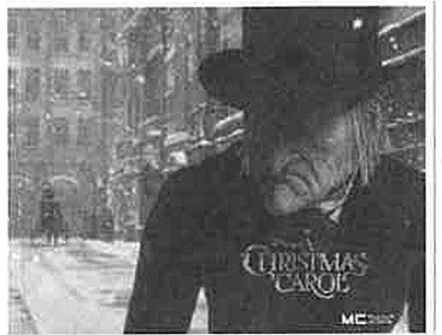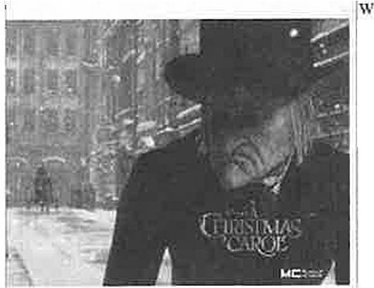

MadLibs Originals

Marley was dead: to begin wilh. There is no doubt whatever about that. The register of he. burial wa signed by the clergyman, the clerk. the undertaker. and the chief mourner. Scrooge signed i1: and Scrooge's name wns good upon 'Change. for anyl!ting he chose to pm bis hand to. Old Murley was as dead a a door-nail. Mindi I donOL mean to say that 1 know, of my own knowledge. what there is pacticularly dend about ti door-nail. I might have been inclined. myself. to regard a coffin-nail as the deadest piece o-f ironmonger)' in the trade. Bue the wisdom of our nn!,cstors is in tl1e imilc: and my unhallowed hands shall not disturb it, or the CountryOs done for. You will therefore pcnnit me to repeat, emph:11ieully. that Marley was as dead as a door-nail.

**A Christmas Carol**

Madlib Version:

* + **Mad Lib**

MadLibs Originals

Dewayne wa sad : to begin with. There is no Sadness whatever about that. The chopping_block of the hanger was igued by the Surveyor . the PsychologL t , the Teacher . nnd 1hc chief Accounmot . Even Scrooge signed it: and Scrooge's name

as atrocious upon DVD_player . for anything he chose LO put a senses 10. No doubt about it. old Malena \\las a. thoughtful as a bar_acccssory . Mind! I don t mean to suy that I know. o( rny own knowJcdgc, wbot .there is piu1icularly late about a

door-nail. l might have been inclined. myself. to regard a coffin-nail as the deadest piece of ironmongery in the trade. But the wisdom of our ancestors is in the simile: and my unhallow.-d hands shall not disturb it. or the Country s done for. You will therefore pcnuit me ro repeat. emphatically. thnt Marley w:1s as dead as a door-nail.

**A Christmas Carol**

Original text:

158

*e ___________* **MedU***_* b*_*_ _

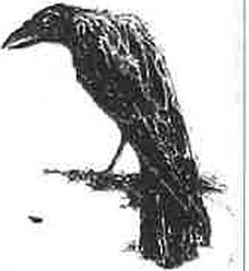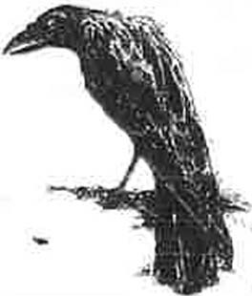

MadUbs Originals

Once upon a midnight dreruy. while I pondered. weak and weruy. Over many a quaint and curious volume of forgoucn lore,

While I nodded. nearly napping, suddenly there came a tapping. As of some one gently rapping, rapping at my chamber door.

* 'Tis some visitor," I muttered. '' lllppiag at my chamber door- Only this. nnd nmhing more.•

**The Raven**

**Madlib version:**

*e -;* 0 Med lib

Madlibs Originals Once upon a daylight dism:ssful , while r reasoned flimsy and f:ccble .

Over many a abcrmm and biza.rro volume of miserable lore

While I sang , nearly milking . suddenly there came a wheezing As of some one gently pulsing , drumming at my Dutch_door . "Tis some mechanic ; I gasped , • crashing at my doggy_door - Only this and notl1ing more."

**The Raven**

package madlib5;

import java.awt.BorderLayout; import java.awt.Font;

import java.awt.event.ActionEvent; import java.awt.event.ActionListener; import java.io.File;

import java.io.FileNotFoundException; import java.util.ArrayList;

import java.util.Scanner; import java.util.logging.Level;

import java.util.logging.Logger;

159

import javax.swing.Imageicon; import javax.swing.JFrame; import javax.swing.JMenu; import javax.swing.JMenuBar; import javax.swing.JMenuitem;

public class MadLib5 extends JFrame

private StoryPanel storyPanel = new StoryPanel();

private String[) fullName = new String() {"Friendship", "I Loved", "Declaration of Independence", "Not in Vain", "The Raven", "A Christmas Carol", "The Tiger", "The Great Gatsby", "Where the Sidewalk Ends", "The Road Not Taken", "How a Toilet Works'', "Tale of Two Cities"};

private String(] shortName = new String[) {"Friendship","Loved", "Declaration", "Vain", "Raven", "Christmas", "Tiger", "Gatsby",

"Sidewalk", "Road", "Toilet", "Tale"};

private String() author= new String(] {"Lucius Seneca", "Langston Hughes", "Ben Franklin", "Emily Dickinson", "Edgar Allan Poe", "Charles Dickens", "William Blake", "F. Scott Fitzgerald", "Shel Silverstein", "Robert Frost", "How Stuf Works", "Charles Dickens"};

public char [] madlibsShortcuts = { 'F' ,'L' , 'N', **1** v' , 'R' , 'o',

'T', 'G', 'S', 'D', 'Q', 'H', 'C'};

public char(] originalsShortcuts = {'F', 'L','N', 'V', 'R', 1 0 1 ,

'T', 'G', 'S', 'D', 'Q', 'H', 'C'};

public String storyTemplateFile public String storyTitle = ""; public String story= 1111;

"".,

public static ArrayList<String> tags= new ArrayList<String>();

public static void main(String[] args) throws FileNotFoundException {

MadLibS frame = new MadLib5(); frame.pack(); frame.setTitle("Mad Lib"); frame.setSize(800, 400);

frame.setDefaultCloseOperation(JFrame.EXIT_ON CLOSE); frame.setVisible(true);

public MadLibS() throws FileNotFoundException {

//read all the tags into an array list:

Scanner fileScanner = new Scanner(new File("tags.txt")); while (fileScanner.hasNext())

tags.add(fileScanner.next()); fileScanner.close();

//initialize the display so the first story pops up at

start:

storyTitle = fullName[0];

storyTemplateFile = shortName[0] + "Original.txt"; String story= getStory(storyTemplateFile);



160

storyPanel.setimageicon(new Imagelcon("images/" + shortName [OJ + ". jpg"));

storyPanel.setTitle(storyTitle); storyPanel.setStory(story); setLayout(new BorderLayout()); add(storyPanel, BorderLayout.CENTER);

//Now, build the menu bar and selections: JMenuBar myMenuBar = new JMenuBar();

//use this listener for all the menu selections: MenuListener myListener = new MenuListener();

//first menu, for the madlibs:

JMenu madlibs = new JMenu("MadLibs");

for (inti= 0; *i* < fullName.length; i++) JMenuitem item= new JMenuitem(fullName[i] +"

(MadLib)", madlibsShortcuts[i));

item.addActionListener(myListener); madlibs.add(item);

//add the "quit" option to the first file menu: JMenuitem item = new JMenuitem("Quit",

madlibsShortcuts[fullName.length)); item.addActionListener(new MenuListener()); madlibs.add(item);

myMenuBar.add(madlibs);

//second menu, for the originals:

JMenu originals = new JMenu("Originals"); for (inti = 0; *i* < fullName.length; i++)

item = new JMenuitem(fullName[i] +" (Original)", originalsShortcuts[i));

item.addActionListener(myListener); originals.add(item);

myMenuBar.add(originals); setJMenuBar(myMenuBar);

class MenuListener implements ActionListener { @Override

public void actionPerforrned(ActionEvent e) {

//if the selection is "quit", then exit the program: if (e.getActionCommand() .equals("Quit")) {

Systern.exit(0);

text, then

//if not "quit", then see which story was selected: for (inti = 0; i < fullName.length; i++) {

//check which story name matches the selected item: if (e.getActionCommand() .indexOf(fullName[i]) = = 0)

try {

//If the selection has "(MadLib)" in the



**161**

for story)

>= 0)

"Template.txt"; "Original.txt 1 ;

//set the storyTemplateFile to the template

//that story: (else, set it to the original if (e.getActionCommand() .indexOf( 1 (MadLib )1 )

1

storyTemplateFile = shortNarne[i] +

else {

storyTemplateFile = shortName[i] +

storyPanel.setirnageicon(new

Imageicon("irnages/ 1 + shortName[i] + 11 .jpg"));

storyTitle = fullName[i]; storyPanel.setTitle(storyTitle); story= getStory(storyTemplateFile); storyPanel.setStory(story);

catch (Exception ex) { Systern.out.println("exception: 11 +

ex.toString());

full Name [i] );

System.out.println("could

not implement:

11 +



public static String getStory(String templateFile) throws FileNotFoundException {

String story= 1 1 " ;

String template= getTemplate(templateFile); Scanner scanner= new Scanner(template);

int wordCount = 0; //might want to count the words

while (scanner.hasNext()) { String word= scanner.next(); wordCount++;

//check the word against each of the tags for (inti= 0; i <tags.size(); i++)

//the new line tag is special:

if (word.equals("<endl>")) { word= "\n";

else (

//if the word matches one of the tags

//then get a random word from the relevant file: if (word.equals("<"+ tags.get(i) + ">")) {

word= getRandomWord(tags.get(i));

**162**

story+= word+ **11 11;**

scanner.close(); return story;

public static String getTemplate(String fileName) throws FileNotFoundException {

//read the story template from a file: String template= 1111 ;

//System.out.println( 1 fileName 11 + fileName); File f = new File(fileName);

//System.out.println( **11** file exists(): 11 + f.exists());

//System.out.println( 1 file canRead(): 1 + f.canRead());

1

//System.out.println( **1** file length(): **11** + f.length());

//System.out.println( 1 file canExecute: 11 + f.canExecute());

//System.out.println( 1 file getAbsoluteFile" + f.getAbsoluteFile());

Scanner fileScanner = new Scanner(f, 1 IS0-8859-11 ) ;

1

//System.out.println("fileScanner.hasNext(): 11 + fileScanner.hasNext() );

while (fileScanner.hasNext()) {

// System.out.println( 1 scanning a line of the file"); template+= fileScanner.nextLine();

fileScanner.close();

//System.out.println("template ="+template); return template;

public static String getRandomWord(String category) throws FileNotFoundException {

//This method gets a random word from the file

//defined by category--> category.txt File file= new File(category + ".txt"); Scanner fileScanner = new Scanner(file);

//Now, copy all the words from the file into an array list: ArrayList<String> words= new ArrayList<String>();

while (fileScanner.hasNext()) { String word= fileScanner.next(); words.add(word);

if (fileScanner.hasNext()) { fileScanner.nextLine();

list:

}

//pick a random number up to the number of words in the

int rand= (int) (words.size() *Math.random());

//return the word at the random index: return words.get(rand);



163

*/llllllll/llllll!IIII//II//IIIIIIIII/II/*

/*

* To change this license header, choose License Headers in Project Properties.
* To change this template file, choose Tools I Templates
* and open the template in the editor.

*/

package madlibS;

import java.awt.BorderLayout; import java.awt.Font;

import javax.swing.Imageicon; import javax.swing.JLabel; import javax.swing.JPanel; import javax.swing.JScrollPane; import javax.swing.JTextArea;

/**

*

* @author wwolfe3

*/

public class StoryPanel extends JPanel {

private JLabel imageTitle private JTextArea jtaStory

public StoryPanel() {

new JLabel(); new JTextArea();

imageTitle.setHorizontalAlignment(JLabel.CENTER); imageTitle.setHorizontalTextPosition(JLabel.CENTER); imageTitle.setVerticalTextPosition(JLabel.BOTTOM); imageTitle.setFont(new Font("SansSerif", Font.BOLD, 20)); jtaStory.setFont(new Font("Serif", Font.PLAIN, 16)); jtaStory.setLineWrap(true); jtaStory.setWrapStyleWord(true); jtaStory.setEditable(false);

jtaStory.setSize(350, 250);

JScrollPane scrollPane = new JScrollPane(jtaStory); setLayout(new BorderLayout(S,5));

add(scrollPane, BorderLayout.CENTER); add(imageTitle, BorderLayout.WEST);

public void setTitle(String title) imageTitle.setText(title);

public void setimageicon(Imageicon icon) imageTitle.seticon(icon);

**164**

public void setStory(String story) jtaStory.setText(story);

**}**

*IIII/IIIIIIIIIIIIIIIIII/I//IIIIIIIII///IIIII//*

Marley was dead: to begin with. There is no doubt whatever about that. The register of his burial was signed by the clergyman, the clerk, the undertaker, and the chief mourner. Scrooge signed it: and Scrooge's name was good upon 'Change, for anything he chose to put his hand to. Old Marley was as dead as a door-nail. Mind! I donft mean to say that I know, of my own knowledge, what there is particularly dead about a door-nail. I might have been inclined, myself, to regard a coffin-nail as the deadest piece of ironmongery in the trade. But the wisdom of our ancestors is in the simile; and my unhallowed hands shall not disturb it, or the Countryfs done for. You will therefore permit me to repeat, emphatically, that Marley was as dead as a door-nail.

*!ll!/ll/lllllllllllllllllllllllll/ll/lll!/IIII*

<name> was <stateofbeing> : to begin with. There is no

<nounAbstract> whatever about that. The <randomstuff> of the

<randomstuff> was signed by the <profession>, the <profession>, the <profession>, and the chief <profession> . Even Scrooge signed it: and Scrooge's name was <quality> upon <randomstuff>, for anything he chose to put a <bodypart> to. No doubt about it, old

<name> was as <stateofbeing> as a <randomstuff> . Mind! I donJEt mean to say that I know, of my own knowledge, what there is particularly

<dead> about a door-nail. I might have been inclined, myself, to regard a coffin-nail as the deadest piece of ironmongery in the trade. But the wisdom of our ancestors is in the simile; and my unhallowed hands shall not disturb it, or the CountryEs done for. You will therefore permit me to repeat, emphatically, that Marley was as dead as a door-nail.

*IIIIIII/IIIIIIII/IIIIIIIIIIIIIIIIIIIIIIIIIIII*

name.txt:

Greta Weston Kristan Eilene Quyen Valentin Verdie Venice Sandie Kirstie Freeda Gita Geraldine

165



*III/IIIIIIIIIIIIII/IIIIIIIIIIIII/I/IIIIIIIIIIIIIIII*

tags.txt:

aching adjective adverb amount animal another bands bendPast bodypart breaking breaking candy causes chemical color container cool

dead declare dissolve divergeP divergePast door

dreary earth ease emotion endl entitle fainting far

flushGerund flushVerb force forgotten friend friendship gas

gerund health help human impel laws liquid live live location

**166**

long lookPast loved mankind midnight mutterPast name nature necessary nest nothing noun

nounAbstract nounPlural number object opinions pain

pastParticiplePassive people

poem political pondered ponderPast pourGerund pourPast pourVerb powers process profession quaint quality randomstuff respect roadPlural sat

say separation soft

sorry soundGerund standPast stateofbeing stop

stuff suckGerund suckPast suckVerb superlative timeofday timeperiod travel

**167**

















































